Humanities · BUILD · Autumn 2 · Week 3 · HUM-BUILD-A2-W03

Knowledge organiser
Handle and describe festival artefacts respectfully.
Look first. Ask before you touch. Use the card to check what the object is for.
Tier | Word | Meaning
Tier 2 | festival | A special time to mark or remember something.
Tier 3 | artefact | An object made or used by people.
Tier 2 | respect | Treat people and their things with care.
Tier 2 | source | Where we get a fact or clue.
I see ____. The card says it is used for ____. I wonder ____.

Humanities · BUILD · Autumn 2 · Week 3 · HUM-BUILD-A2-W03

Look at the two lamps
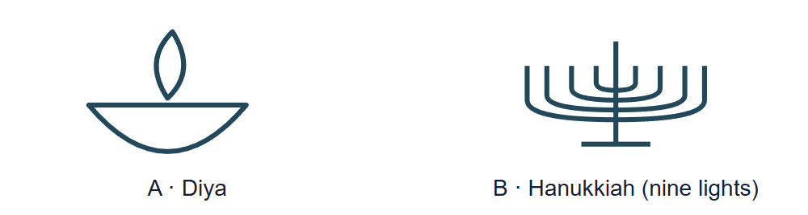
Picture A is a bowl-shaped diya lamp. Picture B is a hanukkiah with eight festival lights and a raised helper light.
Use the drawings with cards D, H and O. Ask before touching a borrowed object. Use an unlit copy for the task.

Humanities · BUILD · Autumn 2 · Week 3 · HUM-BUILD-A2-W03

Evidence cards D and H

D · Diwali
Many Hindus use lamps, pray and meet for Diwali. Light can stand for good winning over bad and for learning.
People mark Diwali in more than one way.

H · Hanukkah
Hanukkah is a Jewish festival. Its lights recall the Temple being made ready for worship again and a story about oil lasting eight nights. The lamp stand has eight festival lights and a helper light.
People mark Hanukkah in more than one way.

Humanities · BUILD · Autumn 2 · Week 3 · HUM-BUILD-A2-W03

Evidence cards O and S

O · Objects and meanings
A diya is a small lamp used at Diwali. A hanukkiah is used at Hanukkah. Ask before you touch a borrowed object. Use a drawing or an unlit copy.
Use the card or ask a person who knows. Shape can give a clue.

S · One family’s plan
In this made-up plan, a family gets a place ready, sets out unlit lamps with an adult, gathers to pray and shares food and greetings.
This is one plan. Other homes may do things in a different order.

Humanities · BUILD · Autumn 2 · Week 3 · HUM-BUILD-A2-W03

Shared investigation
Look at both drawings. Say what you see, what you think and what you wonder. Agree a rule for looking at a borrowed object.
1. What can you see on the diya?
2. What can you see on the hanukkiah?
3. What does card O help us match?
Step | Ask
See | What can I point to?
Think | Which card can help me?
Wonder | What would I like to ask?
Our explanation
____________________________________________________________

Optional · respond to feedback together
Optional: show an adult one detail or card clue. Hear one piece of feedback. Reply with a change, a reason to keep it or a request for help.
My response or improvement
____________________________________________________________

Humanities · BUILD · Autumn 2 · Week 3 · HUM-BUILD-A2-W03

We do decision checkpoint
You see a borrowed lamp. What should you do before you touch it?
1. Ask and follow the rule
2. Pick it up to see the base
3. Guess its use from the shape
My claim and clue
____________________________________________________________

Humanities · BUILD · Autumn 2 · Week 3 · HUM-BUILD-A2-W03

Worked model

Look first
A small bowl shape on the diya. The raised helper light.

Ask first
Ask the owner and follow their rule. Use a drawing or an unlit copy.

Check the card
It is a small lamp used at Diwali. People use it at Hanukkah.

Say what I know
No. Use a card or ask someone who knows. I can see a bowl shape. Card O says the diya is used at Diwali.

Humanities · BUILD · Autumn 2 · Week 3 · HUM-BUILD-A2-W03

Arrival Supported
 | Ready to learn?  ● Green · Ready  ● Amber · Help  ● Red · Pause  You may point, choose or pass.
  1. Point to the picture that matches the top one.  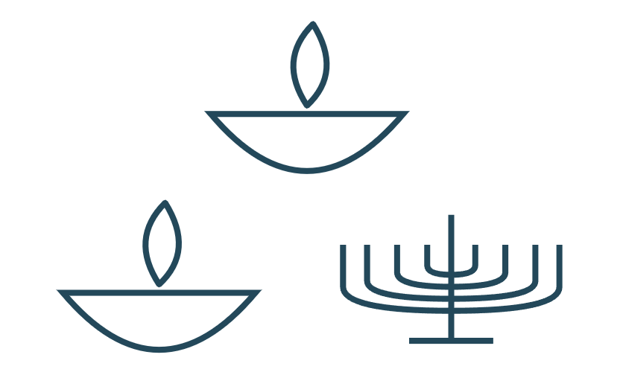  __________________  __________________ | 2. Is a festival a special time or a thing you can hold?  __________________  __________________
  3. What should we do before we touch a borrowed lamp?  __________________  __________________ | 4. Can a shape tell us all we need to know?  __________________  __________________
Point, speak, sign, draw, write or choose. You may pass. An adult may note your own words or choice.

Humanities · BUILD · Autumn 2 · Week 3 · HUM-BUILD-A2-W03

You do Supported
Staff mark I · S · C beside the task.
1. Choose one drawing or unlit copy.
2. Start in your book. Point to one part. Use card O to match its use.
3. Finish: I see ____. The card says ____. I wonder ____.
Word bank: diya · hanukkiah · lamp · light · ask · care.
My example and card detail
____________________________________________________________
My reason and check
____________________________________________________________
Point, speak, sign, draw, write or choose. You may pass. An adult may note your own words or choice.

Humanities · BUILD · Autumn 2 · Week 3 · HUM-BUILD-A2-W03

Review and exit Supported
Edit in the same colour, on the same page.
What do we do before we touch a borrowed lamp?
____________________________________________________________
Can shape tell us all we need to know?
____________________________________________________________
Point, speak, sign, draw, write or choose. You may pass. An adult may note your own words or choice.

Humanities · BUILD · Autumn 2 · Week 3 · HUM-BUILD-A2-W03

Arrival Independent
 | Ready to learn?  ● Green · Ready  ● Amber · Help  ● Red · Pause  You may point, choose or pass.
  1. Point to the picture that matches the top one.  __________________  __________________ | 2. What does festival mean?  __________________  __________________
  3. What should we do before handling a borrowed object?  __________________  __________________ | 4. Can shape tell us what a lamp means?  __________________  __________________
Point, speak, sign, draw, write or choose. You may pass. An adult may note your own words or choice.

Humanities · BUILD · Autumn 2 · Week 3 · HUM-BUILD-A2-W03

You do Independent
Staff mark I · S · C beside the task.
1. Choose one drawing or unlit copy.
2. In your book, show a detail you can see. Use a card to say what the object is for.
3. Add a question the object cannot answer on its own.
Word bank: diya · hanukkiah · lamp · light · ask · care.
My example and card detail
____________________________________________________________
My reason and check
____________________________________________________________
Point, speak, sign, draw, write or choose. You may pass. An adult may note your own words or choice.

Humanities · BUILD · Autumn 2 · Week 3 · HUM-BUILD-A2-W03

Review and exit Independent
Edit in the same colour, on the same page.
What rule should we follow with a borrowed object?
____________________________________________________________
Why do we use a source as well as looking?
____________________________________________________________
Point, speak, sign, draw, write or choose. You may pass. An adult may note your own words or choice.

Humanities · BUILD · Autumn 2 · Week 3 · HUM-BUILD-A2-W03

Arrival Aspire
 | Ready to learn?  ● Green · Ready  ● Amber · Help  ● Red · Pause  You may point, choose or pass.
  1. Point to the picture that matches the top one.  __________________  __________________ | 2. Name one use of lights at a festival.  __________________  __________________
  3. How can we look with care?  __________________  __________________ | 4. What can a card tell you that a shape cannot?  __________________  __________________
Point, speak, sign, draw, write or choose. You may pass. An adult may note your own words or choice.

Humanities · BUILD · Autumn 2 · Week 3 · HUM-BUILD-A2-W03

You do Aspire
Staff mark I · S · C beside the task.
1. Try the challenge after your object note. Pick one detail you can see.
2. Say what you think it might mean. Give a clue from a card and one thing you still need to ask.
Word bank: diya · hanukkiah · lamp · light · ask · care.
My example and card detail
____________________________________________________________
My reason and check
____________________________________________________________
Point, speak, sign, draw, write or choose. You may pass. An adult may note your own words or choice.

Humanities · BUILD · Autumn 2 · Week 3 · HUM-BUILD-A2-W03

Review and exit Aspire
Edit in the same colour, on the same page.
How can we show care and still learn?
____________________________________________________________
Give a visible detail and say what you would check.
____________________________________________________________
Point, speak, sign, draw, write or choose. You may pass. An adult may note your own words or choice.

Humanities · BUILD · Autumn 2 · Week 3 · HUM-BUILD-A2-W03

You do Choice
Staff mark I · S · C beside the task.
1. Choose to draw, point, sign or tell an adult. Keep the record in your book.
2. Show one part and match its use with card O. Show or ask one thing you still want to know.
Word bank: diya · hanukkiah · lamp · light · ask · care.
My example and card detail
____________________________________________________________
My reason and check
____________________________________________________________
Point, speak, sign, draw, write or choose. You may pass. An adult may note your own words or choice.

Humanities · BUILD · Autumn 2 · Week 3 · HUM-BUILD-A2-W03

Review and exit Choice
Show or tell one rule for a borrowed object.
____________________________________________________________
Show how to check what it is for.
____________________________________________________________
Point, speak, sign, draw, write or choose. You may pass. An adult may note your own words or choice.

Humanities · BUILD · Autumn 2 · Week 3 · HUM-BUILD-A2-W03

Route card
Choose one: □ Supported · □ Independent · □ Aspire · □ Choice.
Start in your book and keep your evidence and check together.

Staff feedback boxes and pupil responses

□ VF
My response
____________________________________________________________

□ WS
My response
____________________________________________________________

□ I
My response
____________________________________________________________

□ NS + …
My response
____________________________________________________________

□ E
My response
____________________________________________________________

□ R
My response
____________________________________________________________

□ //
My response
____________________________________________________________

□ ?
My response
____________________________________________________________

Humanities · BUILD · Autumn 2 · Week 3 · HUM-BUILD-A2-W03

Catch-up absence or access only
For absence or access only.
Look at one drawing. Read one line from card O with an adult. Match the object to its use and join the task.

Humanities · BUILD · Autumn 2 · Week 3 · HUM-BUILD-A2-W03

Word page
Picture A is a bowl-shaped diya lamp. Picture B is a hanukkiah with eight festival lights and a raised helper light.
Tier | Word | Meaning
Tier 2 | festival | A special time to mark or remember something.
Tier 3 | artefact | An object made or used by people.
Tier 2 | respect | Treat people and their things with care.
Tier 2 | source | Where we get a fact or clue.

Humanities · BUILD · Autumn 2 · Week 3 · HUM-BUILD-A2-W03

Book strips
Humanities · BUILD · Autumn 2 · Week 3 · HUM-BUILD-A2-W03
Objects and respectful enquiry

Today I can
I can ask before I touch. · I can say what I see. · I can use a card to say what an object is for.
Humanities · BUILD · Autumn 2 · Week 3 · HUM-BUILD-A2-W03
Objects and respectful enquiry

Today I can
I can ask before I touch. · I can say what I see. · I can use a card to say what an object is for.
Humanities · BUILD · Autumn 2 · Week 3 · HUM-BUILD-A2-W03
Objects and respectful enquiry

Today I can
I can ask before I touch. · I can say what I see. · I can use a card to say what an object is for.
Humanities · BUILD · Autumn 2 · Week 3 · HUM-BUILD-A2-W03
Objects and respectful enquiry

Today I can
I can ask before I touch. · I can say what I see. · I can use a card to say what an object is for.

