Week 3 | Microscopy and magnification
  - Weekly teaching plan | LAUNCH Science | Autumn 1
Timetable: Monday, Wednesday and Friday | Period 1 | 09:30–10:10
Week commencing: __________________
Day | Lesson | Learning focus
Monday | W3L1 · Introduce | I can use a light microscope model and explain the difference between magnification and resolution.
Wednesday | W3L2 · Explore | I can use the magnification relationship, convert units and judge whether an answer is plausible.
Friday | W3L3 · Do | I can independently measure, calculate and correct a magnification problem.

Prepare once for the week
Open this week’s folder. Download or sync the complete folder to the classroom PC. Start the named PowerPoint in Slide Show mode. Print the selected PDF route; the Word sheet is an editable master. Keep teaching plans and mark schemes in staff storage.
Microscopes and prepared slides are optional. Use them only with the approved handling procedure and suitable staffing. The diagram route supports observation and calculation; it does not show that a pupil has handled a microscope. Have calculators and rulers ready. Questions use stated lengths, so printer scaling does not affect the answers.

Teaching decisions
Use one shared route: PowerPoint activity, paper or the linked online model. A video replaces up to 90 seconds of the relevant model, rather than adding time. Use the prompt and still diagram if playback is unavailable. Linked videos are freesciencelessons GCSE concept explanations; their AQA practical numbering is not this centre’s assessment record.
If more time is needed, drop optional continuation. Keep one model, one supported attempt and independent evidence, then the Exit. Offer the least help first and leave the pupil’s choice and explanation theirs.
Timetable source: Timetables 2026_2027 (2).xlsx, Launch B5/D5/F5; Matt D3/D9/D15.

W3L1 | Microscopy
  - Monday | 09:30–10:10 | Introduce
Say: Magnification is how many times larger an image is. Resolution is whether close points can be seen separately. Enlarging a blur does not recover detail.

09:30–09:33 | Arrival
What tool could help us see cells that are too small for the eye? Receive a short answer or a point to the image.

09:33–09:37 | Starter
A cell image becomes larger but stays blurred. Has its resolution improved? Commit a view before the model opens. Take a reason before revealing the answer.

09:37–09:42 | I Do
Begin on the lowest-power objective so the specimen is easier to find. Use coarse focus only at low power, then fine focus. Use fine focus only at high power. Total magnification equals eyepiece magnification multiplied by objective magnification.

09:42–09:47 | We Do
A microscope uses a ×10 eyepiece and a ×40 objective. What is the total magnification? Answer: ×400. Ask for the deciding step.
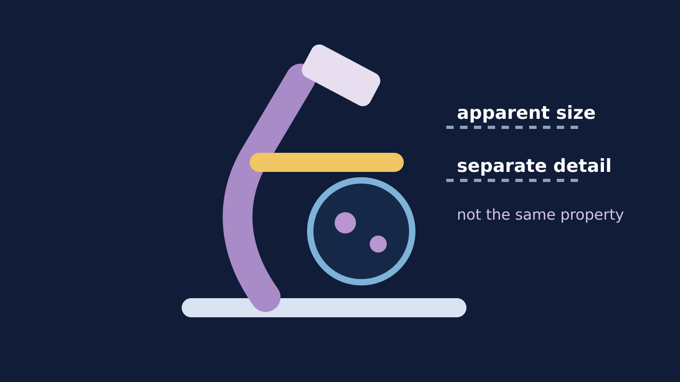
Teaching visual from the matching online lesson. A model, not evidence of practical completion. Use within the modelling time.

W3L1 | Continue the lesson
  - Second half | Keep the same 40-minute sequence

09:47–09:51 | I Do 2
Magnification describes how many times larger the image appears. Resolution describes whether two close points can be seen as separate detail. A larger image is not automatically a more detailed image.

09:51–09:57 | We Do 2 · Task
Choose ×4 then ×40 objectives with a ×10 eyepiece. Predict the total each time. Use the shared-task board; reveal only after a pupil decision.

09:57–10:07 | Independent Task
A pupil changes from a ×4 objective to a ×40 objective while keeping a ×10 eyepiece. Explain the change in total magnification, field of view and visible detail. Include one limitation of the digital model. Select one correction on the same work.

10:07–10:10 | Exit
In one sentence, explain why a bigger image is not always a better-resolved image. Receive a specific learning request and agree the next action.
Watch for: Do not add the lens powers. At high power use fine focus only; follow the microscope’s approved procedure.
Least help first: Ask which change is about size and which is about detail before naming either term.

W3L2 | Magnification
  - Wednesday | 09:30–10:10 | Explore
Say: Name the unknown, match the units, select the relationship, substitute, then check. Magnification is a ratio: write ×200, not 200 mm.

09:30–09:33 | Arrival
Write the relationship between image size, actual size and magnification. Receive a short answer or a point to the image.

09:33–09:37 | Starter
A cell is 50 µm long but its image measures 50 mm. Is the magnification ×1, ×100 or ×1000? Commit before converting. Take a reason before revealing the answer.

09:37–09:42 | I Do
Circle the known quantities and name the unknown. Convert both lengths into the same unit before substituting. Use magnification = image size ÷ actual size, then check whether the scale makes sense.

09:42–09:47 | We Do
An image is 24 mm and the actual cell is 60 µm. Which conversion is useful? Answer: 24 mm = 24,000 µm. Ask for the deciding step.
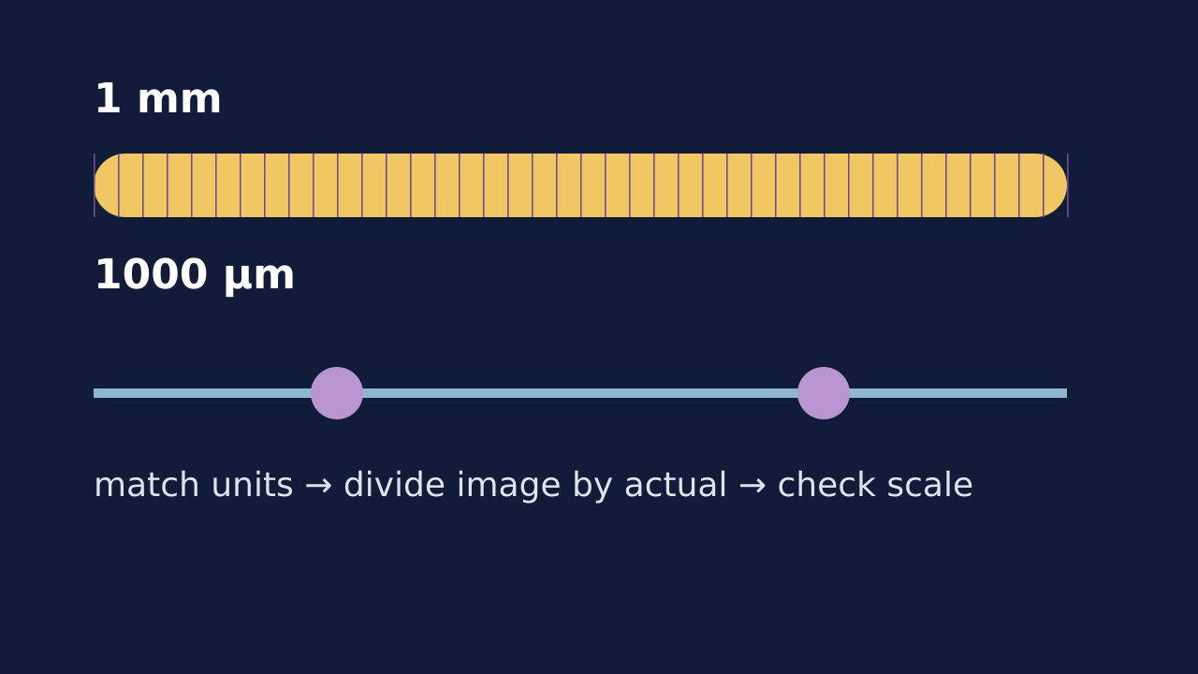
Teaching visual from the matching online lesson. A model, not evidence of practical completion. Use within the modelling time.

W3L2 | Continue the lesson
  - Second half | Keep the same 40-minute sequence

09:47–09:51 | I Do 2
Rearrange only after naming the unknown. Keep units beside substitutions so a mismatch stays visible. A plausibility check asks whether the image is much larger than the actual cell.

09:51–09:57 | We Do 2 · Task
Work alone or in a pair. One person chooses the relationship; the other checks the units. Swap for the next item. Use the shared-task board; reveal only after a pupil decision.

09:57–10:07 | Independent Task
A micrograph of a cell measures 36 mm. The cell’s actual length is 90 µm. Calculate the magnification and explain one check that shows your answer is plausible. Select one correction on the same work.

10:07–10:10 | Exit
What single check should happen before dividing one length by another? Receive a specific learning request and agree the next action.
Watch for: 50 µm is 0.05 mm, not 50 mm. A correct final value is not evidence that the unit route was understood.
Least help first: Ask which two values are known and whether their units match before discussing arithmetic.

W3L3 | Scale Bars
  - Friday | 09:30–10:10 | Do
Say: A ruler measurement changes if a picture is resized. A scale bar stays useful if the image and bar are resized together.

09:30–09:33 | Arrival
Convert 0.08 mm to micrometres. Receive a short answer or a point to the image.

09:33–09:37 | Starter
Two pupils get ×60 and ×600 from the same image. Which evidence would help locate the error? Take a reason before revealing the answer.

09:37–09:42 | I Do
Place the zero mark at the first clear edge and read the second edge once. Keep the measured image length and stated actual length in matching units. Classify an error as measurement, unit, rearrangement or arithmetic before repairing it.

09:42–09:47 | We Do
A pupil divides actual size by image size and gets ×0.002. What type of error is this? Answer: Rearrangement/relationship. Ask for the deciding step.
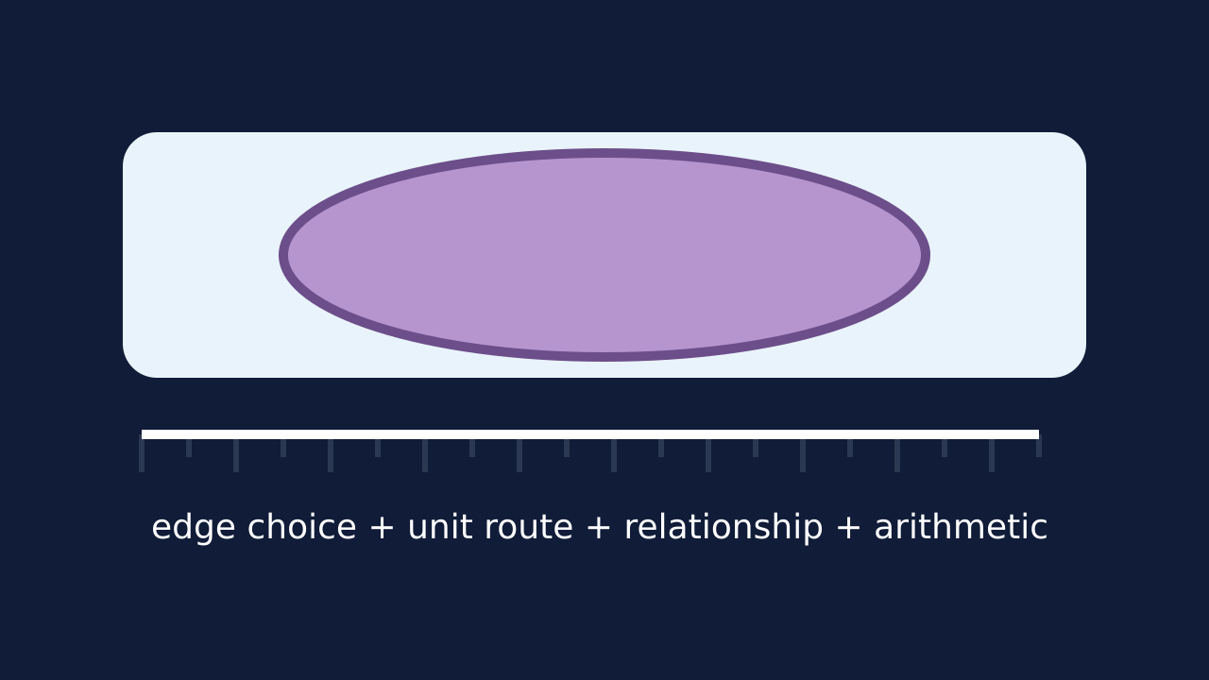
Teaching visual from the matching online lesson. A model, not evidence of practical completion. Use within the modelling time.

W3L3 | Continue the lesson
  - Second half | Keep the same 40-minute sequence

09:47–09:51 | I Do 2
Do not erase the first route; annotate the point where it became invalid. Use the error type to choose one repair, not a full restart. Compare the repaired answer with the image scale.

09:51–09:57 | We Do 2 · Task
Read the stated measurements. This route does not depend on the printer scale. Use the shared-task board; reveal only after a pupil decision.

09:57–10:07 | Independent Task
A specimen image measures 48 mm. Its actual width is 80 µm. Calculate the magnification. Then explain how you would distinguish a unit error from a measurement error if another pupil obtained ×60. Select one correction on the same work.

10:07–10:10 | Exit
Name the error type you would check first when an answer is exactly ten or one thousand times too large. Receive a specific learning request and agree the next action.
Watch for: Do not claim pupils measured a real cell if they used stated lengths or a model. A precise-looking number is not automatically an accurate measurement.
Least help first: Do not repair the whole calculation. Ask the pupil to name the error type and change one step.

