Week 4 | Diffusion
  - Weekly teaching plan | LAUNCH Science | Autumn 1
Timetable: Monday, Wednesday and Friday | Period 1 | 09:30–10:10
Week commencing: __________________
Day | Lesson | Learning focus
Monday | W4L1 · Introduce | I can explain diffusion as net movement down a concentration gradient and use evidence to compare rates.
Wednesday | W4L2 · Explore | I can link alveolus features to rapid gas exchange using concentration gradients and diffusion distance.
Friday | W4L3 · Do | I can select evidence and improve a diffusion explanation in an unfamiliar context.

Prepare once for the week
Open this week’s folder. Download or sync the complete folder to the classroom PC. Start the named PowerPoint in Slide Show mode. Print the selected PDF route; the Word sheet is an editable master. Keep teaching plans and mark schemes in staff storage.
Paper, counters, pens and calculators are enough. The datasets are illustrative. Use the alveolus drawing for gas exchange. An optional physical demonstration needs the setting’s approved procedure; dye spreading in warm water may include convection.

Teaching decisions
Use one shared route: PowerPoint activity, paper or the linked online model. A video replaces up to 90 seconds of the relevant model, rather than adding time. Use the prompt and still diagram if playback is unavailable. Linked videos are freesciencelessons GCSE concept explanations; their AQA practical numbering is not this centre’s assessment record.
If more time is needed, drop optional continuation. Keep one model, one supported attempt and independent evidence, then the Exit. Offer the least help first and leave the pupil’s choice and explanation theirs.
Timetable source: Timetables 2026_2027 (2).xlsx, Launch B5/D5/F5; Matt D3/D9/D15.

W4L1 | Diffusion
  - Monday | 09:30–10:10 | Introduce
Say: Particles move randomly in both directions. Net movement is the difference between those two movements, not a rule obeyed by every particle.

09:30–09:33 | Arrival
What does concentration describe? Receive a short answer or a point to the image.

09:33–09:37 | Starter
Particles move randomly in both directions. Can there still be net movement from high to low concentration? Take a reason before revealing the answer.

09:37–09:42 | I Do
Individual particles move randomly in every direction. More particles start in the high-concentration region, so more crossing events begin there. Net movement is the overall difference between movements in opposite directions.

09:42–09:47 | We Do
Which statement is scientifically accurate during diffusion? Answer: Particles move randomly, with net movement down the gradient. Ask for the deciding step.
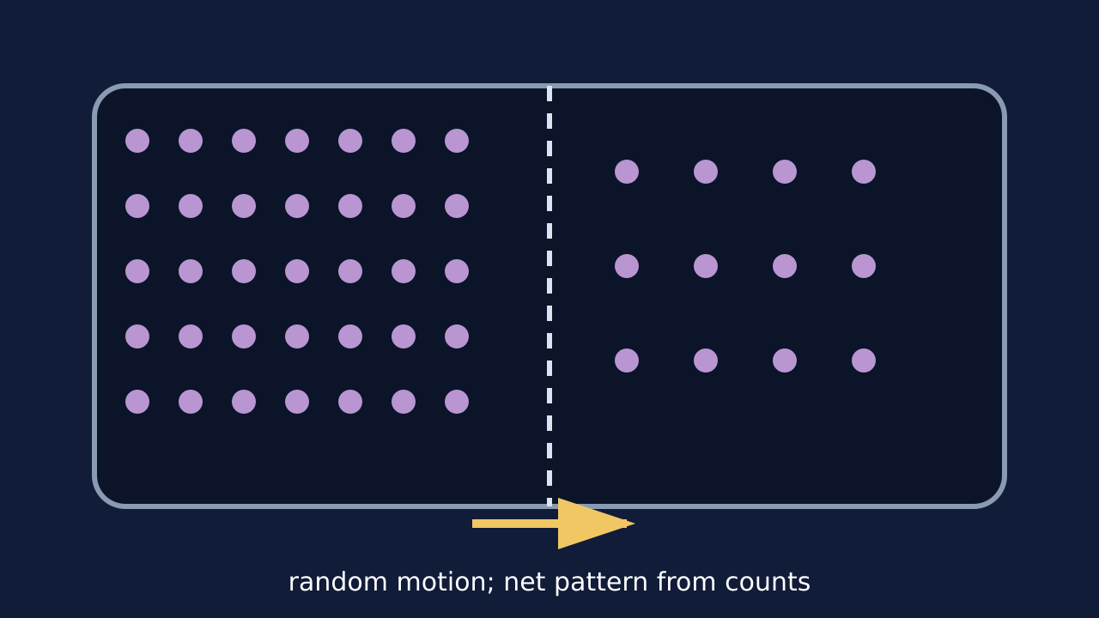
Teaching visual from the matching online lesson. A model, not evidence of practical completion. Use within the modelling time.

W4L1 | Continue the lesson
  - Second half | Keep the same 40-minute sequence

09:47–09:51 | I Do 2
A steeper concentration difference usually increases the net rate. Higher temperature increases particle kinetic energy and movement rate. A longer diffusion distance reduces the rate of exchange.

09:51–09:57 | We Do 2 · Task
Draw two equal-volume regions: 12 particles left and 3 right. Predict the initial net direction. Use the shared-task board; reveal only after a pupil decision.

09:57–10:07 | Independent Task
Two chambers have the same temperature and distance. Chamber A starts with 80 particles on the left and 20 on the right. Chamber B starts with 60 on the left and 40 on the right. Predict which has the faster initial net diffusion and explain using random motion and concentration gradient. Select one correction on the same work.

10:07–10:10 | Exit
What continues at equilibrium even though net movement is zero? Receive a specific learning request and agree the next action.
Watch for: Passive means no energy supplied by respiration is needed. It does not mean particles have no kinetic energy.
Least help first: Ask the pupil to compare starting counts on both sides before discussing direction.

W4L2 | Gas Exchange
  - Wednesday | 09:30–10:10 | Explore
Say: For each feature, say what it changes physically and why that affects diffusion. “Good lungs” is not an explanation.

09:30–09:33 | Arrival
In which direction does oxygen diffuse at an alveolus? Receive a short answer or a point to the image.

09:33–09:37 | Starter
Which change would most directly shorten the distance that oxygen must diffuse: more alveoli, a thinner wall or faster ventilation? Take a reason before revealing the answer.

09:37–09:42 | I Do
Ventilation refreshes alveolar air and helps maintain oxygen and carbon dioxide gradients. Blood flow carries gases away or brings them to the exchange surface, maintaining gradients. A one-cell-thick exchange surface gives a short diffusion distance, while many alveoli give a large surface area.

09:42–09:47 | We Do
Why does a rich blood supply support oxygen diffusion into blood? Answer: It removes oxygenated blood and maintains a gradient. Ask for the deciding step.
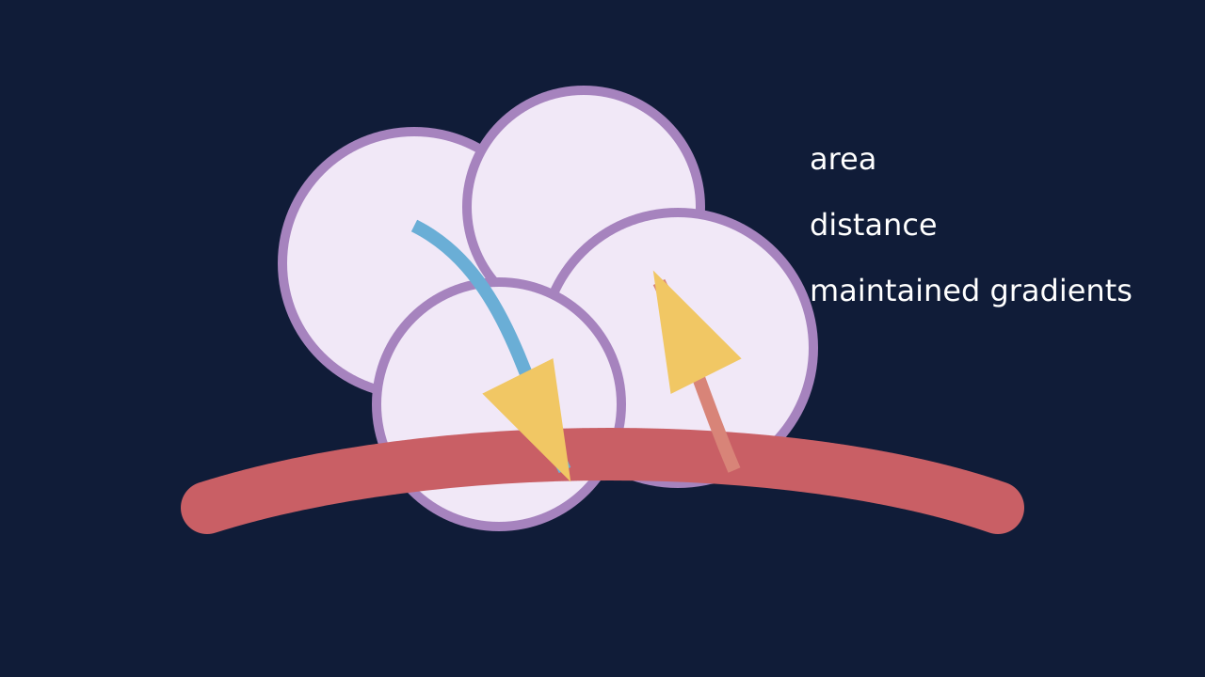
Teaching visual from the matching online lesson. A model, not evidence of practical completion. Use within the modelling time.

W4L2 | Continue the lesson
  - Second half | Keep the same 40-minute sequence

09:47–09:51 | I Do 2
Feature: large surface area. Effect: more membrane available at once. Consequence: greater total diffusion. Feature: thin wall. Effect: shorter diffusion distance. Consequence: faster exchange. Feature: ventilation and blood flow. Effect: maintain gradients. Consequence: continued net movement.

09:51–09:57 | We Do 2 · Task
Sketch an alveolus next to a capillary. Label air and blood. Use the shared-task board; reveal only after a pupil decision.

09:57–10:07 | Independent Task
A disease thickens the alveolar wall but does not initially change surface area. Explain how this affects oxygen uptake. Then state why increasing ventilation may not completely remove the problem. Select one correction on the same work.

10:07–10:10 | Exit
Complete: a thin exchange surface increases diffusion rate because… Receive a specific learning request and agree the next action.
Watch for: Both alveolar and capillary walls contribute to the diffusion path. Do not describe oxygen as choosing a destination.
Least help first: Ask for the feature, then its physical effect, then the diffusion consequence; do not jump straight to ‘more efficient’.

W4L3 | Diffusion Evidence
  - Friday | 09:30–10:10 | Do
Say: Describe tells us the pattern. Explain links that pattern to a mechanism. Evaluation asks whether the evidence supports the conclusion.

09:30–09:33 | Arrival
Define diffusion using ‘net movement’. Receive a short answer or a point to the image.

09:33–09:37 | Starter
A dye spreads through a gel cube faster when the cube is smaller. Which evidence matters most: colour, surface-area-to-volume relationship or the container label? Take a reason before revealing the answer.

09:37–09:42 | I Do
Read the unfamiliar context and identify where concentration is higher and lower. Select only evidence that changes gradient, distance, surface area or particle movement. Build the causal chain before adding context words.

09:42–09:47 | We Do
Which sentence explains rather than only describes? Answer: The small cube had a shorter average diffusion distance, so dye reached its centre sooner.. Ask for the deciding step.
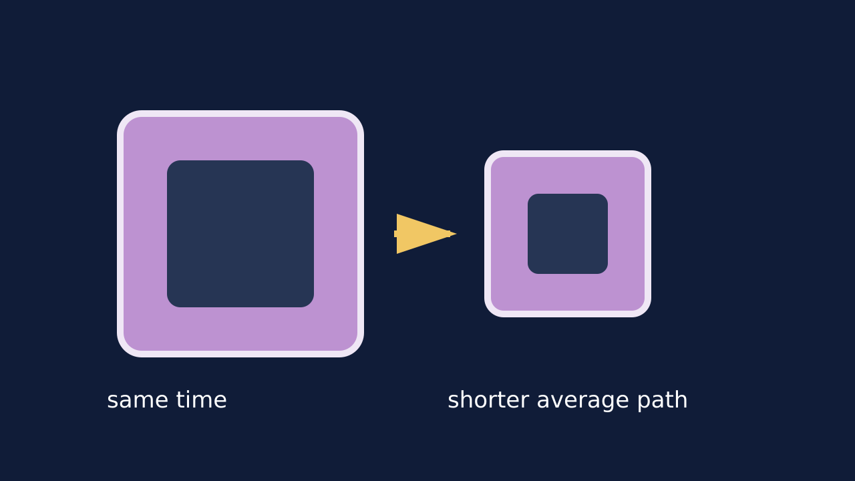
Teaching visual from the matching online lesson. A model, not evidence of practical completion. Use within the modelling time.

W4L3 | Continue the lesson
  - Second half | Keep the same 40-minute sequence

09:47–09:51 | I Do 2
Evidence: smaller cube reached the centre sooner. Science: shorter diffusion distance and greater surface area to volume ratio. Consequence: dye reaches a larger proportion of the cube in the same time.

09:51–09:57 | We Do 2 · Task
Read the controlled comparison below; it is illustrative model data, not a class experiment. Use the shared-task board; reveal only after a pupil decision.

09:57–10:07 | Independent Task
A medicine patch releases particles through the skin. A redesigned patch has the same concentration but a larger contact area. Explain why more medicine may diffuse across the skin each minute. State one piece of extra evidence that would strengthen the conclusion. Select one correction on the same work.

10:07–10:10 | Exit
What is the difference between describing a diffusion pattern and explaining it? Receive a specific learning request and agree the next action.
Watch for: Dye spreading in warm water can include convection. Do not present an uncontrolled demonstration as proof of diffusion rate alone.
Least help first: Ask which evidence changes the gradient, distance or area; do not dictate a model answer.

