Week 5 | Osmosis
  - Weekly teaching plan | LAUNCH Science | Autumn 1
Timetable: Monday, Wednesday and Friday | Period 1 | 09:30–10:10
Week commencing: __________________
Day | Lesson | Learning focus
Monday | W5L1 · Introduce | I can define osmosis and predict net water movement through a partially permeable membrane.
Wednesday | W5L2 · Explore | Plan a fair investigation and analyse sample data; practical only when arranged.
Friday | W5L3 · Do | I can calculate, graph and interpret osmosis data while keeping raw values and anomaly decisions visible.

Prepare once for the week
Open this week’s folder. Download or sync the complete folder to the classroom PC. Start the named PowerPoint in Slide Show mode. Print the selected PDF route; the Word sheet is an editable master. Keep teaching plans and mark schemes in staff storage.
Wednesday defaults to planning and labelled sample-data analysis. If the approved potato practical is arranged, agree the exposure interval, adult supervision and named collection handover before the lesson. A teacher or technician collects the results after the approved exposure; keep those results for Friday. Do not leave potatoes soaking until Friday. Watching a video or using staff samples does not establish pupil practical completion.

Teaching decisions
Use one shared route: PowerPoint activity, paper or the linked online model. A video replaces up to 90 seconds of the relevant model, rather than adding time. Use the prompt and still diagram if playback is unavailable. Linked videos are freesciencelessons GCSE concept explanations; their AQA practical numbering is not this centre’s assessment record.
If more time is needed, drop optional continuation. Keep one model, one supported attempt and independent evidence, then the Exit. Offer the least help first and leave the pupil’s choice and explanation theirs.
Timetable source: Timetables 2026_2027 (2).xlsx, Launch B5/D5/F5; Matt D3/D9/D15.

W5L1 | Osmosis
  - Monday | 09:30–10:10 | Introduce
Say: Osmosis is net water movement through a partially permeable membrane from a more dilute to a more concentrated solution.

09:30–09:33 | Arrival
What does net movement mean? Receive a short answer or a point to the image.

09:33–09:37 | Starter
A membrane lets water through but blocks large solute particles. Which substance can show osmosis in this model? Take a reason before revealing the answer.

09:37–09:42 | I Do
Water particles move randomly on both sides of the membrane. The partially permeable membrane allows water through but blocks the represented solute. Net water movement is from the more dilute solution to the more concentrated solution in this model.

09:42–09:47 | We Do
Which definition is specific to osmosis? Answer: Net movement of water through a partially permeable membrane from a more dilute to a more concentrated solution. Ask for the deciding step.
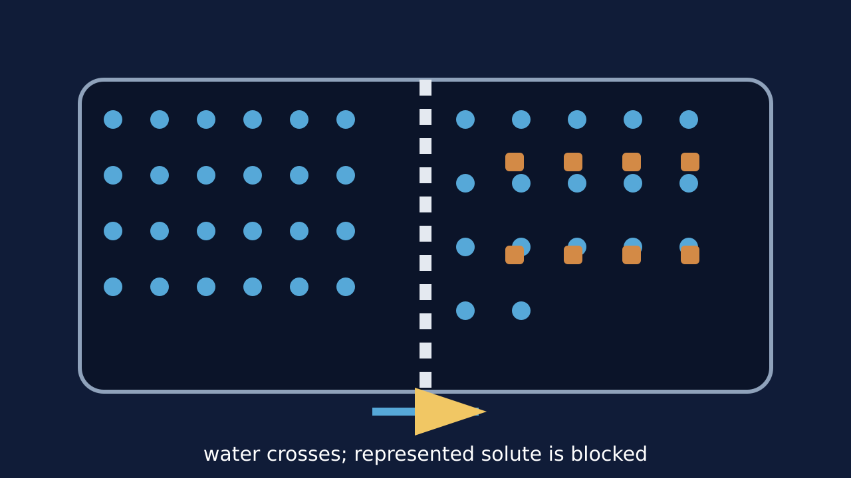
Teaching visual from the matching online lesson. A model, not evidence of practical completion. Use within the modelling time.

W5L1 | Continue the lesson
  - Second half | Keep the same 40-minute sequence

09:47–09:51 | I Do 2
A more dilute solution has a higher concentration of water in the simplified GCSE model. Water can move both ways, but the net movement follows the difference between sides. Cells and tissues gain or lose water depending on the surrounding solution.

09:51–09:57 | We Do 2 · Task
Draw a plant cell in each of three labelled surroundings: more dilute than its cell solution, equal, and more concentrated. Use the shared-task board; reveal only after a pupil decision.

09:57–10:07 | Independent Task
A plant cell is placed in sugar solution more concentrated than its cell solution. Explain the net movement of water and why the solute representation does not cross the membrane in this model. Then distinguish the process from active transport. Select one correction on the same work.

10:07–10:10 | Exit
Which substance and membrane condition distinguish osmosis? Receive a specific learning request and agree the next action.
Watch for: The potato is tissue, not a single membrane. Its cells have membranes. “Concentrated” must be relative to the solution on the other side.
Least help first: Ask what can cross the membrane and compare the solutions before giving any direction cue.

W5L2 | Osmosis Investigation
  - Wednesday | 09:30–10:10 | Explore
Say: Today’s default cover route is planning and sample-data analysis. A full soak, repeated measurements and graph do not fit inside a six-minute shared-task slot.

09:30–09:33 | Arrival
State the independent variable in a potato osmosis investigation. Receive a short answer or a point to the image.

09:33–09:37 | Starter
Two identical potato cylinders start at 3.00 g. Which result would be strongest evidence of net water movement: colour change, final mass or beaker position? Take a reason before revealing the answer.

09:37–09:42 | I Do
Change solution concentration and measure the potato cylinder’s mass change. Control potato source, dimensions, solution volume, time, temperature and blotting method. Use repeats where possible and keep every raw value, including an unusual result.

09:42–09:47 | We Do
Why is percentage change more useful than mass change alone when starting masses differ? Answer: It compares the change with the starting value. Ask for the deciding step.
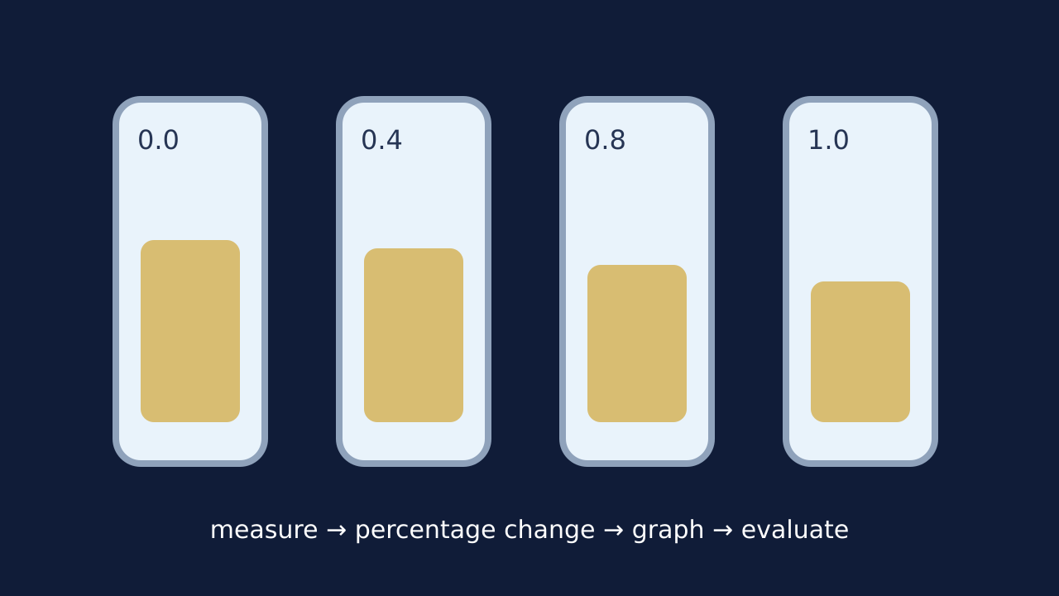
Teaching visual from the matching online lesson. A model, not evidence of practical completion. Use within the modelling time.

W5L2 | Continue the lesson
  - Second half | Keep the same 40-minute sequence

09:47–09:51 | I Do 2
Percentage change = (final mass − initial mass) ÷ initial mass × 100. A positive result means mass gain; a negative result means mass loss. Link each weakness to its effect on the result and a clear improvement.

09:51–09:57 | We Do 2 · Task
Choose the paper/sample route unless the approved practical has been arranged with suitable staffing and equipment. Use the shared-task board; reveal only after a pupil decision.

09:57–10:07 | Independent Task
A group uses potato cylinders with different diameters and blots some for two seconds and others for ten seconds. Explain two threats to validity or measurement quality. For each, state the likely consequence and a specific improvement. Then explain what a negative percentage change means in terms of osmosis. Select one correction on the same work.

10:07–10:10 | Exit
Why is ‘repeat it’ incomplete as an evaluation unless you explain what repeats improve? Receive a specific learning request and agree the next action.
Watch for: Only record practical completion for pupils who actually carry out the approved practical. Sample data and pre-soaked staff samples are not proof of that completion.
Least help first: Ask what must stay the same and what the named problem could do to the measured mass before suggesting an improvement.

W5L3 | Osmosis Data
  - Friday | 09:30–10:10 | Do
Say: Keep the raw data visible. Flag unusual values and investigate. Never delete a value simply because the graph looks tidier without it.

09:30–09:33 | Arrival
What does a negative percentage change mean? Receive a short answer or a point to the image.

09:33–09:37 | Starter
One repeat is very different from two others. Should it be erased, automatically excluded or investigated and kept visible? Take a reason before revealing the answer.

09:37–09:42 | I Do
Show every raw result before calculating a mean. Flag an unusual value and record whether it is included, with a reason. Plot concentration on the x-axis and mean percentage change in mass on the y-axis with units.

09:42–09:47 | We Do
What does a graph crossing near 0% mass change suggest? Answer: The tested tissue and solution had little or no net water movement under those conditions. Ask for the deciding step.
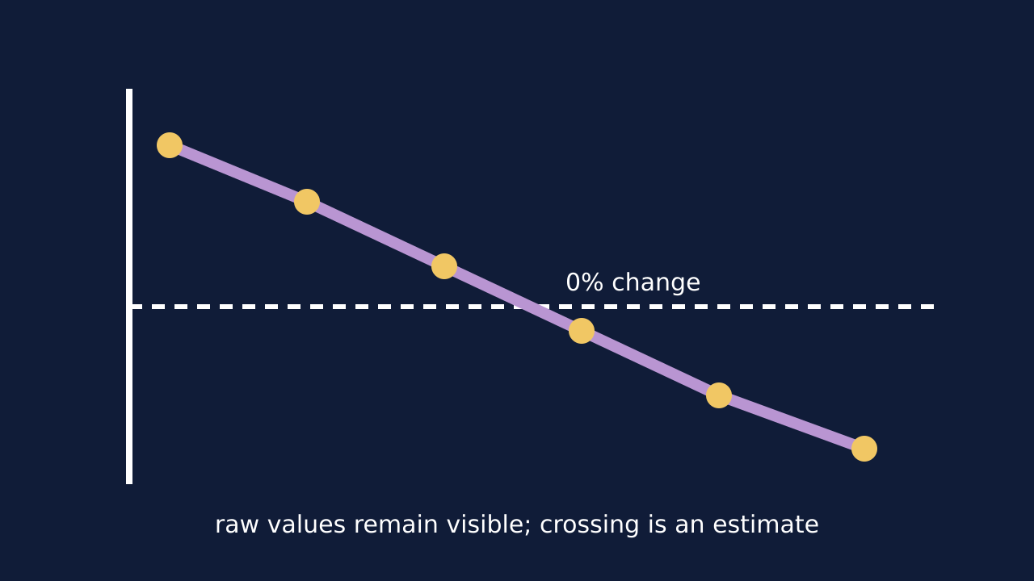
Teaching visual from the matching online lesson. A model, not evidence of practical completion. Use within the modelling time.

W5L3 | Continue the lesson
  - Second half | Keep the same 40-minute sequence

09:47–09:51 | I Do 2
Description states the pattern in the plotted data. Inference links the pattern to osmosis and the tested tissue. Evaluation states how method or data could make the inference more secure.

09:51–09:57 | We Do 2 · Task
Use class data if available; otherwise label this dataset “illustrative sample data”. Use the shared-task board; reveal only after a pupil decision.

09:57–10:07 | Independent Task
The mean percentage change falls from +12% at 0.2 mol dm⁻³ to −8% at 0.6 mol dm⁻³. Estimate the concentration where change may be zero and explain why the estimate should be reported as approximate. Suggest one additional data point that would improve it. Select one correction on the same work.

10:07–10:10 | Exit
Complete: an anomaly is not automatically wrong because… Receive a specific learning request and agree the next action.
Watch for: Between +12% at 0.2 and −8% at 0.6, straight-line interpolation gives 0.44 mol dm⁻³, not the midpoint 0.4.
Least help first: Ask what the data shows before asking what it means, and require a reason for any exclusion decision.

