Week 7 | Review and response
  - Weekly teaching plan | LAUNCH Science | Autumn 1
Timetable: Monday, Wednesday and Friday | Period 1 | 09:30–10:10
Week commencing: __________________
Day | Lesson | Learning focus
Monday | W7L1 · Introduce | I can retrieve and connect microscopy, transport, practical and data ideas before choosing what to revisit.
Wednesday | W7L2 · Explore | I can decode a command word, select the required answer shape and improve a Biology response.
Friday | W7L3 · Do | I can independently apply Topic 1 Biology, use answer-shape feedback and improve my original work.

Prepare once for the week
Open this week’s folder. Download or sync the complete folder to the classroom PC. Start the named PowerPoint in Slide Show mode. Print the selected PDF route; the Word sheet is an editable master. Keep teaching plans and mark schemes in staff storage.
Print the assessment for Friday. Use Q2, Q3 and Q5 only in the ten-minute Independent Task: 11 marks. The full 24-mark paper requires a separate 25-minute slot. Keep first attempts and scores private, and agree one precise next action.

Teaching decisions
Use one shared route: PowerPoint activity, paper or the linked online model. A video replaces up to 90 seconds of the relevant model, rather than adding time. Use the prompt and still diagram if playback is unavailable. Linked videos are freesciencelessons GCSE concept explanations; their AQA practical numbering is not this centre’s assessment record.
If more time is needed, drop optional continuation. Keep one model, one supported attempt and independent evidence, then the Exit. Offer the least help first and leave the pupil’s choice and explanation theirs.
Timetable source: Timetables 2026_2027 (2).xlsx, Launch B5/D5/F5; Matt D3/D9/D15.

W7L1 | Review
  - Monday | 09:30–10:10 | Introduce
Say: This reviews cells, microscopy and transport taught so far. It is not a claim that every part of GCSE Topic 1, including enzymes, has been completed.

09:30–09:33 | Arrival
Write the magnification relationship. Receive a short answer or a point to the image.

09:33–09:37 | Starter
Which link is strongest: magnification ↔ unit conversion, osmosis ↔ percentage change in mass, or active transport ↔ respiration? Take a reason before revealing the answer.

09:37–09:42 | I Do
Retrieve an idea before opening its support card. Link concepts using a reason, not only a line between labels. Treat a wrong first response as a signal for the next retrieval item, not a permanent pupil label.

09:42–09:47 | We Do
Which connection is scientifically justified? Answer: A thinner alveolar wall shortens diffusion distance. Ask for the deciding step.
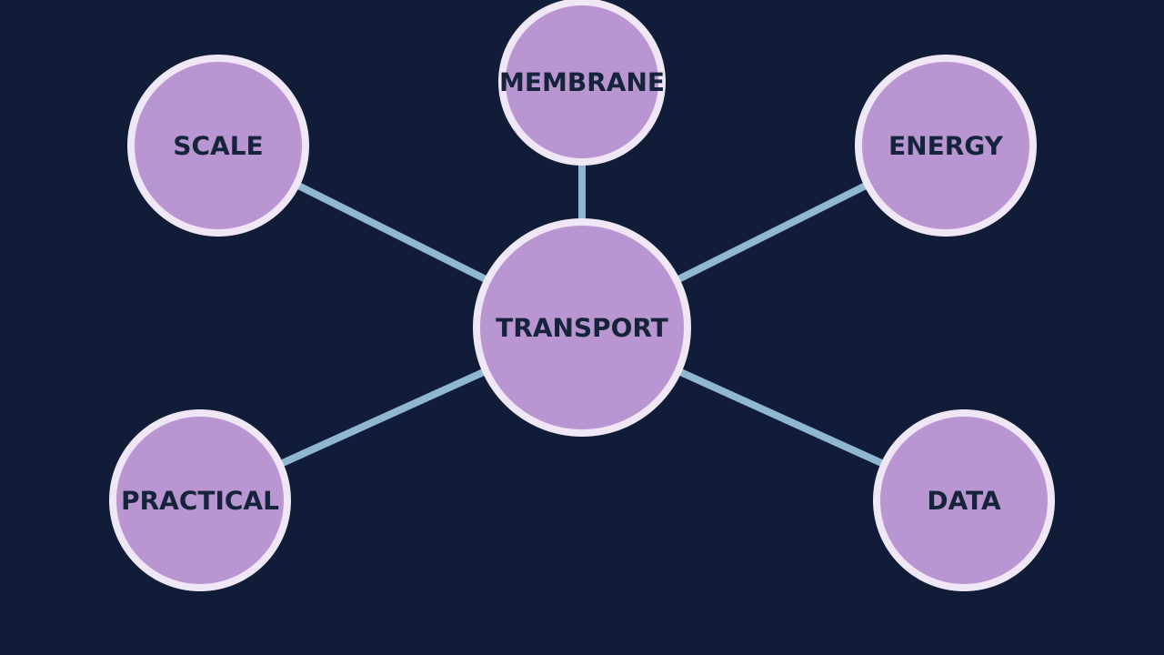
Teaching visual from the matching online lesson. A model, not evidence of practical completion. Use within the modelling time.

W7L1 | Continue the lesson
  - Second half | Keep the same 40-minute sequence

09:47–09:51 | I Do 2
Microscopy links to magnification, units, scale and measurement uncertainty. Transport links to gradients, membranes, surface area, distance and energy. Practicals link variables to raw data, calculations, graphs, conclusions and evaluation.

09:51–09:57 | We Do 2 · Task
Teach the three cell adaptations below before using them in the map. Use the shared-task board; reveal only after a pupil decision.

09:57–10:07 | Independent Task
Create a connected explanation using at least five of these ideas: magnification, micrometre, diffusion, concentration gradient, osmosis, percentage change, active transport, respiration, anomaly and control variable. Explain each link rather than listing terms. Select one correction on the same work.

10:07–10:10 | Exit
Which single connection do you now need to practise next, and what evidence led you to choose it? Receive a specific learning request and agree the next action.
Watch for: Do not turn confidence colours into public rankings. Ask for a piece of work or a corrected explanation to support a review choice.
Least help first: Ask for the reason connecting two ideas; do not turn the map into rapid-fire recall or a public score.

W7L2 | Command Words
  - Wednesday | 09:30–10:10 | Explore
Say: The command word tells you the kind of answer. Marks depend on the question and its mark scheme, not magic words such as “whereas”.

09:30–09:33 | Arrival
What does ‘describe’ ask you to do with data? Receive a short answer or a point to the image.

09:33–09:37 | Starter
A response says ‘The potato lost mass.’ Which command word could this satisfy most directly: state, explain or evaluate? Take a reason before revealing the answer.

09:37–09:42 | I Do
Underline the command word and identify the answer shape before retrieving content. Use the data or context evidence named in the question. Add only the reasoning demanded: explanation, comparison, calculation steps or evaluation chain.

09:42–09:47 | We Do
Which answer best fits ‘evaluate the method’? Answer: Unequal cylinder diameter changes surface area, so concentration is not the only cause; use equal diameters. Ask for the deciding step.
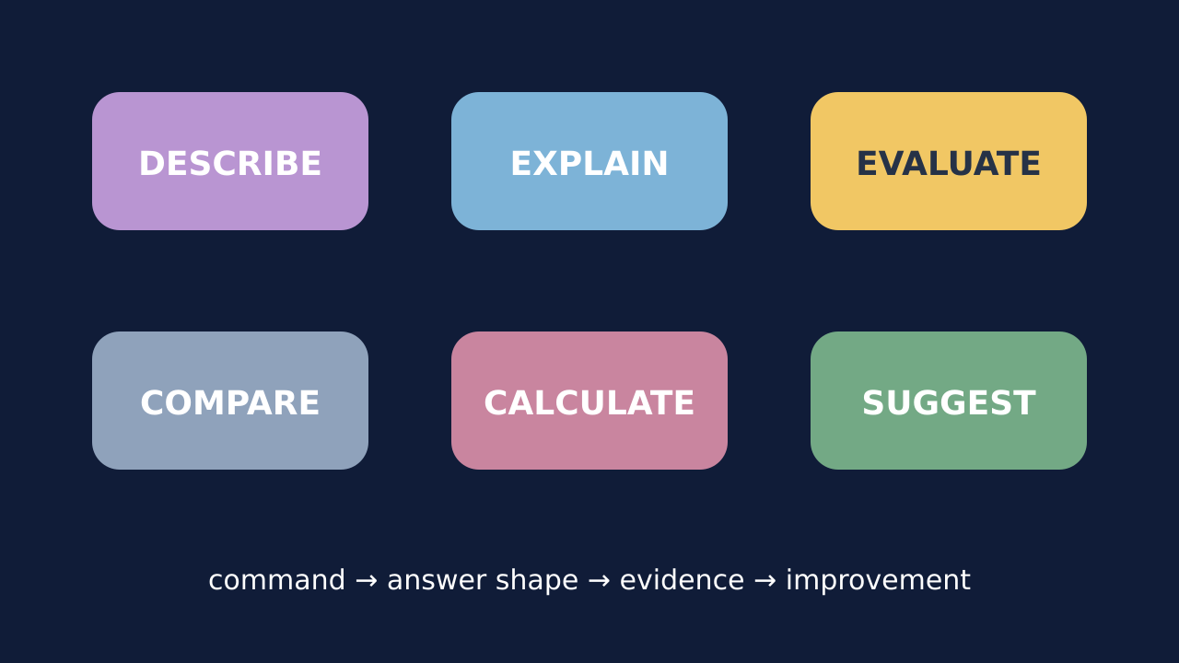
Teaching visual from the matching online lesson. A model, not evidence of practical completion. Use within the modelling time.

W7L2 | Continue the lesson
  - Second half | Keep the same 40-minute sequence

09:47–09:51 | I Do 2
State: give a concise fact or value. Describe: identify the pattern or feature shown by evidence. Explain: link scientific cause to consequence. Compare: give relevant similarities and differences, linked to the question. Calculate: show relationship, substitution, working and unit. Evaluate: weigh relevant evidence or method strengths and limits; justify a judgement or improvement. Suggest: propose a scientifically plausible response to the context.

09:51–09:57 | We Do 2 · Task
Identify the command word before you answer. Use the shared-task board; reveal only after a pupil decision.

09:57–10:07 | Independent Task
For each command word, write the first sentence or calculation line you would use: (1) describe the osmosis graph trend; (2) explain why a thin alveolar wall increases gas exchange; (3) compare diffusion and active transport; (4) evaluate inconsistent blotting; (5) calculate magnification from 30 mm and 75 µm. Select one correction on the same work.

10:07–10:10 | Exit
Which command word most often needs a scientific ‘because’ link, and why? Receive a specific learning request and agree the next action.
Watch for: “Evaluate” is more than listing improvements: weigh relevant evidence or method strengths/limits and make a supported judgement where asked.
Least help first: Ask which command word sets the answer shape before prompting Biology content.

W7L3 | Assessment And Response
  - Friday | 09:30–10:10 | Do
Say: This is original low-stakes classroom assessment, not an official Pearson paper and not a grade predictor. Use agreed access arrangements and keep results private.

09:30–09:33 | Arrival
What should happen before opening an answer checklist? Receive a short answer or a point to the image.

09:33–09:37 | Starter
Which mode best protects independence today: focus on one item, question-by-question, or full-paper mode? Choose and give a reason. Take a reason before revealing the answer.

09:37–09:42 | I Do
Read the command word and evidence before writing. Show calculation relationships, substitutions and units rather than a final number alone. Commit the response before using a teaching checklist; then edit the same work.

09:42–09:47 | We Do
After committing an explanation, what is the most useful next action? Answer: Open the answer-shape checklist, identify one missing link and edit the same answer. Ask for the deciding step.
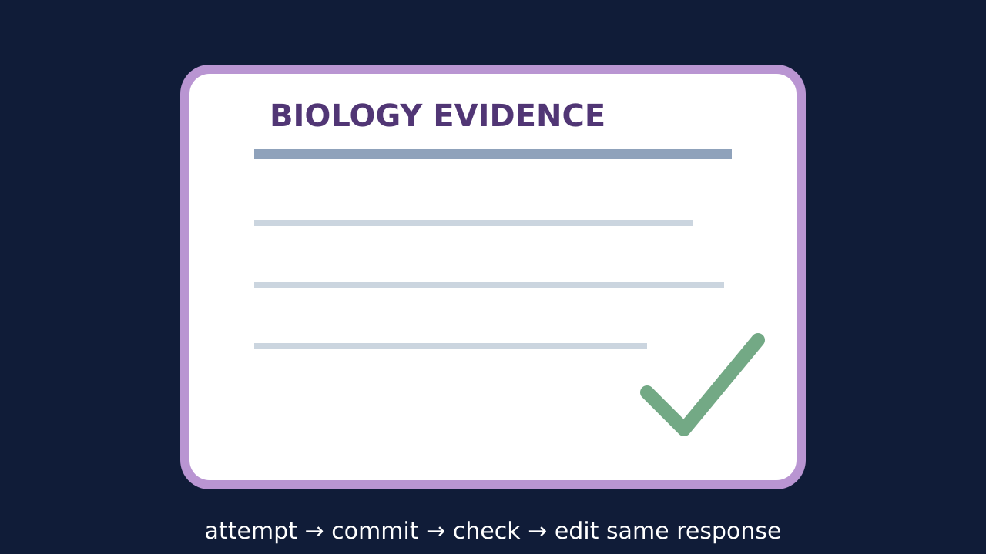
Teaching visual from the matching online lesson. A model, not evidence of practical completion. Use within the modelling time.

W7L3 | Continue the lesson
  - Second half | Keep the same 40-minute sequence

09:47–09:51 | I Do 2
Calculation item: relationship → unit conversion → working → plausible answer. Data item: pattern → evidence values → cautious interpretation. Explanation item: science idea → because → consequence. Practical item: issue → result consequence → improvement. Application item: select relevant evidence and transfer the process.

09:51–09:57 | We Do 2 · Task
Use a separate practice example. Identify the command word and answer shape; save assessment Q2, Q3 and Q5 for the first attempt.

09:57–10:07 | Independent Task
Assessment Q2, Q3 and Q5 only, 11 marks. Do not reveal the mark scheme during the first attempt. Select one correction on the same work.

10:07–10:10 | Exit
What changed in your work because feedback was received, and what should happen next? Receive a specific learning request and agree the next action.
Watch for: A 25-minute paper cannot fit inside a 10-minute Independent Task. The main lesson uses a selected short set; the complete paper is a separately scheduled option.
Least help first: Ask which command word and answer-shape element is missing; preserve authorship and avoid dictating the final response.

