Science · BUILD · Autumn 1 · Week 08 · SCI-BUILD-A1-W08-P1 · Date __________  Animals get food by eating  Today I can… ☐ say that plants make their own food ☐ say that animals must eat to get theirs ☐ put a simple food chain in the right order  Feedback: ☐ VF ☐ WS ☐ I ☐ NS ☐ E ☐ R __________________________ | 
Science · BUILD · Autumn 1 · Week 08 · SCI-BUILD-A1-W08-P1 · Date __________
Animals get food by eating
Today I can… ☐ say that plants make their own food ☐ say that animals must eat to get theirs ☐ put a simple food chain in the right order
Feedback: ☐ VF ☐ WS ☐ I ☐ NS ☐ E ☐ R __________________________
Science · BUILD · Autumn 1 · Week 08 · SCI-BUILD-A1-W08-P1 · Date __________
Animals get food by eating
Today I can… ☐ say that plants make their own food ☐ say that animals must eat to get theirs ☐ put a simple food chain in the right order
Feedback: ☐ VF ☐ WS ☐ I ☐ NS ☐ E ☐ R __________________________
Science · BUILD · Autumn 1 · Week 08 · SCI-BUILD-A1-W08-P1 · Date __________
Animals get food by eating
Today I can… ☐ say that plants make their own food ☐ say that animals must eat to get theirs ☐ put a simple food chain in the right order
Feedback: ☐ VF ☐ WS ☐ I ☐ NS ☐ E ☐ R __________________________
Science · BUILD · Autumn 1 · Week 08 · SCI-BUILD-A1-W08-P1 · Date __________
Animals get food by eating
Today I can… ☐ say that plants make their own food ☐ say that animals must eat to get theirs ☐ put a simple food chain in the right order
Feedback: ☐ VF ☐ WS ☐ I ☐ NS ☐ E ☐ R __________________________
Science · BUILD · Autumn 1 · Week 08 · SCI-BUILD-A1-W08-P1 · Date __________
Animals get food by eating
Today I can… ☐ say that plants make their own food ☐ say that animals must eat to get theirs ☐ put a simple food chain in the right order
Feedback: ☐ VF ☐ WS ☐ I ☐ NS ☐ E ☐ R __________________________
Science · BUILD · Autumn 1 · Week 08 · SCI-BUILD-A1-W08-P1 · Date __________
Animals get food by eating
Today I can… ☐ say that plants make their own food ☐ say that animals must eat to get theirs ☐ put a simple food chain in the right order
Feedback: ☐ VF ☐ WS ☐ I ☐ NS ☐ E ☐ R __________________________
Science · BUILD · Autumn 1 · Week 08 · SCI-BUILD-A1-W08-P1 · Date __________
Animals get food by eating
Today I can… ☐ say that plants make their own food ☐ say that animals must eat to get theirs ☐ put a simple food chain in the right order
Feedback: ☐ VF ☐ WS ☐ I ☐ NS ☐ E ☐ R __________________________

Science · BUILD · Autumn 1 · Week 08 · SCI-BUILD-A1-W08-P1 · Date __________
Animals get food by eating
Today I can… ☐ say that plants make their own food ☐ say that animals must eat to get theirs ☐ put a simple food chain in the right order
Feedback: ☐ VF ☐ WS ☐ I ☐ NS ☐ E ☐ R __________________________

Arrival · four short questions
1. Where does a rabbit get its food: eating grass or making it?
2. Name one plant in a food chain.
3. Link to today: Name one job food does in a body.
4. Do muscles pull or push bones?

Starter
A plant and rabbit both need energy. Which can make its own food?

Exit ticket
1. Point to the producer in grass → rabbit → fox.
2. Explain what one arrow means.
3. Explain why our chains start with a plant and name one model limit.

Method strip
1. Set out only the printed organism cards and paper arrows; do not handle or feed real organisms.
2. Match the animal-food pairs and ask the adult to check the card setup. STOP AND CHECK with the adult before continuing.
3. Build both supplied chains with arrows from food to eater.
4. Repair the reversed arrow, then cover one plant card.
5. Record one feeding-link observation and explain one possible effect of fewer plants, with one model limit.

Science · BUILD · Autumn 1 · Week 08 · SCI-BUILD-A1-W08-P1 · Date __________
Animals get food by eating
Today I can… ☐ say that plants make their own food ☐ say that animals must eat to get theirs ☐ put a simple food chain in the right order
Feedback: ☐ VF ☐ WS ☐ I ☐ NS ☐ E ☐ R __________________________

Animals get food by eating · You do routes
Work in your book. Staff mark I, S or C beside this task.

Independent
Match six supplied animal-food pairs, then build both chains. Add producer/consumer labels; repair an arrow and explain one possible effect of fewer plants.
Help: The __ gets food by eating __. Fewer __ could mean __ because __.

Supported
First match four animal-food pairs using the clues. Then build the grass and leaf chains with two choices at a time; fix a wrong arrow.
Help: Read each worded arrow: __ is eaten by __.

Choice
Match rabbit to grass / stone; fox to rabbit / leaves; caterpillar to leaves / stone; robin to caterpillar / leaves. Order fox, grass, rabbit and robin, leaves, caterpillar into two chains. Choose the producers: plants / animals. Repair a reversed arrow: food to eater / eater to food. Choose: fewer plants may affect only plant-eaters / animals farther along too. Give one reason; choose a limit: selected links / exact animal numbers. Record C beside your book response.

Aspire
Compare the chains. Explain a possible effect on an animal that does not eat plants. Explain why exact numbers cannot be predicted.
Help: Trace each feeding link; mention another possible food source.

Science · BUILD · Autumn 1 · Week 08 · SCI-BUILD-A1-W08-P1 · Date __________
Animals get food by eating
Today I can… ☐ say that plants make their own food ☐ say that animals must eat to get theirs ☐ put a simple food chain in the right order
Feedback: ☐ VF ☐ WS ☐ I ☐ NS ☐ E ☐ R __________________________

Animals get food by eating
I can explain that animals get food by eating, and plants can make their own food.

Word help

Words for this lesson
producer : here, a green plant that makes food using light
consumer : an animal that eats to obtain food
food chain : a model of linked feeding relationships
energy : what passes along the chain when something is eaten
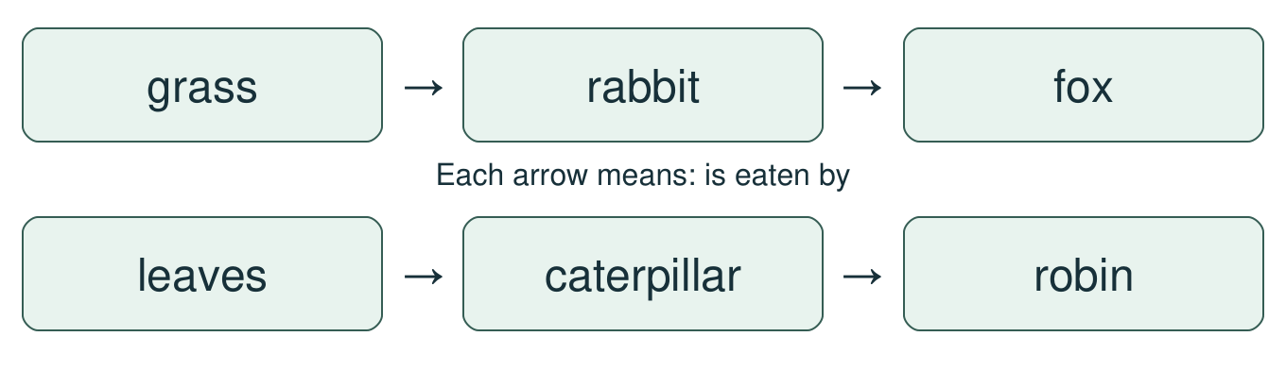

Follow these ideas
• A green plant is a producer: it makes food using light. An animal is a consumer: it eats to obtain food.
• Read grass → rabbit → fox: grass is eaten by the rabbit; the rabbit can be eaten by the fox.
• Read leaves → caterpillar → robin in the same way. The arrow points from food to its eater.

Keep the claim careful
A simple chain shows selected links. It is not a full food web and cannot predict an exact number of animals.

Show it
• I can say that plants make their own food.
• I can say that animals must eat to get theirs.
• I can put a simple food chain in the right order.

Science · BUILD · Autumn 1 · Week 08 · SCI-BUILD-A1-W08-P1 · Date __________
Animals get food by eating
Today I can… ☐ say that plants make their own food ☐ say that animals must eat to get theirs ☐ put a simple food chain in the right order
Feedback: ☐ VF ☐ WS ☐ I ☐ NS ☐ E ☐ R __________________________

Food-chain cards
Cut out the organism cards and arrows. Place them on the desk; record the chain in your book.
grass | rabbit | fox
leaves | caterpillar | robin
cow | owl | small animal
producer | consumer | is eaten by →
is eaten by → | is eaten by → | is eaten by →

• Rabbits can eat grass; foxes can eat rabbits.
• Caterpillars can eat leaves; robins can eat caterpillars.
• Cows can eat grass; owls can eat small animals. These are examples, not complete diets.
• A model shows selected links, not the whole food web.

