Science · GROW · Autumn 1 · Week 08 · SCI-GROW-A1-W08-P1 · Date __________  The Moon's Journey  Today I can… ☐ State that the Moon orbits Earth in roughly a month ☐ Explain that moonlight is reflected sunlight ☐ Explain phases using our changing view of the lit half  Feedback: ☐ VF ☐ WS ☐ I ☐ NS ☐ E ☐ R __________________________ | 
Science · GROW · Autumn 1 · Week 08 · SCI-GROW-A1-W08-P1 · Date __________
The Moon's Journey
Today I can… ☐ State that the Moon orbits Earth in roughly a month ☐ Explain that moonlight is reflected sunlight ☐ Explain phases using our changing view of the lit half
Feedback: ☐ VF ☐ WS ☐ I ☐ NS ☐ E ☐ R __________________________
Science · GROW · Autumn 1 · Week 08 · SCI-GROW-A1-W08-P1 · Date __________
The Moon's Journey
Today I can… ☐ State that the Moon orbits Earth in roughly a month ☐ Explain that moonlight is reflected sunlight ☐ Explain phases using our changing view of the lit half
Feedback: ☐ VF ☐ WS ☐ I ☐ NS ☐ E ☐ R __________________________
Science · GROW · Autumn 1 · Week 08 · SCI-GROW-A1-W08-P1 · Date __________
The Moon's Journey
Today I can… ☐ State that the Moon orbits Earth in roughly a month ☐ Explain that moonlight is reflected sunlight ☐ Explain phases using our changing view of the lit half
Feedback: ☐ VF ☐ WS ☐ I ☐ NS ☐ E ☐ R __________________________
Science · GROW · Autumn 1 · Week 08 · SCI-GROW-A1-W08-P1 · Date __________
The Moon's Journey
Today I can… ☐ State that the Moon orbits Earth in roughly a month ☐ Explain that moonlight is reflected sunlight ☐ Explain phases using our changing view of the lit half
Feedback: ☐ VF ☐ WS ☐ I ☐ NS ☐ E ☐ R __________________________
Science · GROW · Autumn 1 · Week 08 · SCI-GROW-A1-W08-P1 · Date __________
The Moon's Journey
Today I can… ☐ State that the Moon orbits Earth in roughly a month ☐ Explain that moonlight is reflected sunlight ☐ Explain phases using our changing view of the lit half
Feedback: ☐ VF ☐ WS ☐ I ☐ NS ☐ E ☐ R __________________________
Science · GROW · Autumn 1 · Week 08 · SCI-GROW-A1-W08-P1 · Date __________
The Moon's Journey
Today I can… ☐ State that the Moon orbits Earth in roughly a month ☐ Explain that moonlight is reflected sunlight ☐ Explain phases using our changing view of the lit half
Feedback: ☐ VF ☐ WS ☐ I ☐ NS ☐ E ☐ R __________________________
Science · GROW · Autumn 1 · Week 08 · SCI-GROW-A1-W08-P1 · Date __________
The Moon's Journey
Today I can… ☐ State that the Moon orbits Earth in roughly a month ☐ Explain that moonlight is reflected sunlight ☐ Explain phases using our changing view of the lit half
Feedback: ☐ VF ☐ WS ☐ I ☐ NS ☐ E ☐ R __________________________

Science · GROW · Autumn 1 · Week 08 · SCI-GROW-A1-W08-P1 · Date __________
The Moon's Journey
Today I can… ☐ State that the Moon orbits Earth in roughly a month ☐ Explain that moonlight is reflected sunlight ☐ Explain phases using our changing view of the lit half
Feedback: ☐ VF ☐ WS ☐ I ☐ NS ☐ E ☐ R __________________________

The Moon's Journey · Route card
Reference only · record your answers in your book.
Independent  Sequence four model positions and explain why the visible lit part changes. | Supported  Match new, quarter, full and quarter views with a partner.  Use a fixed sunlight arrow and point to the lit half. | Choice  Use phase cards to label four model views. Choose each label: full / quarter / new. Order the labelled views around the model. Mark sunlight direction and the lit half. Choose the cause: our changing view of the lit half / the Moon changing shape. Complete: We see ___ because ___. Choose the lunar eclipse cause: Earth blocks sunlight / the Moon becomes smaller. Record C beside your book response.

Word bank  • satellite: an object that orbits a planet  • phase: the shape of the lit part of the Moon visible from Earth  • orbit: a curved path around another body  • reflected: light that changes direction from a surface | Model steps  • Torch is the Sun, ball is the Moon, observer is Earth. Keep the sunlight direction fixed.  • Half the Moon is illuminated by the Sun. As it orbits, our view of the illuminated half changes.  • When the visible lit half faces us, we see full Moon. When it faces away, we see new Moon.

Kit: Cool LED torch, large foam ball, observer marker and four phase cards.
Safe: Adult uses a low-power cool light; no lasers or looking at the Sun. No blackout: normal-light diagrams are equal routes. Keep the ball above the observer’s head shadow so a false eclipse is not created. Agree before any light change; adult handles equipment and cutting. Keep movement clear.

Aspire
Explain the phase sequence, distinguish eclipses and name one model limit.
Separate changing viewpoint from blocked sunlight; explain the tilted orbit.
Staff mark I, S or C beside this task.

Science · GROW · Autumn 1 · Week 08 · SCI-GROW-A1-W08-P1 · Date __________
The Moon's Journey
Today I can… ☐ State that the Moon orbits Earth in roughly a month ☐ Explain that moonlight is reflected sunlight ☐ Explain phases using our changing view of the lit half
Feedback: ☐ VF ☐ WS ☐ I ☐ NS ☐ E ☐ R __________________________

The Moon's Journey
Reference only · record your answers in your book.
Learning goal: I can explain why the Moon appears to change shape as it orbits Earth.
Word | Meaning
satellite | an object that orbits a planet
phase | the shape of the lit part of the Moon visible from Earth
orbit | a curved path around another body
reflected | light that changes direction from a surface

Key ideas
• Torch is the Sun, ball is the Moon, observer is Earth. Keep the sunlight direction fixed.
• Half the Moon is illuminated by the Sun. As it orbits, our view of the illuminated half changes.
• When the visible lit half faces us, we see full Moon. When it faces away, we see new Moon.
• Trace the light path: Sun → Moon → observer on Earth. Name the Sun as light source and the Moon as reflecting object.

Keep the claim fair
The model does not show realistic sizes, distances or the tilt of the Moon’s orbit.
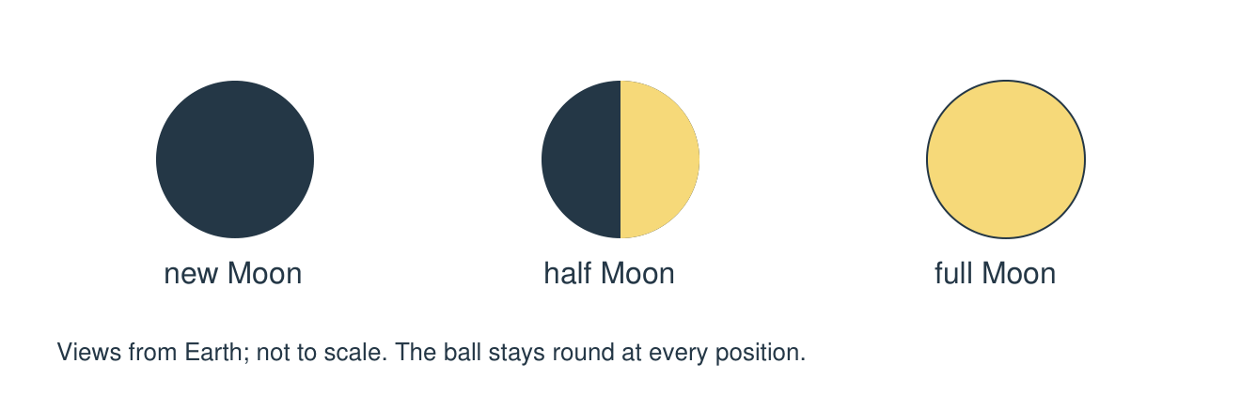
New, half and full are views from Earth. The Moon stays round; its visible lit part changes.

Science · GROW · Autumn 1 · Week 08 · SCI-GROW-A1-W08-P1 · Date __________
The Moon's Journey
Today I can… ☐ State that the Moon orbits Earth in roughly a month ☐ Explain that moonlight is reflected sunlight ☐ Explain phases using our changing view of the lit half
Feedback: ☐ VF ☐ WS ☐ I ☐ NS ☐ E ☐ R __________________________

Staff: cut these apart before the lesson.
Move these pieces for the task. Record the answer and reason in your book.
Crescent: Only a small part of the illuminated half faces us. | Full Moon: The illuminated side faces our observer.
New Moon: The lit half faces mostly away from the observer. | Dark red Moon: Earth blocks direct sunlight during this event.
Own light: The Moon glows by itself. | Every month: Every full Moon must be an eclipse.

Method strip
1. Keep the cool light fixed and use one Moon model or the prepared phase cards.
2. Mark the lit half and the observer position. Stop and check the light direction with the adult.
3. Sequence four views from the same observer, keeping phase and eclipse explanations separate.
4. In your book, label an observation and conclude why the visible lit part changes. Restore lighting and return equipment.
After the practical: record an observation and one conclusion linked to today’s outcome in your book.

