Science · LAUNCH · Autumn 1 · Week 08 · SCI-LAUNCH-A1-W08-L1 · Date __________  Enzyme Action: Preparing the pH Investigation  Today I can… ☐ Use enzyme, substrate, active site and specificity accurately in an explanation ☐ Explain how an unsuitable pH can change an active site's shape and reduce enzyme activity ☐ Identify pH as the independent variable, time to starch disappearance as the dependent variable, and suitable control variables  Feedback: ☐ VF ☐ WS ☐ I ☐ NS ☐ E ☐ R __________________________ | 
Science · LAUNCH · Autumn 1 · Week 08 · SCI-LAUNCH-A1-W08-L1 · Date __________
Enzyme Action: Preparing the pH Investigation
Today I can… ☐ Use enzyme, substrate, active site and specificity accurately in an explanation ☐ Explain how an unsuitable pH can change an active site's shape and reduce enzyme activity ☐ Identify pH as the independent variable, time to starch disappearance as the dependent variable, and suitable control variables
Feedback: ☐ VF ☐ WS ☐ I ☐ NS ☐ E ☐ R __________________________
Science · LAUNCH · Autumn 1 · Week 08 · SCI-LAUNCH-A1-W08-L1 · Date __________
Enzyme Action: Preparing the pH Investigation
Today I can… ☐ Use enzyme, substrate, active site and specificity accurately in an explanation ☐ Explain how an unsuitable pH can change an active site's shape and reduce enzyme activity ☐ Identify pH as the independent variable, time to starch disappearance as the dependent variable, and suitable control variables
Feedback: ☐ VF ☐ WS ☐ I ☐ NS ☐ E ☐ R __________________________
Science · LAUNCH · Autumn 1 · Week 08 · SCI-LAUNCH-A1-W08-L1 · Date __________
Enzyme Action: Preparing the pH Investigation
Today I can… ☐ Use enzyme, substrate, active site and specificity accurately in an explanation ☐ Explain how an unsuitable pH can change an active site's shape and reduce enzyme activity ☐ Identify pH as the independent variable, time to starch disappearance as the dependent variable, and suitable control variables
Feedback: ☐ VF ☐ WS ☐ I ☐ NS ☐ E ☐ R __________________________
Science · LAUNCH · Autumn 1 · Week 08 · SCI-LAUNCH-A1-W08-L1 · Date __________
Enzyme Action: Preparing the pH Investigation
Today I can… ☐ Use enzyme, substrate, active site and specificity accurately in an explanation ☐ Explain how an unsuitable pH can change an active site's shape and reduce enzyme activity ☐ Identify pH as the independent variable, time to starch disappearance as the dependent variable, and suitable control variables
Feedback: ☐ VF ☐ WS ☐ I ☐ NS ☐ E ☐ R __________________________
Science · LAUNCH · Autumn 1 · Week 08 · SCI-LAUNCH-A1-W08-L1 · Date __________
Enzyme Action: Preparing the pH Investigation
Today I can… ☐ Use enzyme, substrate, active site and specificity accurately in an explanation ☐ Explain how an unsuitable pH can change an active site's shape and reduce enzyme activity ☐ Identify pH as the independent variable, time to starch disappearance as the dependent variable, and suitable control variables
Feedback: ☐ VF ☐ WS ☐ I ☐ NS ☐ E ☐ R __________________________
Science · LAUNCH · Autumn 1 · Week 08 · SCI-LAUNCH-A1-W08-L1 · Date __________
Enzyme Action: Preparing the pH Investigation
Today I can… ☐ Use enzyme, substrate, active site and specificity accurately in an explanation ☐ Explain how an unsuitable pH can change an active site's shape and reduce enzyme activity ☐ Identify pH as the independent variable, time to starch disappearance as the dependent variable, and suitable control variables
Feedback: ☐ VF ☐ WS ☐ I ☐ NS ☐ E ☐ R __________________________
Science · LAUNCH · Autumn 1 · Week 08 · SCI-LAUNCH-A1-W08-L1 · Date __________
Enzyme Action: Preparing the pH Investigation
Today I can… ☐ Use enzyme, substrate, active site and specificity accurately in an explanation ☐ Explain how an unsuitable pH can change an active site's shape and reduce enzyme activity ☐ Identify pH as the independent variable, time to starch disappearance as the dependent variable, and suitable control variables
Feedback: ☐ VF ☐ WS ☐ I ☐ NS ☐ E ☐ R __________________________

Science · LAUNCH · Autumn 1 · Week 08 · SCI-LAUNCH-A1-W08-L1 · Date __________
Enzyme Action: Preparing the pH Investigation
Today I can… ☐ Use enzyme, substrate, active site and specificity accurately in an explanation ☐ Explain how an unsuitable pH can change an active site's shape and reduce enzyme activity ☐ Identify pH as the independent variable, time to starch disappearance as the dependent variable, and suitable control variables
Feedback: ☐ VF ☐ WS ☐ I ☐ NS ☐ E ☐ R __________________________

Enzyme Action: Preparing the pH Investigation · Route card
Reference only · use the task and sentence stem in your book.

Arrival · four short answers in your book
1. Which structure holds chromosomes in a eukaryotic animal cell?
2. Link to today: In diffusion, do particles move from higher to lower concentration or the reverse?
3. Which substance moves through a partially permeable membrane in osmosis?
4. Which transport process uses energy to move particles against a concentration gradient?

Starter
Which iodine observation shows starch is still present: blue-black or orange-brown?

Exit ticket
Under the heading Exit ticket: answer the questions in your book.
1. Explain why amylase acts on starch and can be used again.
2. Name the IV, define the timed DV with units, and name one control with a reason.

Independent
1. Write a testable prediction for how pH could affect amylase acting on starch. Explain why the enzyme can act again. [2 marks]
2. Name the IV and define the timed DV with units. Give three controls and justify one. [6 marks]
3. Order the six method cards and explain why iodine is used to test separate sampled drops. [2 marks]
4. Distinguish a no-active-amylase control sample from a control variable. Predict the control result. [3 marks]
5. State suitable table headings for pH, trial, endpoint time / s, observation and relative rate 1/time / s⁻¹. State what to record if there is no endpoint by 300 s. [3 marks]

Supported
1. Use the model to finish: “Amylase is the ___. Starch is the ___. The enzyme is not ___.”
2. Match pH / time to endpoint / temperature to CHANGE / MEASURE / KEEP THE SAME. Give one reason for keeping temperature the same.
3. Order method cards A–F on the reference page. Point to the actions done before mixing.
4. Point to the endpoint sample. Predict the iodine result in a separate sample with starch but no active amylase.
5. Use these results headings: pH | trial | endpoint time / s | observation. If no endpoint is seen by 300 s, choose “0 s” or “no endpoint by 300 s”.

Choice
1. Choose the catalyst: amylase / starch / iodine. Predict: pH 4 will reach the endpoint sooner / later than pH 7. Give one active-site reason. Complete: The enzyme can act again because it is not ___. Record C beside your book response.
2. Match pH / endpoint time / temperature to change / measure / keep the same. Give one reason. Order the six supplied method cards. Choose the iodine check: separate sampled drops / the reaction mixture. Choose no active amylase as a comparison group / changed pH; predict blue-black / orange-brown.
3. Choose the change heading: pH / temperature; repeat heading: trial / colour; observation heading: colour / pH. Choose time unit: s / s⁻¹; rate unit: s⁻¹ / s. Choose the truthful entry at 300 s: zero / no endpoint by 300 s. Give one reason.

Aspire
1. Predict a testable pH–activity pattern. Explain specificity and reuse without claiming that reduced activity proves permanent denaturation. [4 marks]
2. Specify the IV, operational DV and four controls. Justify two controls against competing explanations. [8 marks]
3. Order method cards A–F; explain why iodine goes into separate check drops and why a consistent start matters. [3 marks]
4. Distinguish the no-active-amylase control from a control variable. What would an unexpected orange-brown result make you check? [3 marks]
5. State the evidence from illustrative samples: blue-black at 90 s, orange-brown at 120 s, sampled every 30 s. State the recorded time, the interval containing the threshold crossing, and one precision improvement. For another run with no endpoint by 300 s, choose a truthful table entry. [4 marks]
Staff mark I, S or C beside this task.

Science · LAUNCH · Autumn 1 · Week 08 · SCI-LAUNCH-A1-W08-L1 · Date __________
Enzyme Action: Preparing the pH Investigation
Today I can… ☐ Use enzyme, substrate, active site and specificity accurately in an explanation ☐ Explain how an unsuitable pH can change an active site's shape and reduce enzyme activity ☐ Identify pH as the independent variable, time to starch disappearance as the dependent variable, and suitable control variables
Feedback: ☐ VF ☐ WS ☐ I ☐ NS ☐ E ☐ R __________________________

LAUNCH · GCSE Biology · Enzyme Action: Preparing the pH Investigation
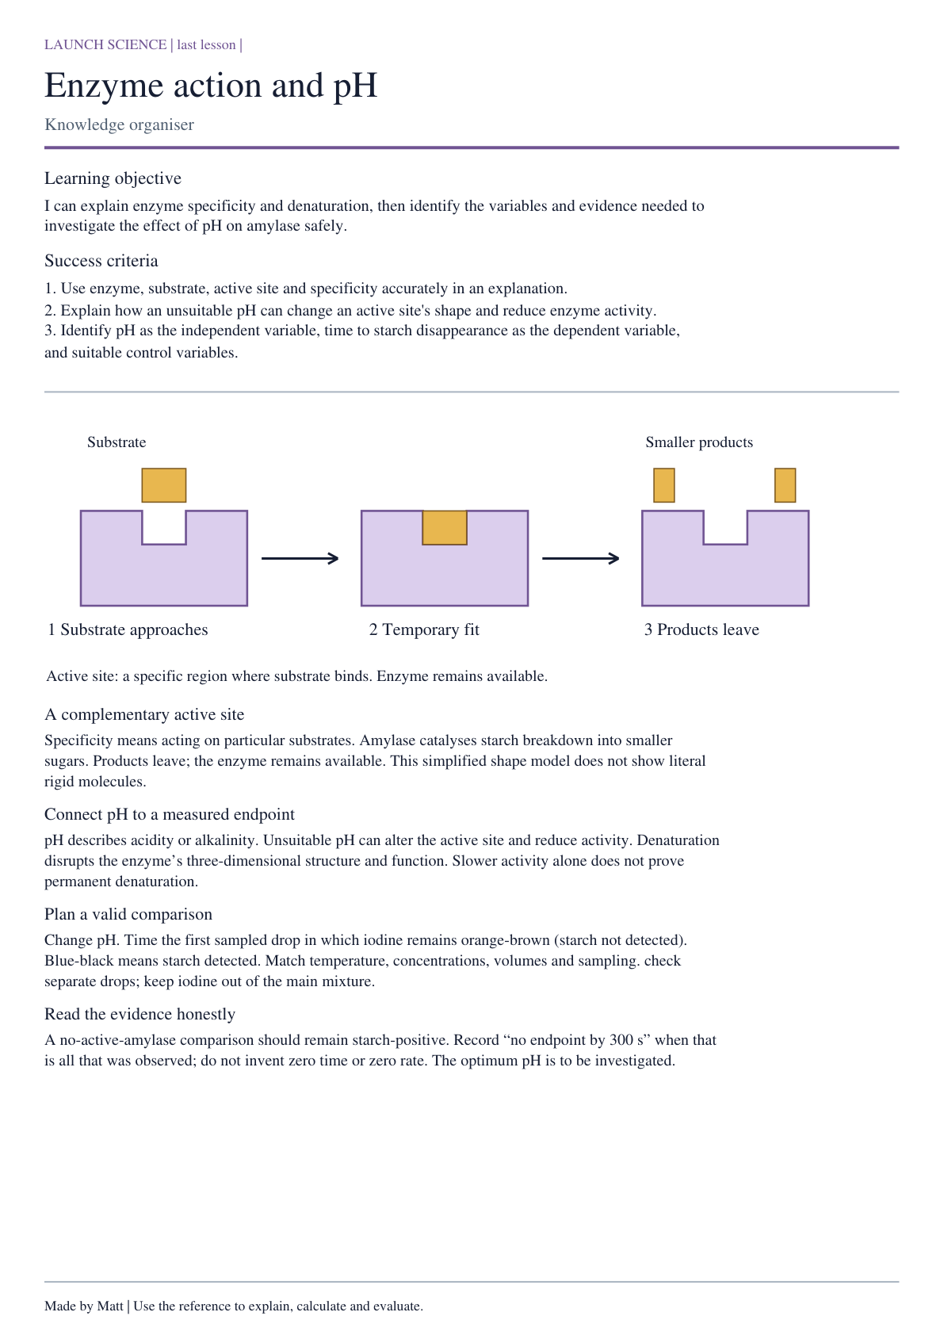

Science · LAUNCH · Autumn 1 · Week 08 · SCI-LAUNCH-A1-W08-L1 · Date __________
Enzyme Action: Preparing the pH Investigation
Today I can… ☐ Use enzyme, substrate, active site and specificity accurately in an explanation ☐ Explain how an unsuitable pH can change an active site's shape and reduce enzyme activity ☐ Identify pH as the independent variable, time to starch disappearance as the dependent variable, and suitable control variables
Feedback: ☐ VF ☐ WS ☐ I ☐ NS ☐ E ☐ R __________________________

Staff: cut these apart before the lesson.
Move these pieces for the task. Record the answer and reason in your book.
Smaller sugar products | Active site
Amylase enzyme | Starch substrate

Enzyme model
