Card 1 Food service helper
This job and its needs are made up for practice. They are not rules for all jobs.
Picture | Role
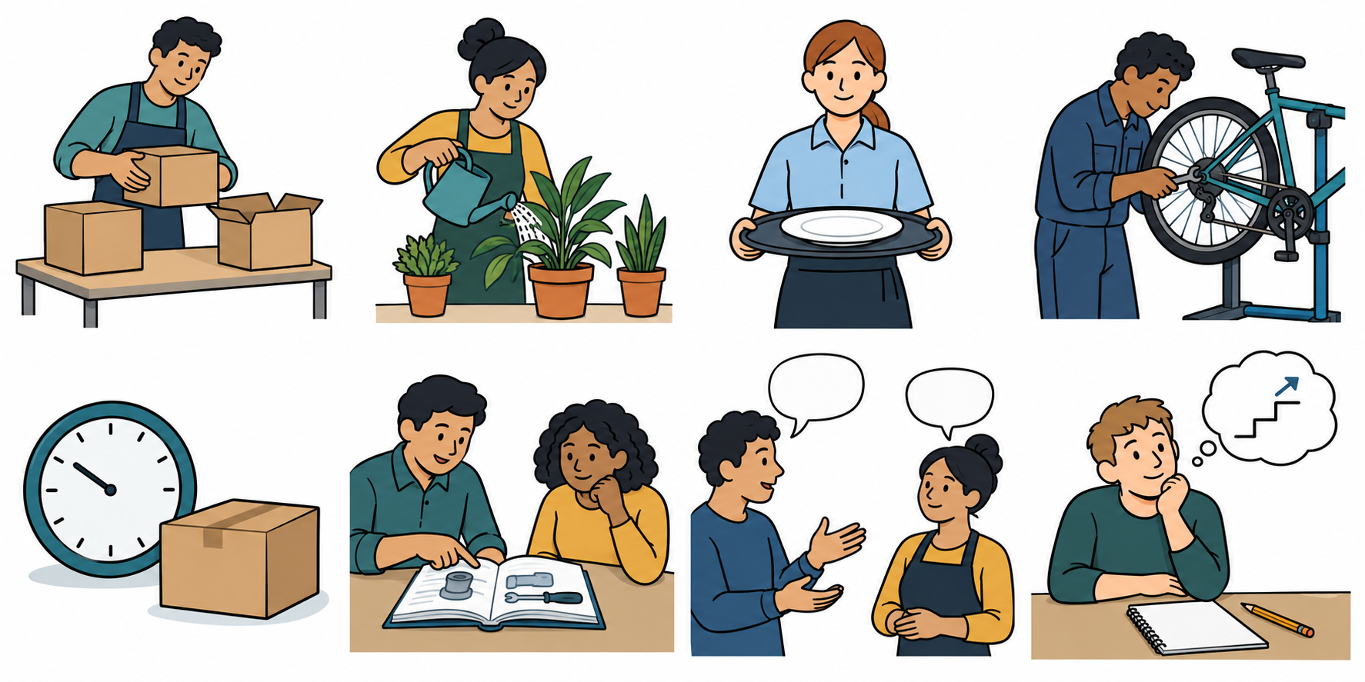 | A Food service helper
Need | Job card detail
Attendance | Be ready at the agreed start time.
Qualification | An entry-level qualification.
Skill | Put three order cards in plan order, with usual aid.
Attitude | Ask for help if a step is not clear.

Made up record
The made-up person asked for help with a word. They have not tried a three-step plan yet. We have no facts on their attendance or qualifications.

Our model match
Attitude: S Shown here. Skill: N Next step. Attendance and qualification: ? Check.

One target
Next lesson, use a word list with a trusted adult to put three order cards in plan order. Check all three.

Card 2 Stockroom helper
This job and its needs are made up for practice. They are not rules for all jobs.
Picture | Role
 | B Stockroom helper
Need | Job card detail
Attendance | Be ready at the agreed start time.
Qualification | A level 1 qualification.
Skill | Put three stock labels in list order, with usual aid.
Attitude | Ask for help if a step is not clear.

Try the class task
Plan: bag then box then tray.
Mixed words: tray / bag / box.
Put the words in plan order. You may point, type, use your book or usual aid. Do not do the real job.

Match and choose
Use your task as a clue for the skill. Check unknown facts; no personal records needed. Choose one thing to check or practise. A trusted adult can help.
A target could be: Next lesson, practise one new list with a trusted adult and a word card. Check all three labels.

Card 3 Garden helper
This job and its needs are made up for practice. They are not rules for all jobs.
Picture | Role
 | C Garden helper
Need | Job card detail
Attendance | Be ready at the agreed start time.
Qualification | An entry-level qualification.
Skill | Put three task cards in plan order, with usual aid.
Attitude | Ask for help if a step is not clear.

Try the class task
Plan: fill pot then add seed then water.
Mixed words: water / fill pot / add seed.
Put the words in plan order. You may point, type, use your book or usual aid. Do not do the real job.

Match and choose
Use your task as a clue for the skill. Check unknown facts; no personal records needed. Choose one thing to check or practise. A trusted adult can help.
A target could be: Next lesson, practise one new plan with a trusted adult and a word card. Check all three steps.

Card 4 Check and plan
A need is something a role asks for. A gap can be a thing to check or practise. It does not mean a route is closed.
Mark and words | Meaning
S Shown here | There is a clear clue from this task.
? Check | We do not know yet. Ask for help to check.
N Next step | Choose a small step to practise or find out.

Help for a next step
Picture | One choice
 | Practise a new list or plan with a trusted adult. Use a word card.
 | Ask a trusted adult what the level means and what to check next.
Target: “Next lesson, I will ... with ... . I will check ... .”
For a check target, keep the answer or the question still to ask. No guess is needed.

Help in private
Use a trusted adult or the school’s help route. Point to HELP or ask for a private talk. You may pass, pause and return with help.

