Art · BUILD · Autumn 2 · Week 1 · ART-BUILD-A2-W01-P2 · Date __________  Make — My festival light pattern  Today I can… □ choose shapes and two or three bright colours. □ use the same bit again. □ check one thing in my plan.  Feedback: □ VF □ WS □ I □ NS □ E □ R □ [//] □ [?] ______ | 

Art · BUILD · Autumn 2 · Week 1 · ART-BUILD-A2-W01-P2 · Date __________
Make — My festival light pattern
Today I can… □ choose shapes and two or three bright colours. □ use the same bit again. □ check one thing in my plan.
Feedback: □ VF □ WS □ I □ NS □ E □ R □ [//] □ [?] ______

Art · BUILD · Autumn 2 · Week 1 · ART-BUILD-A2-W01-P2 · Date __________
Make — My festival light pattern
Today I can… □ choose shapes and two or three bright colours. □ use the same bit again. □ check one thing in my plan.
Feedback: □ VF □ WS □ I □ NS □ E □ R □ [//] □ [?] ______

Art · BUILD · Autumn 2 · Week 1 · ART-BUILD-A2-W01-P2 · Date __________
Make — My festival light pattern
Today I can… □ choose shapes and two or three bright colours. □ use the same bit again. □ check one thing in my plan.
Feedback: □ VF □ WS □ I □ NS □ E □ R □ [//] □ [?] ______

Art · BUILD · Autumn 2 · Week 1 · ART-BUILD-A2-W01-P2 · Date __________
Make — My festival light pattern
Today I can… □ choose shapes and two or three bright colours. □ use the same bit again. □ check one thing in my plan.
Feedback: □ VF □ WS □ I □ NS □ E □ R □ [//] □ [?] ______

Art · BUILD · Autumn 2 · Week 1 · ART-BUILD-A2-W01-P2 · Date __________
Make — My festival light pattern
Today I can… □ choose shapes and two or three bright colours. □ use the same bit again. □ check one thing in my plan.
Feedback: □ VF □ WS □ I □ NS □ E □ R □ [//] □ [?] ______

Art · BUILD · Autumn 2 · Week 1 · ART-BUILD-A2-W01-P2 · Date __________
Make — My festival light pattern
Today I can… □ choose shapes and two or three bright colours. □ use the same bit again. □ check one thing in my plan.
Feedback: □ VF □ WS □ I □ NS □ E □ R □ [//] □ [?] ______

Art · BUILD · Autumn 2 · Week 1 · ART-BUILD-A2-W01-P2 · Date __________
Make — My festival light pattern
Today I can… □ choose shapes and two or three bright colours. □ use the same bit again. □ check one thing in my plan.
Feedback: □ VF □ WS □ I □ NS □ E □ R □ [//] □ [?] ______

Art · BUILD · Autumn 2 · Week 1 · ART-BUILD-A2-W01-P2 · Date __________
Make — My festival light pattern
Today I can… □ choose shapes and two or three bright colours. □ use the same bit again. □ check one thing in my plan.
Feedback: □ VF □ WS □ I □ NS □ E □ R □ [//] □ [?] ______

Arrival | Supported

Arrival · 5 min · 00 to 05

In your book: Four small choices or marks, numbered 1 to 4, one for each question.

1. Start
Which comes first: the yellow dot or pink ring?
Clue: Look at the left end of A.
Write, draw or stick your answer here.

2. Colours
Is the ring pink or yellow?
Clue: Look at a round line with an empty middle.
Write, draw or stick your answer here.

3. Next mark
What comes just after the first ring?
Clue: Choose: yellow dot or pink ring.
Write, draw or stick your answer here.

4. Again
Which pair will we use again today?
Clue: Look at the card beside A.
Write, draw or stick your answer here.

Art · BUILD · Autumn 2 · Week 1 · ART-BUILD-A2-W01-P2 · Date __________
Make — My festival light pattern
Today I can… □ choose shapes and two or three bright colours. □ use the same bit again. □ check one thing in my plan.
Feedback: □ VF □ WS □ I □ NS □ E □ R □ [//] □ [?] ______

Exit ticket | Supported

Exit ticket · 3 min · 37 to 40

In your book: One Exit check, in words or marks.

1. Repeat
What does repeat ask us to do?
Clue: Choose: use the same bit again or use a new bit.
Write, draw or stick your answer here.

2. Again
Show the bit you used again in your work.
Clue: Point to it, then point to it again.
Write, draw or stick your answer here.

3. Check
Find one colour from your plan in your work.
Clue: Put the plan and your work side by side.
Write, draw or stick your answer here.

Art · BUILD · Autumn 2 · Week 1 · ART-BUILD-A2-W01-P2 · Date __________
Make — My festival light pattern
Today I can… □ choose shapes and two or three bright colours. □ use the same bit again. □ check one thing in my plan.
Feedback: □ VF □ WS □ I □ NS □ E □ R □ [//] □ [?] ______

Arrival | Standard

Arrival · 5 min · 00 to 05

In your book: Four small choices or marks, numbered 1 to 4, one for each question.

1. Order
Show the first two marks.
Clue: Start at the left end of A.
Write, draw or stick your answer here.

2. Colours
How many colours are in the marks?
Clue: Name yellow and pink once each.
Write, draw or stick your answer here.

3. Next mark
What comes just after each dot?
Clue: Follow the row from the left.
Write, draw or stick your answer here.

4. Again
How would you show this pair once more?
Clue: Look at the first two marks.
Write, draw or stick your answer here.

Art · BUILD · Autumn 2 · Week 1 · ART-BUILD-A2-W01-P2 · Date __________
Make — My festival light pattern
Today I can… □ choose shapes and two or three bright colours. □ use the same bit again. □ check one thing in my plan.
Feedback: □ VF □ WS □ I □ NS □ E □ R □ [//] □ [?] ______

Exit ticket | Standard

Exit ticket · 3 min · 37 to 40

In your book: One Exit check, in words or marks.

1. Repeat
Show the bit you used again in your pattern.
Clue: Find it twice.
Write, draw or stick your answer here.

2. Check
How can you check your pattern?
Clue: Think of the plan beside your art.
Write, draw or stick your answer here.

3. Choice
Show one choice you made in your light pattern.
Clue: Think of shape or colour.
Write, draw or stick your answer here.

Art · BUILD · Autumn 2 · Week 1 · ART-BUILD-A2-W01-P2 · Date __________
Make — My festival light pattern
Today I can… □ choose shapes and two or three bright colours. □ use the same bit again. □ check one thing in my plan.
Feedback: □ VF □ WS □ I □ NS □ E □ R □ [//] □ [?] ______

Arrival | Stretch

Arrival · 5 min · 00 to 05

In your book: Four small choices or marks, numbered 1 to 4, one for each question.

1. Order
If each pair starts with a ring, what is the new row?
Clue: Swap the two marks in both pairs.
Write, draw or stick your answer here.

2. Dark paper
Why might dark paper help these bright marks?
Clue: Think of how clear they are to see.
Write, draw or stick your answer here.

3. Again
What stays the same when we use this pair again?
Clue: Look at each mark and its colour.
Write, draw or stick your answer here.

4. Change
How could we use new colours and still use a pair again?
Clue: Think of blue dots and yellow rings.
Write, draw or stick your answer here.

Art · BUILD · Autumn 2 · Week 1 · ART-BUILD-A2-W01-P2 · Date __________
Make — My festival light pattern
Today I can… □ choose shapes and two or three bright colours. □ use the same bit again. □ check one thing in my plan.
Feedback: □ VF □ WS □ I □ NS □ E □ R □ [//] □ [?] ______

Exit ticket | Stretch

Exit ticket · 3 min · 37 to 40

In your book: One Exit check, in words or marks.

1. Colours
Does the dark paper count as a third mark colour in A?
Clue: Think of the yellow and pink marks.
Write, draw or stick your answer here.

2. Change
If you used three colours, what must the bit you use again include?
Clue: Think of one mark in each colour.
Write, draw or stick your answer here.

3. Check
What did your check show?
Clue: Use one thing from your plan and your work.
Write, draw or stick your answer here.

Art · BUILD · Autumn 2 · Week 1 · ART-BUILD-A2-W01-P2 · Date __________
Make — My festival light pattern
Today I can… □ choose shapes and two or three bright colours. □ use the same bit again. □ check one thing in my plan.
Feedback: □ VF □ WS □ I □ NS □ E □ R □ [//] □ [?] ______

Starter and method strip

Starter · 3 min · 05 to 08

In your book: Your chosen row and its pair, in words or marks.

Which row uses the same pair again?
A: Yellow dot / pink ring / yellow dot / pink ring.
B: Yellow dot / pink ring / yellow dot / pink dot.
Show your choice. Find the same pair again.
Write, draw or stick your answer here.
I do · key model

In your book: The planned pair, with one mark to show the shape check.

We can make light art for a made-up festival.
My plan is a yellow dot, then a pink ring.
I will use two bright colours on dark paper.
I make a dot, then a ring.
I use that pair again.
Now I check one thing: my shapes.
The last mark in B is a dot. I planned a ring.
I swap that dot for a ring.
Now my second pair has the shapes I planned.
Record one key link or step.

Art · BUILD · Autumn 2 · Week 1 · ART-BUILD-A2-W01-P2 · Date __________
Make — My festival light pattern
Today I can… □ choose shapes and two or three bright colours. □ use the same bit again. □ check one thing in my plan.
Feedback: □ VF □ WS □ I □ NS □ E □ R □ [//] □ [?] ______

You do | Independent

You do · 15 min · 22 to 37

In your book: Your pattern and one change or check.

I · S · C □

Make a small light pattern on dark paper.
First, plan one or two shapes.
Choose two or three bright colours.
Show the bit you will use again.
Make that bit. Then use it again.
Use all the colours you chose.
Review: Pick one thing in your plan: a shape or a colour.
Find it in your work. Does it match? Show a match or a change.
Write, draw or stick your answer here.

Art · BUILD · Autumn 2 · Week 1 · ART-BUILD-A2-W01-P2 · Date __________
Make — My festival light pattern
Today I can… □ choose shapes and two or three bright colours. □ use the same bit again. □ check one thing in my plan.
Feedback: □ VF □ WS □ I □ NS □ E □ R □ [//] □ [?] ______

You do | Supported

You do · 15 min · 22 to 37

In your book: Your pattern and one change or check.

I · S · C □

Choose a dot or a ring.
Choose two bright colours.
This is your plan: one shape in each colour.
Show your plan with an adult.
Make that pair on dark paper.
Make the same pair once more.
Review: Pick one colour in your plan.
Find it in your work. Does it match?
Write, draw or stick your answer here.

Art · BUILD · Autumn 2 · Week 1 · ART-BUILD-A2-W01-P2 · Date __________
Make — My festival light pattern
Today I can… □ choose shapes and two or three bright colours. □ use the same bit again. □ check one thing in my plan.
Feedback: □ VF □ WS □ I □ NS □ E □ R □ [//] □ [?] ______

You do | Choice

You do · 15 min · 22 to 37

In your book: Your pattern and one change or check.

I · S · C □

Choose to draw, move cut shapes or direct an adult.
Plan a dot, ring, ray or lamp shape.
Choose two or three bright colours.
Put one mark in each colour in an order.
That is the bit to use again.
Make it on dark paper. Make the same bit once more.
Review: Pick your shape or one colour from the plan.
Show where it is in your work. Does it match?
Say, sign or show one word or reason for your choice.
Write, draw or stick your answer here.

Art · BUILD · Autumn 2 · Week 1 · ART-BUILD-A2-W01-P2 · Date __________
Make — My festival light pattern
Today I can… □ choose shapes and two or three bright colours. □ use the same bit again. □ check one thing in my plan.
Feedback: □ VF □ WS □ I □ NS □ E □ R □ [//] □ [?] ______

You do | Aspire

You do · 15 min · 22 to 37

In your book: Your pattern and one change or check.

I · S · C □

Aspire

Plan a small light pattern on dark paper.
Pick one or two shapes and two or three bright colours.
Show the bit you will use again.
Choose where it will go: one row or two rows.
Make your bit at least twice.
Leave space so the shapes are clear to see.
Review: Choose one thing in your plan to check.
Show a match or a change. Show why you chose that space.
Write, draw or stick your answer here.

Art · BUILD · Autumn 2 · Week 1 · ART-BUILD-A2-W01-P2 · Date __________
Make — My festival light pattern
Today I can… □ choose shapes and two or three bright colours. □ use the same bit again. □ check one thing in my plan.
Feedback: □ VF □ WS □ I □ NS □ E □ R □ [//] □ [?] ______

Knowledge organiser

I can make a light pattern on dark paper.

Choose a plan  plan — choose what to make before you start.  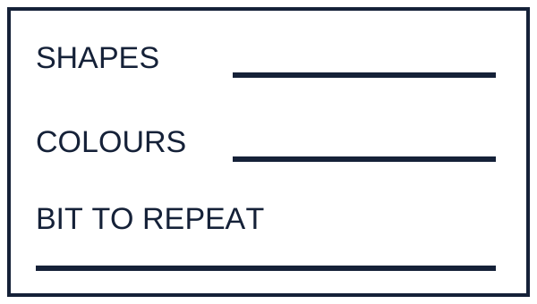  A plan card has spaces for shapes, colours and the bit to repeat.  SHAPES · COLOURS · BIT TO REPEAT | Choose a shape  shape — the form of a mark, like a dot or a ring.    A filled dot and a round ring show two shapes.
Repeat the bit  repeat — use the same bit again.  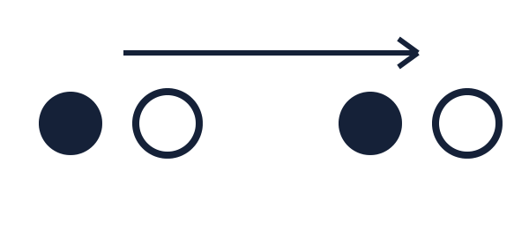  A dot-and-ring pair is shown twice. An arrow goes from the first pair to the next. | Make a pattern  pattern — marks put in an order.  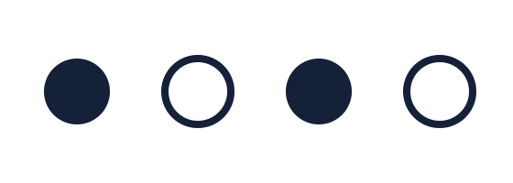  A dot, a ring, a dot and a ring are put in a row.

Today I can… □ I can choose shapes and two or three bright colours. □ I can use the same bit again. □ I can check one thing in my plan.

Art · BUILD · Autumn 2 · Week 1 · ART-BUILD-A2-W01-P2 · Date __________
Make — My festival light pattern
Today I can… □ choose shapes and two or three bright colours. □ use the same bit again. □ check one thing in my plan.
Feedback: □ VF □ WS □ I □ NS □ E □ R □ [//] □ [?] ______

Word page

Choose a plan
plan — choose what to make before you start.
A plan card has spaces for shapes, colours and the bit to repeat.
SHAPES · COLOURS · BIT TO REPEAT

Choose a shape
shape — the form of a mark, like a dot or a ring.
A filled dot and a round ring show two shapes.

Repeat the bit
repeat — use the same bit again.
A dot-and-ring pair is shown twice. An arrow goes from the first pair to the next.

Make a pattern
pattern — marks put in an order.
A dot, a ring, a dot and a ring are put in a row.

Art · BUILD · Autumn 2 · Week 1 · ART-BUILD-A2-W01-P2 · Date __________
Make — My festival light pattern
Today I can… □ choose shapes and two or three bright colours. □ use the same bit again. □ check one thing in my plan.
Feedback: □ VF □ WS □ I □ NS □ E □ R □ [//] □ [?] ______

Cards · Example A

Use these cards for the task.

Example A


On dark paper, a yellow dot and pink ring appear twice in the same order.

Plan for A

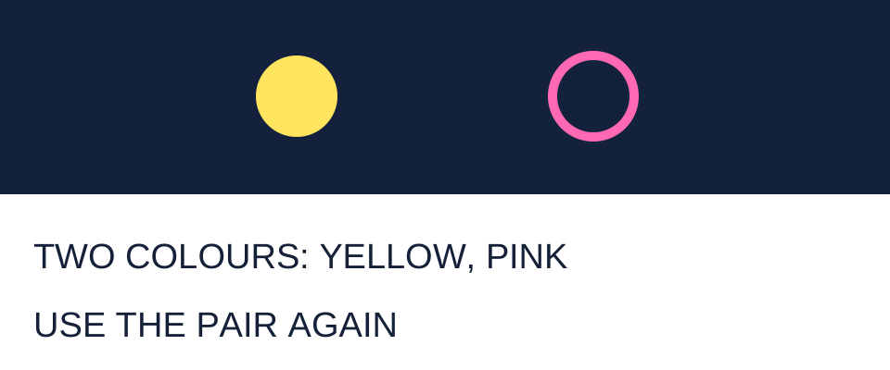
The plan shows a yellow dot followed by a pink ring. It names two colours, yellow and pink, and says to use the pair again.
TWO COLOURS: YELLOW, PINK · USE THE PAIR AGAIN

Art · BUILD · Autumn 2 · Week 1 · ART-BUILD-A2-W01-P2 · Date __________
Make — My festival light pattern
Today I can… □ choose shapes and two or three bright colours. □ use the same bit again. □ check one thing in my plan.
Feedback: □ VF □ WS □ I □ NS □ E □ R □ [//] □ [?] ______

Cards · Example B

Use these cards for the task.

Example B


The row on dark paper is yellow dot, pink ring, yellow dot, pink dot. The last shape differs from the planned ring.

Loose pink ring for the model


A loose pink ring can replace the last pink dot in Example B.

Art · BUILD · Autumn 2 · Week 1 · ART-BUILD-A2-W01-P2 · Date __________
Make — My festival light pattern
Today I can… □ choose shapes and two or three bright colours. □ use the same bit again. □ check one thing in my plan.
Feedback: □ VF □ WS □ I □ NS □ E □ R □ [//] □ [?] ______

Cards · Dot shape card

Use these cards for the task.

Dot shape card

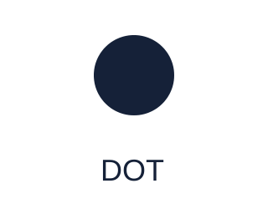
A filled round spot is shown above the word dot.
DOT

Ring shape card

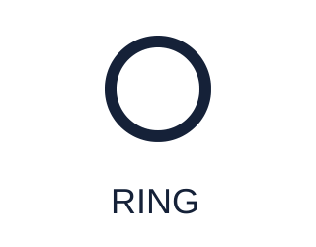
A round line with an empty middle is shown above the word ring.
RING

Art · BUILD · Autumn 2 · Week 1 · ART-BUILD-A2-W01-P2 · Date __________
Make — My festival light pattern
Today I can… □ choose shapes and two or three bright colours. □ use the same bit again. □ check one thing in my plan.
Feedback: □ VF □ WS □ I □ NS □ E □ R □ [//] □ [?] ______

Cards · Ray shape card

Use these cards for the task.

Ray shape card

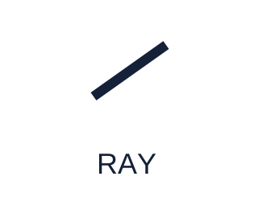
One short straight line is shown above the word ray.
RAY

Lamp shape card

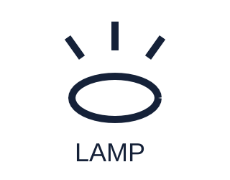
A plain oval line has three short rays above it. It is a made-up sign for a light, with no flame.
LAMP

Art · BUILD · Autumn 2 · Week 1 · ART-BUILD-A2-W01-P2 · Date __________
Make — My festival light pattern
Today I can… □ choose shapes and two or three bright colours. □ use the same bit again. □ check one thing in my plan.
Feedback: □ VF □ WS □ I □ NS □ E □ R □ [//] □ [?] ______

Cards · Yellow colour card

Use these cards for the task.

Yellow colour card

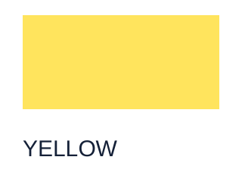
A yellow colour card is shown with its colour name.
YELLOW

Pink colour card

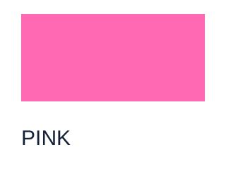
A pink colour card is shown with its colour name.
PINK

Art · BUILD · Autumn 2 · Week 1 · ART-BUILD-A2-W01-P2 · Date __________
Make — My festival light pattern
Today I can… □ choose shapes and two or three bright colours. □ use the same bit again. □ check one thing in my plan.
Feedback: □ VF □ WS □ I □ NS □ E □ R □ [//] □ [?] ______

Cards · Light Blue colour card

Use these cards for the task.

Light Blue colour card

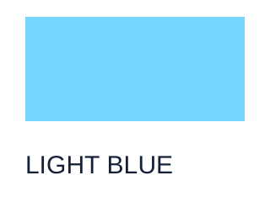
A light blue colour card is shown with its colour name.
LIGHT BLUE

plan word-and-symbol card

choose what to make before you start.
A plan card has spaces for shapes, colours and the bit to repeat.
SHAPES · COLOURS · BIT TO REPEAT

Art · BUILD · Autumn 2 · Week 1 · ART-BUILD-A2-W01-P2 · Date __________
Make — My festival light pattern
Today I can… □ choose shapes and two or three bright colours. □ use the same bit again. □ check one thing in my plan.
Feedback: □ VF □ WS □ I □ NS □ E □ R □ [//] □ [?] ______

Cards · shape word-and-symbol card

Use these cards for the task.

shape word-and-symbol card

the form of a mark, like a dot or a ring.
A filled dot and a round ring show two shapes.

repeat word-and-symbol card

use the same bit again.
A dot-and-ring pair is shown twice. An arrow goes from the first pair to the next.

Art · BUILD · Autumn 2 · Week 1 · ART-BUILD-A2-W01-P2 · Date __________
Make — My festival light pattern
Today I can… □ choose shapes and two or three bright colours. □ use the same bit again. □ check one thing in my plan.
Feedback: □ VF □ WS □ I □ NS □ E □ R □ [//] □ [?] ______

Cards · pattern word-and-symbol card

Use these cards for the task.

pattern word-and-symbol card

marks put in an order.
A dot, a ring, a dot and a ring are put in a row.

Start response card
START

Art · BUILD · Autumn 2 · Week 1 · ART-BUILD-A2-W01-P2 · Date __________
Make — My festival light pattern
Today I can… □ choose shapes and two or three bright colours. □ use the same bit again. □ check one thing in my plan.
Feedback: □ VF □ WS □ I □ NS □ E □ R □ [//] □ [?] ______

Cards · Stop response card

Use these cards for the task.

Stop response card
STOP

My plan

A plan card has spaces for shapes, colours and the bit to repeat.
SHAPES · COLOURS · BIT TO REPEAT

Art · BUILD · Autumn 2 · Week 1 · ART-BUILD-A2-W01-P2 · Date __________
Make — My festival light pattern
Today I can… □ choose shapes and two or three bright colours. □ use the same bit again. □ check one thing in my plan.
Feedback: □ VF □ WS □ I □ NS □ E □ R □ [//] □ [?] ______

Cards · Guided example: choose the last shape

Use these cards for the task.

Guided example: choose the last shape

Our example space: Yellow dot / pink ring / yellow dot / __________

The row on dark paper shows a yellow dot, pink ring and yellow dot, with a blank space for the last shape.
LAST

Art · BUILD · Autumn 2 · Week 1 · ART-BUILD-A2-W01-P2 · Date __________
Make — My festival light pattern
Today I can… □ choose shapes and two or three bright colours. □ use the same bit again. □ check one thing in my plan.
Feedback: □ VF □ WS □ I □ NS □ E □ R □ [//] □ [?] ______

We do · guided record

We do · 8 min · 14 to 22

In your book: Our guided example's last shape, then your planned bit, with one shape or colour check shown.

Build our pattern
Guided example
Our plan is a yellow dot, then a pink ring.
We use that pair again.
Our example space: Yellow dot / pink ring / yellow dot / __________
Choose the last shape. Now show our pair twice.
Each of us now makes a plan.
Pick one or two shapes.
Choose two bright colours.
Put your shapes in a small bit.
Use that bit once more on dark paper.
Check one thing: a shape or a colour.
Does it match your plan?
Record one guided example and one clue.

Art · BUILD · Autumn 2 · Week 1 · ART-BUILD-A2-W01-P2 · Date __________
Make — My festival light pattern
Today I can… □ choose shapes and two or three bright colours. □ use the same bit again. □ check one thing in my plan.
Feedback: □ VF □ WS □ I □ NS □ E □ R □ [//] □ [?] ______

STAFF ANSWERS · Arrival | Supported

1. Start: The yellow dot.
2. Colours: Pink.
3. Next mark: A yellow dot, the third mark in the row.
4. Again: The yellow dot, then the pink ring.
Use one tier. Keep these answers out of pupil view until after the first response.

Art · BUILD · Autumn 2 · Week 1 · ART-BUILD-A2-W01-P2 · Date __________
Make — My festival light pattern
Today I can… □ choose shapes and two or three bright colours. □ use the same bit again. □ check one thing in my plan.
Feedback: □ VF □ WS □ I □ NS □ E □ R □ [//] □ [?] ______

STAFF ANSWERS · Arrival | Standard

1. Order: Yellow dot, then pink ring.
2. Colours: Two colours in the marks; the dark paper is the background, not an extra mark colour.
3. Next mark: A pink ring.
4. Again: Add or direct a yellow dot followed by a pink ring, retaining the same shape and colour order.
Use one tier. Keep these answers out of pupil view until after the first response.

Art · BUILD · Autumn 2 · Week 1 · ART-BUILD-A2-W01-P2 · Date __________
Make — My festival light pattern
Today I can… □ choose shapes and two or three bright colours. □ use the same bit again. □ check one thing in my plan.
Feedback: □ VF □ WS □ I □ NS □ E □ R □ [//] □ [?] ______

STAFF ANSWERS · Arrival | Stretch

1. Order: Pink ring / yellow dot / pink ring / yellow dot.
2. Dark paper: The bright yellow and pink marks stand out against the dark paper. Accept a gesture comparing marks and ground or a simple visibility explanation.
3. Again: A yellow dot followed by a pink ring, in that order, stays the same.
4. Change: Give the dot and the ring new colours and use that pair again.
Use one tier. Keep these answers out of pupil view until after the first response.

Art · BUILD · Autumn 2 · Week 1 · ART-BUILD-A2-W01-P2 · Date __________
Make — My festival light pattern
Today I can… □ choose shapes and two or three bright colours. □ use the same bit again. □ check one thing in my plan.
Feedback: □ VF □ WS □ I □ NS □ E □ R □ [//] □ [?] ______

STAFF ANSWERS · Exit ticket | Supported

1. Repeat: Use the same bit again.
2. Again: The pupil points to two places where their own unit appears. Record what they showed.
3. Check: The pupil locates a planned colour in their artwork, or identifies that it is missing or different. Record the actual match or difference shown.
Use one tier. Keep these answers out of pupil view until after the first response.

Art · BUILD · Autumn 2 · Week 1 · ART-BUILD-A2-W01-P2 · Date __________
Make — My festival light pattern
Today I can… □ choose shapes and two or three bright colours. □ use the same bit again. □ check one thing in my plan.
Feedback: □ VF □ WS □ I □ NS □ E □ R □ [//] □ [?] ______

STAFF ANSWERS · Exit ticket | Standard

1. Repeat: The pupil shows two occurrences of their own repeated unit, in the same order.
2. Check: Compare one planned shape, colour or repeat with the artwork. A clear demonstration of such a comparison is valid.
3. Choice: A pupil-owned shape, colour, repeat or placement decision. Accept a gesture to that part with a clear meaning.
Use one tier. Keep these answers out of pupil view until after the first response.

Art · BUILD · Autumn 2 · Week 1 · ART-BUILD-A2-W01-P2 · Date __________
Make — My festival light pattern
Today I can… □ choose shapes and two or three bright colours. □ use the same bit again. □ check one thing in my plan.
Feedback: □ VF □ WS □ I □ NS □ E □ R □ [//] □ [?] ______

STAFF ANSWERS · Exit ticket | Stretch

1. Colours: No. The dark paper is the background; A uses two bright colours for its marks.
2. Change: All three marks, in the same order each time; the whole three-mark unit is used again.
3. Check: A specific comparison, such as planned pink rings present in the work, one missing ring noticed, or an intentional colour change identified. No change is required when the chosen feature already matches.
Use one tier. Keep these answers out of pupil view until after the first response.

Art · BUILD · Autumn 2 · Week 1 · ART-BUILD-A2-W01-P2 · Date __________
Make — My festival light pattern
Today I can… □ choose shapes and two or three bright colours. □ use the same bit again. □ check one thing in my plan.
Feedback: □ VF □ WS □ I □ NS □ E □ R □ [//] □ [?] ______

STAFF ANSWERS · teaching and routes

Starter: A repeats the yellow-dot/pink-ring pair. B changes the last shape to a dot, so its second pair does not match the first.
I do: The planned last shape is a pink ring. The adult's check compares the actual shape with the plan.
We do: Pink ring. The adult models reading the first pair, then every pupil chooses the last shape before the shared example is completed.
We do: A pupil-chosen unit in two or three bright colours, repeated on dark paper, with one actual shape or colour compared with the pupil's stated plan. A match, a noticed mismatch or an intentional change can be valid evidence; note what the pupil showed.
You do · Independent: A pupil-owned plan precedes a small artwork on dark paper with a repeated unit and two or three bright colours. The pupil compares one stated shape or colour in the plan with the work. Accept a matching feature, a pupil-identified mismatch with a proposed change, or an explained intentional change. Fine motor precision is not the success criterion.
You do · Supported: A chosen dot or ring used in two chosen bright colours, with the two-colour pair repeated on dark paper. The pupil identifies one planned colour and locates it in the work, or notices a difference. Record whether the choices, repetition and check were independent or prompted.
You do · Choice: The pupil selects a method, shape and two or three bright colours, then makes or directs a repeated unit on a dark ground. The review compares an actual feature with one planned shape or colour. Ready-cut shapes may remain arranged on the paper until the pupil directs an adult to glue them; the pupil's decisions are the evidence, not who controls the tool. Record C, the method chosen and the pupil's one word, phrase or reason.
You do · Aspire: A planned artwork uses a repeated unit and two or three bright colours on dark paper, with an intentional one- or two-row layout. The pupil compares one planned feature with the work and identifies how their spacing helps the shapes remain clear or separated. If they change the plan, record the original choice, actual change and reason rather than requiring a replica of the model.
Staff: mark I, S or C beside the You do response for actual independence, support or choice.

Art · BUILD · Autumn 2 · Week 1 · ART-BUILD-A2-W01-P2 · Date __________
Make — My festival light pattern
Today I can… □ choose shapes and two or three bright colours. □ use the same bit again. □ check one thing in my plan.
Feedback: □ VF □ WS □ I □ NS □ E □ R □ [//] □ [?] ______

TA brief

Prepare the simple word, shape and colour cards described here before the lesson; no external image, named resource or screen interaction is needed. Read pupil wording aloud, one short prompt at a time. All response choices apply to EVERY question, demonstration response, shared task, route, review and Exit: pupils may point, speak, sign, use symbols, draw or write. A pupil may direct an adult to place a shape or move a card. Offer a silent director role throughout; do not require making marks, touching materials or speaking to the group. Never cold call. Any pupil may pass. A pass needs no book entry.
Use one Arrival tier and one Exit tier per pupil. Keep Answer (adult) lines out of pupil view until the response. The three Exit checks are brief choices or short responses, not three extended written answers. Allow private thinking before any shared reveal. An adult may record the pupil's own choice, gesture or exact words. No board copying, cutting or gluing is needed in the timed stages.
Festival context: light and colour are ways some people celebrate. People within a tradition may celebrate in different ways. These are original, made-up classroom pictures of light shapes, not copies of any tradition's sacred images. Never ask about a pupil's belief, family, worship or loss. Discuss the shapes and colours in these pictures, not personal disclosure.
Materials safety and access: use pencils, pastels or chalk, coloured and dark paper, and optional glue. Any scissors are used with adult care; prepare cut shapes in advance so cutting is never required. Use no flames. Keep chalk on the paper and do not blow dust. Announce each short task, use a predictable short count-in with a matching hand gesture, and show a flat hand for STOP. At STOP, pause marks or card moves and rest tools on the table. A pupil can choose the silent director role, a quiet place or a pause without explaining why. Offer large, clearly spaced shapes and describe their colour and position; do not infer lack of art understanding from a visual or motor access need.

Art · BUILD · Autumn 2 · Week 1 · ART-BUILD-A2-W01-P2 · Date __________
Make — My festival light pattern
Today I can… □ choose shapes and two or three bright colours. □ use the same bit again. □ check one thing in my plan.
Feedback: □ VF □ WS □ I □ NS □ E □ R □ [//] □ [?] ______

TA brief

Kit and stimulus: Each pupil needs a small piece of dark paper, bright yellow, pink and light blue pencils, pastels or chalk, or ready-cut coloured paper shapes with optional glue. Use only two or three bright colours in each artwork. Provide DOT / RING / RAY / LAMP cards: dot = a filled round spot; ring = a round line with an empty middle; ray = one short straight line; lamp = a plain oval outline with three short rays above it, with no flame. A lamp here is only a made-up drawn sign for a light. Add START / STOP cards and a small plan space with SHAPES / COLOURS / BIT TO REPEAT. Say colour names aloud and describe card positions. An adult can draw or place shapes exactly as the pupil directs. No earlier lesson or completed work is needed. Use a retained P1 plan if available, or make a fresh brief plan within the lesson. Prepare four must-know word cards, each with the word and a simple matching symbol, read aloud: plan (a small plan card), shape (a dot and a ring), repeat (one pair, an arrow, the same pair), pattern (a row of marks). Show them from the Opening.
Adult-made Example A and its plan: Draw or arrange four large, evenly spaced marks in one row on dark paper: yellow dot / pink ring / yellow dot / pink ring. Beside it, make a plan card showing a yellow dot followed by a pink ring, with the words TWO COLOURS: YELLOW, PINK and USE THE PAIR AGAIN. This is an original classroom example, not a named artwork or a sacred image. The finished row matches the plan.
Adult-made Example B: Make another row on dark paper: yellow dot / pink ring / yellow dot / pink dot. It uses the same two colours as A, but its second pair has a dot where the plan calls for a ring. Prepare the last pink dot as a loose paper shape and a pink ring to swap in, so the adult can show one simple change without covering a pupil's work. Adult cutting happens before the lesson.
Adult-only EHCP note: Possible outcome areas are communication and interaction; cognition and learning; sensory and/or physical needs; social, emotional and mental health. Link observations only to an actual individual target; do not infer an outcome from participation alone. Regulation strategy: use the announced count-in and visible STOP cue, with an agreed silent return to the next small task if the pupil needs a pause.

Art · BUILD · Autumn 2 · Week 1 · ART-BUILD-A2-W01-P2 · Date __________
Make — My festival light pattern
Today I can… □ choose shapes and two or three bright colours. □ use the same bit again. □ check one thing in my plan.
Feedback: □ VF □ WS □ I □ NS □ E □ R □ [//] □ [?] ______

TA brief

Same-day evidence — ART-BUILD-A2-W01-P2: The assigned adult records one chosen book item or a brief observation of the pupil's own response, response mode and actual prompt used, and files it in the evidence app the same day under ART-BUILD-A2-W01-P2. A photo is optional and needs the accompanying observation; a photo alone does not show understanding. Do not require a public display.
1. Set out dark paper, the full shape/colour choices, the four word-and-symbol cards and the simple plan space; do not assume attendance at P1.
2. Use the count-in and clear stop cue; every pupil may direct silently or pass. Keep cut shapes ready and support any scissors use.
3. In We do, each pupil chooses a part before the shared example is completed; allow an adult to carry out the pupil's instructions.
4. In You do, offer one route; note the pupil's own shapes, colours, repeat and check rather than praise alone.
5. Record one specific choice or changed part with the response mode and prompts, and file the evidence in the evidence app the same day under ART-BUILD-A2-W01-P2.
Arrival · 5 minutes
Adult note: Show Example A and its plan. Name the dot and ring shapes, then let each pupil find the order and colours before any reveal. Example A and its plan are supplied clues, not a test of prior learning; pupils do not need to remember P1. Invite four brief responses from one tier.
Starter · 3 minutes
Adult note: Show and read both rows, pointing to each mark; each pupil chooses privately before a shared reveal. Use the two adult-made examples described above.
I do · 6 minutes
Adult note: Spend four minutes modelling the plan, repeat and one check, then two on the word meanings and one choice. Show the plan for A beside B. Move a finger along the first pair, then the second, so the comparison is visible. Use loose shapes for the one change.

Art · BUILD · Autumn 2 · Week 1 · ART-BUILD-A2-W01-P2 · Date __________
Make — My festival light pattern
Today I can… □ choose shapes and two or three bright colours. □ use the same bit again. □ check one thing in my plan.
Feedback: □ VF □ WS □ I □ NS □ E □ R □ [//] □ [?] ______

TA brief

Adult note: Swap only the last pink dot for the prepared pink ring. Invite every pupil to show the shape named in the plan before revealing the change. A pupil whose work already matches may show that match; a change is not compulsory. The aim is one intentional check, not a neat copy of the adult's artwork.
We do · 8 minutes
Adult note: Two minutes for the guided example, four to plan and try, two to check. Every pupil has dark paper or a dark card space and dot/ring choices in two bright colours. A pupil can direct an adult or use selected shape cards. All decide before shared cards move.
Adult note: Every pupil makes or directs their own short trial. A pair with one mark of each chosen colour is a manageable starting point. If a pupil plans a third colour, use a three-mark unit and repeat the whole unit. Save the plan as cards, marks or an adult record for You do; no public display is required.
You do · 15 minutes
Adult note: Two minutes to set up; eleven to plan, make and record; final two to review one check. Offer a small piece of dark paper and drawing or ready-cut shape choices. Every route can be completed as a silent director. No earlier work is required; the model and full instructions are here. Reuse a P1 or We do plan if the pupil chooses, or record a fresh shape/colour plan before making. Give one precise success and one next step, and allow the pupil to show the check or a chosen change. Use only two or three bright mark colours; the dark background does not count as one of them. Name back what the pupil made and one choice they made, ask for one spoken, signed or shown reason, and scribe it with the evidence.
the adult marks I (Independent), S (Supported) or C (Choice) and records actual support. For Aspire, record I or S according to the support used.
Exit ticket · 3 minutes
Adult note: Show the unchanged Example A and its plan. Use one tier and brief responses. Use the pupil's plan and artwork wherever a check asks for their work.

Art · BUILD · Autumn 2 · Week 1 · ART-BUILD-A2-W01-P2 · Date __________
Make — My festival light pattern
Today I can… □ choose shapes and two or three bright colours. □ use the same bit again. □ check one thing in my plan.
Feedback: □ VF □ WS □ I □ NS □ E □ R □ [//] □ [?] ______

TA brief · feedback and prompt ladder

Prompt ladder for adults
1. Point to the relevant place / instruction.
2. Ask one short question: "What is it asking you to find?"
3. Rephrase the instruction in simpler language.
4. Provide a scaffold or limited choice.
5. Model the first step only, then return the task to the pupil.
No cold calling; nobody is asked to read difficult text aloud.
Space: allow quiet thinking and a private response.
Feedback [VF] [NS]: name one success and one change against the art criteria.
Voice [//]: retain the pupil’s own mark, choice, artwork or explanation, with their actual support.
Audience: record the pupil’s comment; listen to any clip in full before tagging. Name the choice back and mark [R] only after receipt and a next step.
Influence: use the photo and comment in the Discover log to check the next skill.
Use [WS] for supported work and [I] for independent work. Use [?] to invite a read-back and [//] for a self-edit.
Evidence [E] · ART-BUILD-A2-W01-P2: the assigned adult uploads the selected book item, artwork photo with its observation, or exact response to the evidence app the same day, labelled ART-BUILD-A2-W01-P2. Capture is not closure; a photo alone does not establish understanding.
Staff: mark I, S or C beside the You do response for actual independence, support or choice.

