Visual step cards
Week 7 Lesson 1 • Part D • 14–18 December 2026
I can choose what I enjoyed and what I learnt to do.
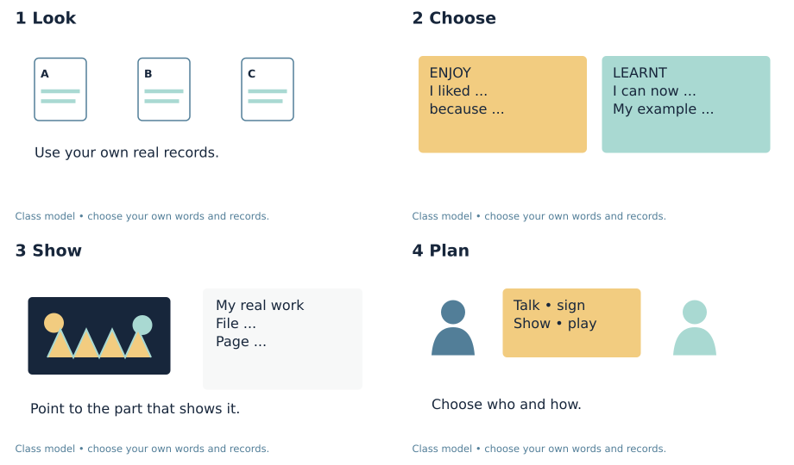
1. Look: Look back at your own work and records.
2. Choose: Choose one thing you liked and one thing you learnt to do.
3. Show: Find a real example to show each choice.
4. Plan: Choose who to share with and how to share.
You can point, speak, sign, draw or write. You may ask for a quiet space or a pause.

Words for my share
Week 7 Lesson 1 • Part D • 14–18 December 2026

enjoy
To like what you do.

achieve
To learn or do a new thing through your own work.

audience
The people who see or hear your share.

evidence
A record of what you did or learnt.

Words for my own record
I enjoyed ___ because ___.
________________________________________________________________
I learnt to ___.
________________________________________________________________
You can see this in ___.
________________________________________________________________
I would like to share with ___.
________________________________________________________________

Knowledge organiser
Week 7 Lesson 1 • Part D • 14–18 December 2026
I can choose what I enjoyed and what I learnt to do.
I can look back at my own art and records.
I can show one thing I liked and say why.
I can show one thing I learnt to do.
enjoy — To like what you do.
achieve — To learn or do a new thing through your own work.
audience — The people who see or hear your share.
evidence — A record of what you did or learnt.
My record: D_Share.pdf • page 1
The real share has its own date, audience and record.

Choose your sharing cards
Week 7 Lesson 1 • Part D • 14–18 December 2026
Use your own work. Pick a way to share that suits you.
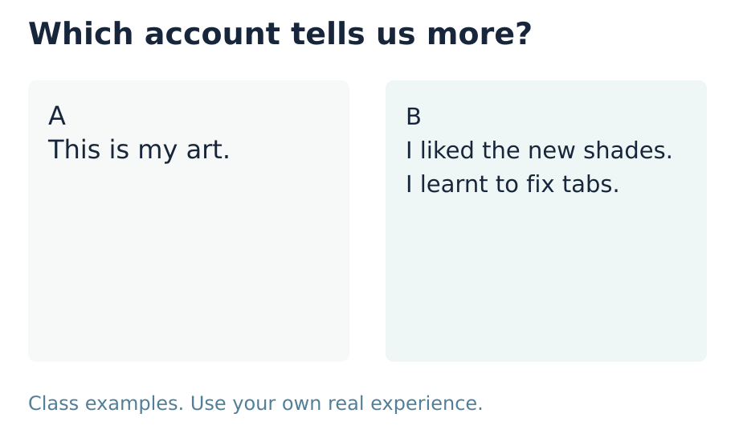
ENJOY: one thing I liked and why.
LEARNT: one thing I can do or know now.
SHOW: my real work or record.
SHARE: talk, sign, show or play my own words.
My own check or next step
________________________________________________________________
________________________________________________________________

Supported route
Week 7 Lesson 1 • Part D • 14–18 December 2026

Recall
Find your own art and records.
Show one thing you made or tried.

My task
1. Look at two real pieces with help.
2. Point to one thing you liked. Say or show why.
3. Point to one thing you learnt to do.
4. Use a prompt card to show your own choice.
5. Choose a way to share with someone you trust.
My own words or sketch
________________________________________________________________
________________________________________________________________
________________________________________________________________

Check before you finish
What did you enjoy, and why?
What did you learn to do? Show one example.
Who might you share with, and how?
You can point, speak, sign, draw or write. You may ask for a quiet space or a pause.
Staff prompt record: I / S / C ______ Actual support __________________

Independent route
Week 7 Lesson 1 • Part D • 14–18 December 2026

Recall
Find your own art and records.
Show one thing you made or tried.

My task
1. Look back at your own A, B and C records.
2. Choose one thing you enjoyed and say why.
3. Choose one thing you learnt or did well.
4. Link both choices to work you can show.
5. Plan who to share with and how.
My own words or sketch
________________________________________________________________
________________________________________________________________
________________________________________________________________

Check before you finish
What did you enjoy, and why?
What did you learn to do? Show one example.
Who might you share with, and how?
You can point, speak, sign, draw or write. You may ask for a quiet space or a pause.
Staff prompt record: I / S / C ______ Actual support __________________

Aspire route
Week 7 Lesson 1 • Part D • 14–18 December 2026

Recall
Find your own art and records.
Show one thing you made or tried.

My task
1. Look back at two choices in your art.
2. Explain what you enjoyed and what you learnt.
3. Use real details to show how your work changed.
4. If two real artists are known, compare an idea.
5. Set one next aim and say how you will check it.
My own words or sketch
________________________________________________________________
________________________________________________________________
________________________________________________________________

Check before you finish
What did you enjoy, and why?
What did you learn to do? Show one example.
Who might you share with, and how?
You can point, speak, sign, draw or write. You may ask for a quiet space or a pause.
Staff prompt record: I / S / C ______ Actual support __________________

My choices for the share
Week 7 Lesson 1 • Part D • 14–18 December 2026
Learner code __________ Actual date __________
D_Share.pdf • page 1
Show or sketch the real work you chose

________________________________________________________________
________________________________________________________________
I enjoyed ___ because ___.
________________________________________________________________
I learnt to ___.
________________________________________________________________
My real example is ___ in file ___ on page ___.
________________________________________________________________
I would like to share with ___ by ___.
________________________________________________________________
The event date and audience are confirmed: yes / not yet.
An adult wrote my words: yes / no. I checked them: yes / not yet.
This is my plan. The real share will have its own date and record.

Optional artist comparison
Week 7 Lesson 1 • Part D • 14–18 December 2026
Use two real works if they are here. Name who made each one. Say how your own art uses or changes an idea.

First real artist and work
Name and work title or description
________________________________________________________________
Where I saw it and one choice I can show
________________________________________________________________

Second real artist and work
Name and work title or description
________________________________________________________________
Where I saw it and one choice I can show
________________________________________________________________
Both artists ___.
________________________________________________________________
One difference is ___.
________________________________________________________________
In my own piece I chose ___ because ___.
________________________________________________________________
My next aim is ___. I will check it by ___.
________________________________________________________________
If you have just one real work, review it in more depth. Keep this comparison for when two real works are here.
This page does not prove a real Part B encounter.

My short book tasks
Week 7 Lesson 1 • Part D • 14–18 December 2026

Look back
Find your own art and records.
________________________________________________________________
Show one thing you made or tried.
________________________________________________________________
Which part did you like doing?
________________________________________________________________
What can you do now that was hard before?
________________________________________________________________

Look and choose
Which card tells us what the maker enjoyed and learnt? Choose A or B.
My choice and reason
________________________________________________________________

At the end
What did you enjoy, and why?
What did you learn to do? Show one example.
Who might you share with, and how?
My next step
________________________________________________________________
Keep selected work in the existing D file or index. This sheet is a class resource.

TA brief
Week 7 Lesson 1 • Part D • 14–18 December 2026
Use one route, with Independent as the GROW default. Offer Supported when useful and Aspire as optional stretch. All pupil text uses the BUILD band. The routes change support and depth, not the part requirements. For five learners, use a pair and a trio, with a separate piece and record for each learner. In the trio, rotate maker, observer and materials roles; every learner retains their own choices. Offer private responses, silent directing and a pause. Do not cold call or seek personal or family disclosure. Scribe exact words or confirmed choices, read them back and allow correction. Do not compose pupils’ plans or reviews. Mark I, S or C beside the task in staff records and note the actual prompt. Give one specific success and one useful next step. Use VF / WS / I / NS+ / // / ? / R / E as appropriate. Record R only after Voice, Audience, an NS+ prompt and the pupil’s response in their own colour; capture alone is not closure. Upload the selected individual evidence to the evidence app on the same day.

Prompt ladder
1. Point to the relevant place / instruction.
2. Ask one short question: "What is it asking you to find?"
3. Rephrase the instruction in simpler language.
4. Provide a scaffold or limited choice.
5. Model the first step only, then return the task to the pupil.

Evidence focus
Part D is a personal account of enjoyment and achievement chosen by looking back at A–C. Keep both elements, pupil authorship, the example/file/page and intended audience/mode on D page 1. It is preparation, not proof of the actual December share. Mark absent B or C evidence as a gap in the Evidence Index; do not invent it. The actual sharing record belongs at D page 3 when it happens.

One end question
What did you enjoy, what did you learn, and where can you show it?
I = independent; S = supported; C = coached. Note the actual prompt used. Record R only after Voice + Audience + NS+ + the learner’s response in their own colour.

Staff answers and checks
Week 7 Lesson 1 • Part D • 14–18 December 2026

Arrival
Use the learner’s actual records; do not substitute class examples.
Any genuine activity or work. Keep A and C distinct.
Accept the learner’s own choice, including mixed feelings. No forced praise.
A real skill, choice or achievement. Supported participation is valid; ask for a specific example.

Starter
B gives a personal reason for enjoyment and a specific learnt skill. A only names an object. B is a class example; each learner must choose their own account.

Guided practice
The class model liked mixing shades and learnt to fix the tabs. Link each statement to the labelled sample. Pupils can prefer other aspects of their own work.

Exit
Own enjoyment and reason, linked to an actual activity.
Own achievement with a clear real example.
A feasible preferred audience and method. The owner confirms event arrangements; do not promise a booking.

Acceptable responses
The learner’s own account may differ from the class model. Check both enjoyment and achievement. Accept pointing, speech, signs, drawing or checked scribing. Do not award a part result from route choice or attendance.

