Visual step cards
Week 7 Lesson 2 • Part D • 14–18 December 2026
I can practise my share and check that my records can be found.
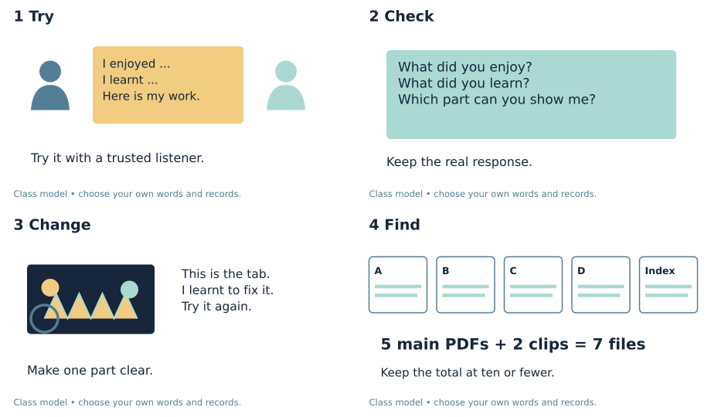
1. Try: Try your share with a listener you trust.
2. Check: Ask what they learnt from your share.
3. Change: Make one part clear. Try that part once more.
4. Find: Check your files, pages and gaps with an adult.
You can point, speak, sign, draw or write. You may ask for a quiet space or a pause.

Words for my share
Week 7 Lesson 2 • Part D • 14–18 December 2026

rehearse
To try your share before the real event.

response
What someone says, signs or shows back to you.

index
A list that shows where to find each record.

file
A saved record with its own name.

Words for my own record
My listener said or showed ___.
________________________________________________________________
I made ___ clear by ___.
________________________________________________________________
My work is in file ___ on page ___.
________________________________________________________________
My next task is ___.
________________________________________________________________

Knowledge organiser
Week 7 Lesson 2 • Part D • 14–18 December 2026
I can practise my share and check that my records can be found.
I can share what I enjoyed and learnt with a listener.
I can use a response to make my share clear.
I can find my work and check the file count.
rehearse — To try your share before the real event.
response — What someone says, signs or shows back to you.
index — A list that shows where to find each record.
file — A saved record with its own name.
My record: D_Share.pdf • page 2; Evidence_Index.pdf • pages 1–2
The real share has its own date, audience and record.

Find the file and count
Week 7 Lesson 2 • Part D • 14–18 December 2026
Use the class example first. Then check your own files.
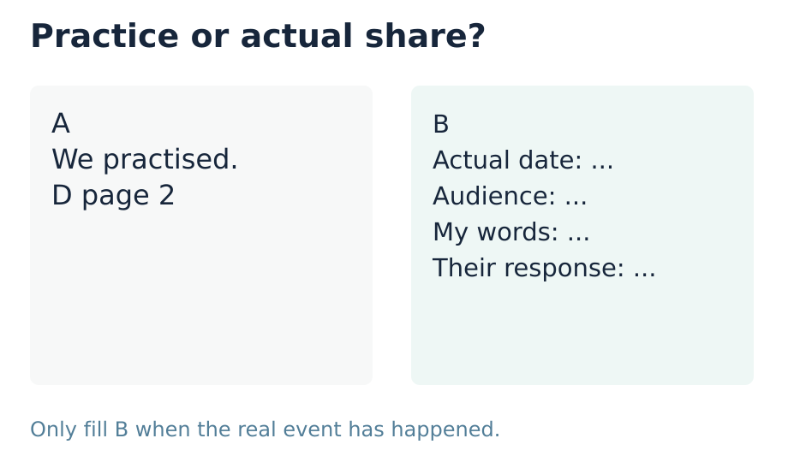
Five main PDFs plus two clips make seven files.
Five main PDFs plus six clips make eleven files.
The index counts as one file.
Keep key proof. Ask staff to help combine records.
My own check or next step
________________________________________________________________
________________________________________________________________

Supported route
Week 7 Lesson 2 • Part D • 14–18 December 2026

Recall
Find the choices you made for your share.
What did you enjoy, and why?

My task
1. Use your own cue card with a trusted adult.
2. Show what you liked and what you learnt.
3. Ask what they saw or heard.
4. Try one part again with help if needed.
5. Find the right pages and count files with an adult.
My own words or sketch
________________________________________________________________
________________________________________________________________
________________________________________________________________

Check before you finish
What did your listener understand?
What did you make clear when you tried again?
What is the file count, and what still needs to be done?
You can point, speak, sign, draw or write. You may ask for a quiet space or a pause.
Staff prompt record: I / S / C ______ Actual support __________________

Independent route
Week 7 Lesson 2 • Part D • 14–18 December 2026

Recall
Find the choices you made for your share.
What did you enjoy, and why?

My task
1. Rehearse your own share with a listener.
2. Ask what they understood about your choices.
3. Use their response to make one part clear.
4. Try that part again and keep a short record.
5. Open the files and pages in your index. Count them.
My own words or sketch
________________________________________________________________
________________________________________________________________
________________________________________________________________

Check before you finish
What did your listener understand?
What did you make clear when you tried again?
What is the file count, and what still needs to be done?
You can point, speak, sign, draw or write. You may ask for a quiet space or a pause.
Staff prompt record: I / S / C ______ Actual support __________________

Aspire route
Week 7 Lesson 2 • Part D • 14–18 December 2026

Recall
Find the choices you made for your share.
What did you enjoy, and why?

My task
1. Explain two choices and what you learnt from them.
2. Ask which detail made your meaning clear.
3. Use the response to refine your own account.
4. Link your next aim to what you can show.
5. Check every page link and set a plan for each gap.
My own words or sketch
________________________________________________________________
________________________________________________________________
________________________________________________________________

Check before you finish
What did your listener understand?
What did you make clear when you tried again?
What is the file count, and what still needs to be done?
You can point, speak, sign, draw or write. You may ask for a quiet space or a pause.
Staff prompt record: I / S / C ______ Actual support __________________

My rehearsal and next step
Week 7 Lesson 2 • Part D • 14–18 December 2026
Learner code __________ Actual date __________
D_Share.pdf • page 2; Evidence_Index.pdf • pages 1–2
My cue or work that helped the listener

________________________________________________________________
________________________________________________________________
Actual practice date ___ Listener or code ___.
________________________________________________________________
My listener said or showed ___.
________________________________________________________________
I changed or kept ___ because ___.
________________________________________________________________
When I tried again ___.
________________________________________________________________
My next task is ___ with ___ by ___.
________________________________________________________________
Keep the file count and any gaps in the index.
An adult wrote my words: yes / no. I checked them: yes / not yet.
This is practice. Use page 3 only for the real December share.

Optional artist comparison
Week 7 Lesson 2 • Part D • 14–18 December 2026
Use two real works if they are here. Name who made each one. Say how your own art uses or changes an idea.

First real artist and work
Name and work title or description
________________________________________________________________
Where I saw it and one choice I can show
________________________________________________________________

Second real artist and work
Name and work title or description
________________________________________________________________
Where I saw it and one choice I can show
________________________________________________________________
Both artists ___.
________________________________________________________________
One difference is ___.
________________________________________________________________
In my own piece I chose ___ because ___.
________________________________________________________________
My next aim is ___. I will check it by ___.
________________________________________________________________
If you have just one real work, review it in more depth. Keep this comparison for when two real works are here.
This page does not prove a real Part B encounter.

My short book tasks
Week 7 Lesson 2 • Part D • 14–18 December 2026

Look back
Find the choices you made for your share.
________________________________________________________________
What did you enjoy, and why?
________________________________________________________________
What did you learn or achieve?
________________________________________________________________
What will you show to help your listener?
________________________________________________________________

Look and choose
Which record shows a real share? A says “we practised”. B has a real date, audience and own words.
My choice and reason
________________________________________________________________

At the end
What did your listener understand?
What did you make clear when you tried again?
What is the file count, and what still needs to be done?
My next step
________________________________________________________________
Keep selected work in the existing D file or index. This sheet is a class resource.

TA brief
Week 7 Lesson 2 • Part D • 14–18 December 2026
Use one route, with Independent as the GROW default. Offer Supported when useful and Aspire as optional stretch. All pupil text uses the BUILD band. The routes change support and depth, not the part requirements. For five learners, use a pair and a trio, with a separate piece and record for each learner. In the trio, rotate maker, observer and materials roles; every learner retains their own choices. Offer private responses, silent directing and a pause. Do not cold call or seek personal or family disclosure. Scribe exact words or confirmed choices, read them back and allow correction. Do not compose pupils’ plans or reviews. Mark I, S or C beside the task in staff records and note the actual prompt. Give one specific success and one useful next step. Use VF / WS / I / NS+ / // / ? / R / E as appropriate. Record R only after Voice, Audience, an NS+ prompt and the pupil’s response in their own colour; capture alone is not closure. Upload the selected individual evidence to the evidence app on the same day.

Prompt ladder
1. Point to the relevant place / instruction.
2. Ask one short question: "What is it asking you to find?"
3. Rephrase the instruction in simpler language.
4. Provide a scaffold or limited choice.
5. Model the first step only, then return the task to the pupil.

Evidence focus
D page 2 records the actual rehearsal, listener response, pupil’s chosen adjustment or reasoned retained feature, and another try. Audit A–D separately against the existing requirements. Use Evidence_Index pages 1–2 for verified file/page locators, real time totals, file count and gaps. Count the index among the five core PDFs and all separate media within ten. The actual December event must later record enjoyment and achievement, date, audience and receipt at D page 3. Do not prefill a part outcome.

One end question
What did your listener understand, and what still needs to be done?
I = independent; S = supported; C = coached. Note the actual prompt used. Record R only after Voice + Audience + NS+ + the learner’s response in their own colour.

Staff answers and checks
Week 7 Lesson 2 • Part D • 14–18 December 2026

Arrival
D page 1 or an actual learner-authored choice record.
Own enjoyment and reason. Read back any scribed words.
Own learnt skill or achievement, not a prescribed success statement.
A real piece, page, cue card or the pupil’s own recording. Do not require public performance.

Starter
B could support the actual share only if those details describe a real event. A is rehearsal. A label or tick alone is not evidence; check that enjoyment and achievement were actually communicated and received.

Guided practice
The listener’s question prompts a clearer point to the tab. The model index points to an actual opened page. Five main PDFs plus two separate clips total seven files. Do not count five files as proof all four parts are met.

Exit
A real listener response recorded at D page 2, in words, signs or confirmed choices.
A specific change or a reasoned decision to retain an already clear feature, followed by another try.
An actual file count no greater than ten for the submitted portfolio, verified locators and named gaps/actions. D page 3 remains pending unless the actual event has occurred.

Acceptable responses
The learner’s own account may differ from the class model. Check both enjoyment and achievement. Accept pointing, speech, signs, drawing or checked scribing. Do not award a part result from route choice or attendance.

