Art · LAUNCH · Autumn 2 · Week 1 · ART-LAUNCH-A2-W01 · Date __________  A review with evidence  Today I can… □ describe a feature I can check. □ explain and qualify my judgement. □ recommend a work to an audience, with a reason.  Feedback: □ VF □ WS □ I □ NS □ E □ R □ [//] □ [?] ______ | 

Art · LAUNCH · Autumn 2 · Week 1 · ART-LAUNCH-A2-W01 · Date __________
A review with evidence
Today I can… □ describe a feature I can check. □ explain and qualify my judgement. □ recommend a work to an audience, with a reason.
Feedback: □ VF □ WS □ I □ NS □ E □ R □ [//] □ [?] ______

Art · LAUNCH · Autumn 2 · Week 1 · ART-LAUNCH-A2-W01 · Date __________
A review with evidence
Today I can… □ describe a feature I can check. □ explain and qualify my judgement. □ recommend a work to an audience, with a reason.
Feedback: □ VF □ WS □ I □ NS □ E □ R □ [//] □ [?] ______

Art · LAUNCH · Autumn 2 · Week 1 · ART-LAUNCH-A2-W01 · Date __________
A review with evidence
Today I can… □ describe a feature I can check. □ explain and qualify my judgement. □ recommend a work to an audience, with a reason.
Feedback: □ VF □ WS □ I □ NS □ E □ R □ [//] □ [?] ______

Art · LAUNCH · Autumn 2 · Week 1 · ART-LAUNCH-A2-W01 · Date __________
A review with evidence
Today I can… □ describe a feature I can check. □ explain and qualify my judgement. □ recommend a work to an audience, with a reason.
Feedback: □ VF □ WS □ I □ NS □ E □ R □ [//] □ [?] ______

Art · LAUNCH · Autumn 2 · Week 1 · ART-LAUNCH-A2-W01 · Date __________
A review with evidence
Today I can… □ describe a feature I can check. □ explain and qualify my judgement. □ recommend a work to an audience, with a reason.
Feedback: □ VF □ WS □ I □ NS □ E □ R □ [//] □ [?] ______

Art · LAUNCH · Autumn 2 · Week 1 · ART-LAUNCH-A2-W01 · Date __________
A review with evidence
Today I can… □ describe a feature I can check. □ explain and qualify my judgement. □ recommend a work to an audience, with a reason.
Feedback: □ VF □ WS □ I □ NS □ E □ R □ [//] □ [?] ______

Art · LAUNCH · Autumn 2 · Week 1 · ART-LAUNCH-A2-W01 · Date __________
A review with evidence
Today I can… □ describe a feature I can check. □ explain and qualify my judgement. □ recommend a work to an audience, with a reason.
Feedback: □ VF □ WS □ I □ NS □ E □ R □ [//] □ [?] ______

Art · LAUNCH · Autumn 2 · Week 1 · ART-LAUNCH-A2-W01 · Date __________
A review with evidence
Today I can… □ describe a feature I can check. □ explain and qualify my judgement. □ recommend a work to an audience, with a reason.
Feedback: □ VF □ WS □ I □ NS □ E □ R □ [//] □ [?] ______

Arrival | Supported

Arrival · 5 min · 00 to 05

In your book: Four numbered responses, 1 to 4: words, marks, annotations or selected symbols.

1. A feature
Which colour is Flow's small circle: orange or blue?
Clue: Find the small circle above the bands.
Write, draw or stick your answer here.

2. A line
Are Crossing's dark strips curved or straight?
Clue: Follow one edge with your finger or point.
Write, draw or stick your answer here.

3. Evidence or opinion
Which can you check in Flow: 'three bands' or 'the best art'?
Clue: Count what is shown.
Write, draw or stick your answer here.

4. A listener
Who is the audience: people viewing the art or the paint?
Clue: Think about who receives the work.
Write, draw or stick your answer here.

Art · LAUNCH · Autumn 2 · Week 1 · ART-LAUNCH-A2-W01 · Date __________
A review with evidence
Today I can… □ describe a feature I can check. □ explain and qualify my judgement. □ recommend a work to an audience, with a reason.
Feedback: □ VF □ WS □ I □ NS □ E □ R □ [//] □ [?] ______

Exit ticket | Supported

Exit ticket · 3 min · 37 to 40

In your book: Your answer to each check, 1 to 3 (a word, mark or short phrase), and your next action: keep, clarify or revise.

1. Feature
Point to one feature used in your review.
Clue: Find its shape or colour in the work.
Write, draw or stick your answer here.

2. Judgement
Is 'calm' a colour or a possible effect?
Clue: Think about what the word tells a viewer.
Write, draw or stick your answer here.

3. Audience
Who might value your chosen work? Show one reason.
Clue: Use your audience card and one feature.
Write, draw or stick your answer here.

Art · LAUNCH · Autumn 2 · Week 1 · ART-LAUNCH-A2-W01 · Date __________
A review with evidence
Today I can… □ describe a feature I can check. □ explain and qualify my judgement. □ recommend a work to an audience, with a reason.
Feedback: □ VF □ WS □ I □ NS □ E □ R □ [//] □ [?] ______

Arrival | Standard

Arrival · 5 min · 00 to 05

In your book: Four numbered responses, 1 to 4: words, marks, annotations or selected symbols.

1. A feature
Identify one feature of Flow precisely.
Clue: Name a colour, shape and position.
Write, draw or stick your answer here.

2. A comparison
Describe one difference between the lines in the two works.
Clue: Compare the bands and strips.
Write, draw or stick your answer here.

3. Evidence or opinion
Which is an observation about Crossing: 'the circle is cropped' or 'the picture is exciting'? Explain.
Clue: Which claim can another viewer check directly?
Write, draw or stick your answer here.

4. A listener
Why might a review name its intended audience?
Clue: Different viewers may want different experiences.
Write, draw or stick your answer here.

Art · LAUNCH · Autumn 2 · Week 1 · ART-LAUNCH-A2-W01 · Date __________
A review with evidence
Today I can… □ describe a feature I can check. □ explain and qualify my judgement. □ recommend a work to an audience, with a reason.
Feedback: □ VF □ WS □ I □ NS □ E □ R □ [//] □ [?] ______

Exit ticket | Standard

Exit ticket · 3 min · 37 to 40

In your book: Your answer to each check, 1 to 3 (a word, mark or short phrase), and your next action: keep, clarify or revise.

1. Evidence
Identify the feature that best supports one of your judgements.
Clue: Point as you explain.
Write, draw or stick your answer here.

2. Qualification
Give a different reading or one limit to your review.
Clue: Another viewer could see the work differently; context may be missing.
Write, draw or stick your answer here.

3. Audience
Explain your recommendation in one short claim.
Clue: Who might value what, and why?
Write, draw or stick your answer here.

Art · LAUNCH · Autumn 2 · Week 1 · ART-LAUNCH-A2-W01 · Date __________
A review with evidence
Today I can… □ describe a feature I can check. □ explain and qualify my judgement. □ recommend a work to an audience, with a reason.
Feedback: □ VF □ WS □ I □ NS □ E □ R □ [//] □ [?] ______

Arrival | Stretch

Arrival · 5 min · 00 to 05

In your book: Four numbered responses, 1 to 4: words, marks, annotations or selected symbols.

1. A feature
Select one feature of Flow and suggest an effect it could create.
Clue: Separate what is visible from your interpretation.
Write, draw or stick your answer here.

2. A comparison
Compare the direction of the forms in both works. What different effects might result?
Clue: Use 'curved' and 'diagonal' if they help.
Write, draw or stick your answer here.

3. A limit
Does Crossing prove its maker was angry? Justify your answer.
Clue: What evidence would a claim about the maker need?
Write, draw or stick your answer here.

4. A listener
Evaluate 'Everyone should see this'. What would make the recommendation more useful?
Clue: Specify who and why.
Write, draw or stick your answer here.

Art · LAUNCH · Autumn 2 · Week 1 · ART-LAUNCH-A2-W01 · Date __________
A review with evidence
Today I can… □ describe a feature I can check. □ explain and qualify my judgement. □ recommend a work to an audience, with a reason.
Feedback: □ VF □ WS □ I □ NS □ E □ R □ [//] □ [?] ______

Exit ticket | Stretch

Exit ticket · 3 min · 37 to 40

In your book: Your answer to each check, 1 to 3 (a word, mark or short phrase), and your next action: keep, clarify or revise.

1. Evidence
Justify why one feature is stronger support than a general word such as 'good'.
Clue: Compare what another viewer can check.
Write, draw or stick your answer here.

2. Qualification
Evaluate the claim that your interpretation proves the maker's intention.
Clue: Separate a viewer's reading from evidence about the maker.
Write, draw or stick your answer here.

3. Audience
Qualify your recommendation for a viewer with a different interest.
Clue: What does the work offer, and what might they be seeking?
Write, draw or stick your answer here.

Art · LAUNCH · Autumn 2 · Week 1 · ART-LAUNCH-A2-W01 · Date __________
A review with evidence
Today I can… □ describe a feature I can check. □ explain and qualify my judgement. □ recommend a work to an audience, with a reason.
Feedback: □ VF □ WS □ I □ NS □ E □ R □ [//] □ [?] ______

Starter and method strip

Starter · 3 min · 05 to 08

In your book: A or B, with one feature that supports your choice.

Which review gives you evidence you can check?
A: 'It is amazing. Everyone will love it.'
B: 'Flow draws my eye because its small orange circle contrasts with the blue bands.'
Choose A or B. Point to the evidence in the artwork.
Write, draw or stick your answer here.
I do · key model

In your book: One feature from the model and a word or symbol for its possible effect.

Step 1 — Describe the evidence
'Flow has three broad curved bands and a small orange circle. The pale spaces keep the forms apart.'
Step 2 — Explain a judgement
'The repeated curves feel calm to me because my eye can follow them across the image. The orange circle adds a contrast in colour.'
Step 3 — Qualify and recommend
'Another viewer may find the open space empty rather than calm. I would recommend this to someone who enjoys simple abstract shapes, because the curves and circle give them a clear colour contrast to explore. My view is based on this image; I do not know its maker's intention.'
Record one key link or step.

Art · LAUNCH · Autumn 2 · Week 1 · ART-LAUNCH-A2-W01 · Date __________
A review with evidence
Today I can… □ describe a feature I can check. □ explain and qualify my judgement. □ recommend a work to an audience, with a reason.
Feedback: □ VF □ WS □ I □ NS □ E □ R □ [//] □ [?] ______

You do | Independent

You do · 15 min · 22 to 37

In your book: Your practice review and one checked or revised claim.

I · S · C □

ART-LAUNCH-A2-W01 — Week 1 — CLASSROOM PRACTICE
1. Choose Flow or Crossing and record its title.
2. Describe two features you can point to.
3. Explain how those features support your judgement of the work.
4. Add another possible interpretation or a limit to your review.
5. Recommend the work to a particular audience. Give a reason linked to the work.
6. Check one claim against the image. Share it with your chosen listener and confirm or correct what they heard.
Help: Feature → effect → judgement. 'Another viewer might ___. I recommend it to ___ because ___. My evidence is limited to ___.'
You can point, speak, sign, use symbols, draw or write. You may pass.
Write, draw or stick your answer here.

Art · LAUNCH · Autumn 2 · Week 1 · ART-LAUNCH-A2-W01 · Date __________
A review with evidence
Today I can… □ describe a feature I can check. □ explain and qualify my judgement. □ recommend a work to an audience, with a reason.
Feedback: □ VF □ WS □ I □ NS □ E □ R □ [//] □ [?] ______

You do | Supported

You do · 15 min · 22 to 37

In your book: Your practice review and one checked or revised claim.

I · S · C □

ART-LAUNCH-A2-W01 — Week 1 — CLASSROOM PRACTICE
1. Choose Flow or Crossing. Point to its title.
2. With the image visible, choose two feature cues that fit.
Flow cues: curved bands / small orange circle / dark straight strips.
Crossing cues: overlapping diagonal strips / cropped white circle / three curved blue bands.
3. Choose or give an effect. Link it to one of your features.
Effect words you may use: calm / movement / tension / structure. You can choose a different effect.
4. Complete: 'I think ___ because I can see ___. Another viewer might ___. '
5. Choose an audience: viewers who enjoy abstract images, or viewers seeking a detailed lifelike portrait. Give one reason for your recommendation.
6. Show one claim to your listener. Check what they heard and make one change if it helps.
Help: Show one choice at a time. The adult may reread a cue or scribe your words; you make the decisions.
You can point, speak, sign, use symbols, draw or write. You may pass.
Write, draw or stick your answer here.

Art · LAUNCH · Autumn 2 · Week 1 · ART-LAUNCH-A2-W01 · Date __________
A review with evidence
Today I can… □ describe a feature I can check. □ explain and qualify my judgement. □ recommend a work to an audience, with a reason.
Feedback: □ VF □ WS □ I □ NS □ E □ R □ [//] □ [?] ______

You do | Choice

You do · 15 min · 22 to 37

In your book: Your practice review and one checked or revised claim.

I · S · C □

ART-LAUNCH-A2-W01 — Week 1 — CLASSROOM PRACTICE
1. Choose one work: Flow or Crossing.
2. Choose a feature that fits it: curved blue bands / overlapping dark diagonal strips. Point to it.
3. Choose an effect or give your own: calm / movement / tension / structure. Say, show or select why the feature creates that effect for you.
4. Choose the careful claim: 'This is my reading' / 'Every viewer must agree'.
5. Recommend it to viewers who enjoy abstract images or viewers seeking a lifelike portrait. Add one reason based on what the work shows.
6. Ask your listener to name back your feature and judgement. Confirm or correct the account.
Help: 'I chose ___ because ___. My feature is ___. It suggests ___ to me. I recommend it to ___ because ___. '
You can point, speak, sign, use symbols, draw or write. You may pass.
Write, draw or stick your answer here.

Art · LAUNCH · Autumn 2 · Week 1 · ART-LAUNCH-A2-W01 · Date __________
A review with evidence
Today I can… □ describe a feature I can check. □ explain and qualify my judgement. □ recommend a work to an audience, with a reason.
Feedback: □ VF □ WS □ I □ NS □ E □ R □ [//] □ [?] ______

You do | Aspire

You do · 15 min · 22 to 37

In your book: Your practice review and one checked or revised claim.

I · S · C □

Aspire

ART-LAUNCH-A2-W01 — Week 1 — CLASSROOM PRACTICE
1. Compare Flow and Crossing, identifying one precise feature from each.
2. Explain which work more strongly supports your chosen judgement, using both features as evidence.
3. Evaluate a competing interpretation of one work. Explain what its evidence supports and where your view differs.
4. State what further context could change your judgement. Do not invent a maker's intention.
5. Recommend one work, or the comparison, to a clearly defined audience. Justify the fit.
6. Check a claim with your chosen listener. Confirm, qualify or revise it after they name back your meaning.
Help: 'Both readings account for ___. This evidence supports ___ more strongly because ___. I would need ___ before claiming ___. '
You can point, speak, sign, use symbols, draw or write. You may pass.
Write, draw or stick your answer here.

Art · LAUNCH · Autumn 2 · Week 1 · ART-LAUNCH-A2-W01 · Date __________
A review with evidence
Today I can… □ describe a feature I can check. □ explain and qualify my judgement. □ recommend a work to an audience, with a reason.
Feedback: □ VF □ WS □ I □ NS □ E □ R □ [//] □ [?] ______

Knowledge organiser

I can support an arts review with evidence and recommend it to an audience.

Find a feature  feature — a particular part of a work that you can identify.  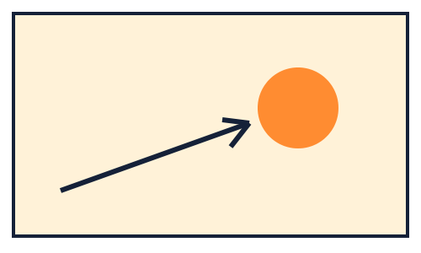  An arrow points to one orange circle, showing a feature that can be identified. | Support the claim  evidence — a detail or reliable record that supports a statement.  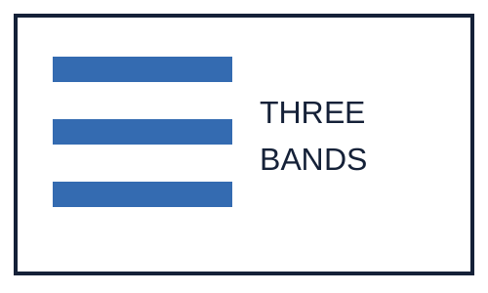  Three blue bands can be counted beside the statement three bands.  THREE · BANDS
Explain a reading  interpretation — a meaning or effect you draw from the work.  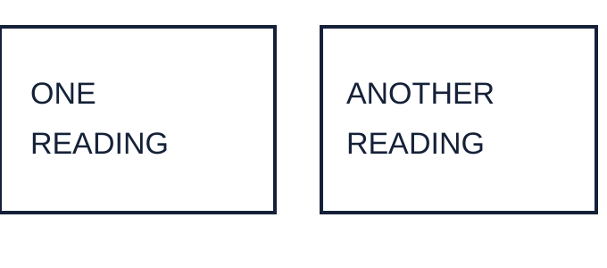  Two outlined comment cards show that one work can have more than one reading.  ONE · READING · ANOTHER | Name the audience  audience — the people who view, hear or experience the work.  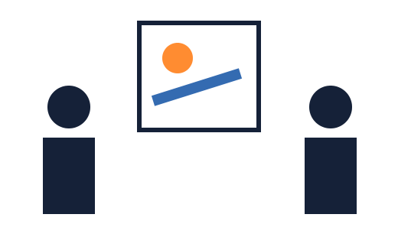  Two simple viewer symbols face a small picture frame.

Today I can… □ I can describe a feature I can check. □ I can explain and qualify my judgement. □ I can recommend a work to an audience, with a reason.

Art · LAUNCH · Autumn 2 · Week 1 · ART-LAUNCH-A2-W01 · Date __________
A review with evidence
Today I can… □ describe a feature I can check. □ explain and qualify my judgement. □ recommend a work to an audience, with a reason.
Feedback: □ VF □ WS □ I □ NS □ E □ R □ [//] □ [?] ______

Word page

Find a feature
feature — a particular part of a work that you can identify.
An arrow points to one orange circle, showing a feature that can be identified.

Support the claim
evidence — a detail or reliable record that supports a statement.
Three blue bands can be counted beside the statement three bands.
THREE · BANDS

Explain a reading
interpretation — a meaning or effect you draw from the work.
Two outlined comment cards show that one work can have more than one reading.
ONE · READING · ANOTHER

Name the audience
audience — the people who view, hear or experience the work.
Two simple viewer symbols face a small picture frame.

Art · LAUNCH · Autumn 2 · Week 1 · ART-LAUNCH-A2-W01 · Date __________
A review with evidence
Today I can… □ describe a feature I can check. □ explain and qualify my judgement. □ recommend a work to an audience, with a reason.
Feedback: □ VF □ WS □ I □ NS □ E □ R □ [//] □ [?] ______

Cards · Artwork A — Flow

Use these cards for the task.

Artwork A — Flow

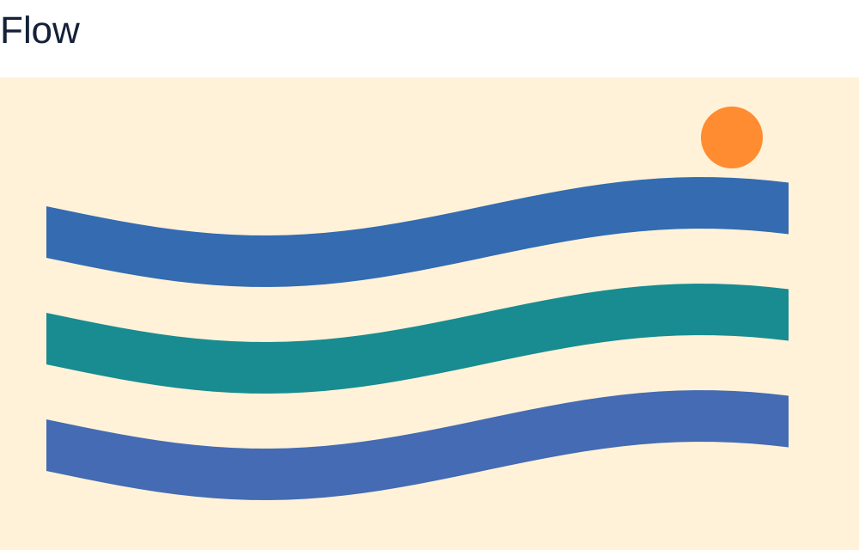
Flow has a pale cream field. Three broad blue and teal curved bands run towards the right with clear pale gaps. A small solid orange circle sits above the bands near the upper right, without touching them.
Flow

Artwork B — Crossing

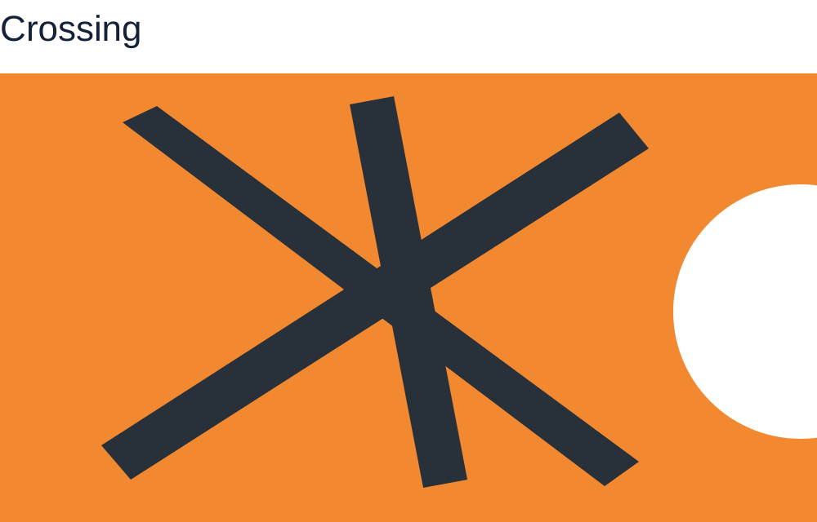
Crossing has an orange field. Three dark charcoal strips have straight edges and cross near the centre. A large white circle is at the right edge, where part of it is cut off by the edge.
Crossing

Art · LAUNCH · Autumn 2 · Week 1 · ART-LAUNCH-A2-W01 · Date __________
A review with evidence
Today I can… □ describe a feature I can check. □ explain and qualify my judgement. □ recommend a work to an audience, with a reason.
Feedback: □ VF □ WS □ I □ NS □ E □ R □ [//] □ [?] ______

Cards · Category card

Use these cards for the task.

Category card
Feature

Category card
Interpretation

Art · LAUNCH · Autumn 2 · Week 1 · ART-LAUNCH-A2-W01 · Date __________
A review with evidence
Today I can… □ describe a feature I can check. □ explain and qualify my judgement. □ recommend a work to an audience, with a reason.
Feedback: □ VF □ WS □ I □ NS □ E □ R □ [//] □ [?] ______

Cards · Category card

Use these cards for the task.

Category card
Recommendation

Category card
Unsupported claim

Art · LAUNCH · Autumn 2 · Week 1 · ART-LAUNCH-A2-W01 · Date __________
A review with evidence
Today I can… □ describe a feature I can check. □ explain and qualify my judgement. □ recommend a work to an audience, with a reason.
Feedback: □ VF □ WS □ I □ NS □ E □ R □ [//] □ [?] ______

Cards · Guided-example sentence card

Use these cards for the task.

Guided-example sentence card
Flow has pale gaps between its bands.

Sentence card 1
Dark diagonal strips overlap in Crossing.

Art · LAUNCH · Autumn 2 · Week 1 · ART-LAUNCH-A2-W01 · Date __________
A review with evidence
Today I can… □ describe a feature I can check. □ explain and qualify my judgement. □ recommend a work to an audience, with a reason.
Feedback: □ VF □ WS □ I □ NS □ E □ R □ [//] □ [?] ______

Cards · Sentence card 2

Use these cards for the task.

Sentence card 2
Their changing directions feel restless to me.

Sentence card 3
I recommend Crossing to viewers who enjoy abstract patterns because the strips create strong changes of direction.

Art · LAUNCH · Autumn 2 · Week 1 · ART-LAUNCH-A2-W01 · Date __________
A review with evidence
Today I can… □ describe a feature I can check. □ explain and qualify my judgement. □ recommend a work to an audience, with a reason.
Feedback: □ VF □ WS □ I □ NS □ E □ R □ [//] □ [?] ______

Cards · Sentence card 4

Use these cards for the task.

Sentence card 4
The maker was definitely angry when making Crossing.

Audience card
Viewers who enjoy abstract images

Art · LAUNCH · Autumn 2 · Week 1 · ART-LAUNCH-A2-W01 · Date __________
A review with evidence
Today I can… □ describe a feature I can check. □ explain and qualify my judgement. □ recommend a work to an audience, with a reason.
Feedback: □ VF □ WS □ I □ NS □ E □ R □ [//] □ [?] ______

Cards · Audience card

Use these cards for the task.

Audience card
Viewers seeking a detailed, lifelike portrait

Guided example record
Category choice __________
Evidence detail __________

Art · LAUNCH · Autumn 2 · Week 1 · ART-LAUNCH-A2-W01 · Date __________
A review with evidence
Today I can… □ describe a feature I can check. □ explain and qualify my judgement. □ recommend a work to an audience, with a reason.
Feedback: □ VF □ WS □ I □ NS □ E □ R □ [//] □ [?] ______

Cards · Review record

Use these cards for the task.

Review record
CLASSROOM PRACTICE
Title __________
Feature → effect → judgement.
Another viewer might ___.
I recommend it to ___ because ___.
My evidence is limited to ___.

feature word card

a particular part of a work that you can identify.
An arrow points to one orange circle, showing a feature that can be identified.

Art · LAUNCH · Autumn 2 · Week 1 · ART-LAUNCH-A2-W01 · Date __________
A review with evidence
Today I can… □ describe a feature I can check. □ explain and qualify my judgement. □ recommend a work to an audience, with a reason.
Feedback: □ VF □ WS □ I □ NS □ E □ R □ [//] □ [?] ______

Cards · evidence word card

Use these cards for the task.

evidence word card

a detail or reliable record that supports a statement.
Three blue bands can be counted beside the statement three bands.
THREE · BANDS

interpretation word card

a meaning or effect you draw from the work.
Two outlined comment cards show that one work can have more than one reading.
ONE · READING · ANOTHER

Art · LAUNCH · Autumn 2 · Week 1 · ART-LAUNCH-A2-W01 · Date __________
A review with evidence
Today I can… □ describe a feature I can check. □ explain and qualify my judgement. □ recommend a work to an audience, with a reason.
Feedback: □ VF □ WS □ I □ NS □ E □ R □ [//] □ [?] ______

Cards · audience word card

Use these cards for the task.

audience word card

the people who view, hear or experience the work.
Two simple viewer symbols face a small picture frame.

Art · LAUNCH · Autumn 2 · Week 1 · ART-LAUNCH-A2-W01 · Date __________
A review with evidence
Today I can… □ describe a feature I can check. □ explain and qualify my judgement. □ recommend a work to an audience, with a reason.
Feedback: □ VF □ WS □ I □ NS □ E □ R □ [//] □ [?] ______

We do · guided record

We do · 8 min · 14 to 22

In your book: The guided example's category and evidence, one sorted card and a revised claim, using words, symbols or an annotation.

Sort the sentence cards
Categories: Feature / Interpretation / Recommendation / Unsupported claim.
One guided example — allow two minutes
Example card: 'Flow has pale gaps between its bands.'
Choose its category. Point to the evidence.
Four shared cards — allow six minutes
Card 1: 'Dark diagonal strips overlap in Crossing.'
Card 2: 'Their changing directions feel restless to me.'
Card 3: 'I recommend Crossing to viewers who enjoy abstract patterns because the strips create strong changes of direction.'
Card 4: 'The maker was definitely angry when making Crossing.'
Choose each card's main job. Then repair Card 4 without claiming to know the maker's feelings.
Record one guided example and one clue.

Art · LAUNCH · Autumn 2 · Week 1 · ART-LAUNCH-A2-W01 · Date __________
A review with evidence
Today I can… □ describe a feature I can check. □ explain and qualify my judgement. □ recommend a work to an audience, with a reason.
Feedback: □ VF □ WS □ I □ NS □ E □ R □ [//] □ [?] ______

STAFF ANSWERS · Arrival | Supported

1. A feature: Orange.
2. A line: Straight; the strips run diagonally.
3. Evidence or opinion: Three bands, in Flow. 'The best art' is a judgement.
4. A listener: People viewing the art.
Use one tier. Keep these answers out of pupil view until after the first response.

Art · LAUNCH · Autumn 2 · Week 1 · ART-LAUNCH-A2-W01 · Date __________
A review with evidence
Today I can… □ describe a feature I can check. □ explain and qualify my judgement. □ recommend a work to an audience, with a reason.
Feedback: □ VF □ WS □ I □ NS □ E □ R □ [//] □ [?] ______

STAFF ANSWERS · Arrival | Standard

1. A feature: For example, a small orange circle above the curved bands towards the upper right. Accept another accurate, specific feature.
2. A comparison: Flow has curved bands; Crossing has straight diagonal strips. A difference must refer to both works.
3. Evidence or opinion: The cropped circle in Crossing can be checked at the right edge. Exciting is an interpretation or judgement that needs a reason.
4. A listener: To explain who might value the work and why, instead of assuming everyone will respond alike.
Use one tier. Keep these answers out of pupil view until after the first response.

Art · LAUNCH · Autumn 2 · Week 1 · ART-LAUNCH-A2-W01 · Date __________
A review with evidence
Today I can… □ describe a feature I can check. □ explain and qualify my judgement. □ recommend a work to an audience, with a reason.
Feedback: □ VF □ WS □ I □ NS □ E □ R □ [//] □ [?] ______

STAFF ANSWERS · Arrival | Stretch

1. A feature: For example, the orange circle contrasts with the blue bands, so it could draw attention. Accept a different plausible effect supported by an accurate feature.
2. A comparison: Curved bands may suggest flow or a gentle movement; crossing diagonals may suggest tension or a strong structure. Require a feature from each work; interpretations may differ.
3. A limit: No. The shapes may support a viewer's interpretation of tension, but do not prove the maker's emotional state or intention. A reliable account from the maker could add relevant context.
4. A listener: It assumes universal taste and gives no reason. Name a relevant audience and connect the recommendation to a feature or experience.
Use one tier. Keep these answers out of pupil view until after the first response.

Art · LAUNCH · Autumn 2 · Week 1 · ART-LAUNCH-A2-W01 · Date __________
A review with evidence
Today I can… □ describe a feature I can check. □ explain and qualify my judgement. □ recommend a work to an audience, with a reason.
Feedback: □ VF □ WS □ I □ NS □ E □ R □ [//] □ [?] ______

STAFF ANSWERS · Exit ticket | Supported

1. Feature: Accept any accurately located feature in the chosen work, consistent with the review.
2. Judgement: A possible effect or interpretation; it is not a colour. It needs a feature as support.
3. Audience: Accept a fitting audience and feature-based reason, such as abstract-image viewers comparing its shapes. No single audience is compulsory if the reasoning fits.
Use one tier. Keep these answers out of pupil view until after the first response.

Art · LAUNCH · Autumn 2 · Week 1 · ART-LAUNCH-A2-W01 · Date __________
A review with evidence
Today I can… □ describe a feature I can check. □ explain and qualify my judgement. □ recommend a work to an audience, with a reason.
Feedback: □ VF □ WS □ I □ NS □ E □ R □ [//] □ [?] ______

STAFF ANSWERS · Exit ticket | Standard

1. Evidence: Require an accurate feature and a clear link to the judgement, in any response mode.
2. Qualification: Accept a plausible alternative or real scope limit, such as reviewing only one image and not knowing the maker's intention. Do not require an invented negative comment.
3. Audience: A specific audience linked to an artistic feature or experience. Unsupported 'everyone' is insufficient without qualification.
Use one tier. Keep these answers out of pupil view until after the first response.

Art · LAUNCH · Autumn 2 · Week 1 · ART-LAUNCH-A2-W01 · Date __________
A review with evidence
Today I can… □ describe a feature I can check. □ explain and qualify my judgement. □ recommend a work to an audience, with a reason.
Feedback: □ VF □ WS □ I □ NS □ E □ R □ [//] □ [?] ______

STAFF ANSWERS · Exit ticket | Stretch

1. Evidence: The named feature can be located and its link to a judgement discussed; 'good' alone gives neither evidence nor a criterion.
2. Qualification: A supported interpretation does not establish intention. Reliable contextual evidence would be needed; even then the review should distinguish the source from the viewer's judgement.
3. Audience: Accept a fair limit linked to the viewer's interest, for example that someone seeking realistic portraits may find less of that here while still valuing the colour or form. Do not assume a whole group's taste.
Use one tier. Keep these answers out of pupil view until after the first response.

Art · LAUNCH · Autumn 2 · Week 1 · ART-LAUNCH-A2-W01 · Date __________
A review with evidence
Today I can… □ describe a feature I can check. □ explain and qualify my judgement. □ recommend a work to an audience, with a reason.
Feedback: □ VF □ WS □ I □ NS □ E □ R □ [//] □ [?] ______

STAFF ANSWERS · teaching and routes

Starter: B names the circle and bands and links their contrasting colours to the reviewer's attention. A is a possible opinion, but it supplies no evidence and assumes that all viewers agree. A confident voice alone does not strengthen evidence.
We do: Feature. The pale gaps can be located directly. Model one check against the image, then return the next choice to pupils.
We do: 1 Feature; 2 Interpretation; 3 Recommendation, supported by a feature; 4 Unsupported claim. A valid repair is 'Crossing feels tense to me because the dark strips cross in different directions.' A pupil may prefer 'structured' or another interpretation with visible support. Do not judge pupils' taste or demand agreement.
You do · Independent: Look for two accurate features, a supported judgement, a plausible qualification and an audience reason. For example, a review of Crossing may link its overlapping diagonal strips and cropped circle to movement, acknowledge that another viewer sees a stable structure, and recommend it to viewers interested in abstract composition. An equally supported different judgement is valid. Do not accept a definite claim about the maker's mental state without evidence. Record the pupil's checked meaning, not copied model wording.
You do · Supported: Flow's fitting cues are curved bands and small orange circle; Crossing's are overlapping diagonal strips and cropped white circle. Effects have no fixed answer: require a plausible link to the selected visible detail. Abstract-image viewers are a directly justified audience for these examples; another recommendation may be accepted if the pupil explains the fit or limitation honestly. 'Another viewer might see the straight strips as a strong structure' is one valid qualification. The pupil retains ownership of the review when assisted with recording.
You do · Choice: Curved blue bands match Flow; overlapping dark diagonal strips match Crossing. Accept a reasoned effect rather than prescribing taste. 'This is my reading' correctly qualifies the interpretation. An audience choice needs a reason: these works offer abstract forms rather than a lifelike portrait. A card choice alone is not a complete review; invite the feature-to-effect link and audience reason in any mode, with the option to pass. Keep the original choice and note any adult scaffold.

Art · LAUNCH · Autumn 2 · Week 1 · ART-LAUNCH-A2-W01 · Date __________
A review with evidence
Today I can… □ describe a feature I can check. □ explain and qualify my judgement. □ recommend a work to an audience, with a reason.
Feedback: □ VF □ WS □ I □ NS □ E □ R □ [//] □ [?] ______

STAFF ANSWERS · teaching and routes

You do · Aspire: Accept an evidence-led comparison, not a prescribed favourite. A strong response could compare the repeated curves and pale spaces in Flow with Crossing's overlapping diagonals, evaluate movement versus structure as readings of Crossing, and explain that a larger image or reliable context from the maker might alter its judgement. The recommendation must explain audience fit. Require a fair account of the competing view; inventing a fault or claiming universal taste does not meet the aim. A signed, annotated or scribed review can show the same reasoning.
Staff: mark I, S or C beside the You do response for actual independence, support or choice.

Art · LAUNCH · Autumn 2 · Week 1 · ART-LAUNCH-A2-W01 · Date __________
A review with evidence
Today I can… □ describe a feature I can check. □ explain and qualify my judgement. □ recommend a work to an audience, with a reason.
Feedback: □ VF □ WS □ I □ NS □ E □ R □ [//] □ [?] ______

TA brief

They are constructed classroom examples, not historical artworks or evidence of attendance at an arts event. Label this lesson's mini-gallery review CLASSROOM PRACTICE. Keep any genuine experience record separate; this lesson does not complete or sign off Unit 1.
Read one prompt at a time. Every task can be answered by pointing, speaking, signing, using symbols, drawing or writing. A pupil may pass. No cold calling or required public reading. Allow thinking time, then invite all pupils to show a choice together. An adult can move cards or scribe the pupil's exact words. Do not substitute an adult's interpretation for the pupil's. A pass needs no book entry.
Use one Arrival tier and one Exit tier for each pupil, not all three. Keep Answer (adult) lines out of pupil view until after responses. Offer one You do route; the four routes are alternatives. Keep the artworks visible and invite evidence-based disagreement. Personal taste is not marked right or wrong. No personal story, belief, family detail or loss is requested.
Preparation — complete teaching-artwork cues
Prepare two plain rectangular images before the lesson. Show both throughout. No names, logos or branding appear on them. These descriptions are the specification for the classroom examples. Do not substitute a different image; keep these answer keys.
Artwork A, title Flow: a pale cream field; three broad blue and teal curved bands running from left towards right, with clear pale gaps; one small solid orange circle above the bands towards the upper right. The circle does not touch a band. Leave open pale space around the forms. No people, letters or objects are depicted.
Artwork B, title Crossing: an orange field; three dark charcoal diagonal strips crossing and overlapping near the centre; a large white circle at the right edge with part of the circle beyond the image, so it is cropped. The strips have straight edges. No people or letters are depicted.

Art · LAUNCH · Autumn 2 · Week 1 · ART-LAUNCH-A2-W01 · Date __________
A review with evidence
Today I can… □ describe a feature I can check. □ explain and qualify my judgement. □ recommend a work to an audience, with a reason.
Feedback: □ VF □ WS □ I □ NS □ E □ R □ [//] □ [?] ______

TA brief

Prepare four category cards: Feature / Interpretation / Recommendation / Unsupported claim. Prepare the four sentence cards printed in We do. Provide two plain audience cards: Viewers who enjoy abstract images / Viewers seeking a detailed, lifelike portrait. Read all cards aloud. Offer large, high-contrast copies and a spoken description of each artwork. If a pupil uses the description, note that access route; do not treat visual acuity as reviewing skill. Make a private adult-listener option available.
Adult-only note: Possible EHCP outcome areas are communication and interaction (expressing and checking meaning), cognition and learning (selecting evidence and organising an explanation), and independence (choosing a response mode and checking one claim). Observe only the relevant individual outcome actually shown; do not infer progress in every area from a finished review.
Adult-only note: Regulation strategy — agree a quiet pause signal at the start; keep the pupil's selected image and first step ready for a calm return within task time.
Same-day evidence — ART-LAUNCH-A2-W01: the assigned adult records the chosen artwork, the pupil's exact review or selected/annotated evidence, the response mode and actual support. File one book item, a before-and-after photograph of the upgraded claim or brief observation in the evidence app the same day under ART-LAUNCH-A2-W01. Record how the listener received and checked the pupil's meaning. A photograph alone does not establish the reasoning. Use no pupil, staff or school names in this teaching document.
1. Prepare the exact two constructed artwork cues, category cards and sentence cards. Keep practice and genuine event records separate; this lesson makes no Unit 1 completion claim.
2. Read one prompt at a time. Offer point, speech, sign, symbols, drawing or writing, private sharing and pass. Never select an unwilling pupil to perform or read aloud.
3. Separate feature, interpretation and evidence about intention. Accept a different supported view; do not reward certainty or agreement with the adult.

Art · LAUNCH · Autumn 2 · Week 1 · ART-LAUNCH-A2-W01 · Date __________
A review with evidence
Today I can… □ describe a feature I can check. □ explain and qualify my judgement. □ recommend a work to an audience, with a reason.
Feedback: □ VF □ WS □ I □ NS □ E □ R □ [//] □ [?] ______

TA brief

4. Offer one You do route. Record the actual prompt and pupil decision. Check one claim against the work and let the pupil confirm the listener's account.
5. Use the agreed pause signal and quiet return step. File a concise record in the evidence app the same day under ART-LAUNCH-A2-W01 showing the review evidence, audience exchange and support used.
Arrival · 5 minutes
Adult note: Display Flow and Crossing with their titles. Read the preparation descriptions if needed. Accept a point or selection as evidence of a feature; ask for the extra reason only where the selected tier asks for it. Invite four short responses. Do not require any earlier review or event attendance. The two artworks and their descriptions are supplied clues, not a test of prior learning.
Starter · 3 minutes
Adult note: Read both once. All pupils decide privately before anyone shares. A pupil may pass or ask for the choices again. The adult points only where the pupil directs, without locating the evidence for them.
I do · 6 minutes
Adult note: Model a short practice review using the visible Flow image. Point as you speak. Allow a quiet check after each step. Pupils can point, speak, sign, use symbols, draw or write to signal agreement, a question or a different reading; they may pass. Do not require them to copy the model.
Adult note: Explain contrast here as a noticeable difference. The feature is visible; calm is one reading, not an agreed fact about the work.
Adult note: A fair review need not invent a bad point. It can acknowledge another reading, an audience need or a real limit in the evidence.
We do · 8 minutes
Adult note: Give each pupil the four category choices or symbols. For each card, read it, allow a private decision, then invite every pupil to show a category together. No cold calling; pass is allowed. A volunteer or adult moves the shared card only after these decisions. A sentence can serve more than one purpose; accept a reasoned classification while naming its main job here.

Art · LAUNCH · Autumn 2 · Week 1 · ART-LAUNCH-A2-W01 · Date __________
A review with evidence
Today I can… □ describe a feature I can check. □ explain and qualify my judgement. □ recommend a work to an audience, with a reason.
Feedback: □ VF □ WS □ I □ NS □ E □ R □ [//] □ [?] ______

TA brief

Reserved guided-example space: [Leave space here for one category choice and one pointed, drawn, selected or written evidence detail.]
You do · 15 minutes
Adult note: All work here is CLASSROOM PRACTICE, using the fully specified mini-gallery. Allow two minutes to select evidence, nine to compose, two to check a claim and two to review it with an adult. These are inside the stage, not extra stages. Keep both works visible. A private spoken, signed, symbol or drawn review can carry the same reasoning as a written one; the adult records only the pupil's own meaning. No electronic recording is required.
Adult note: The listener names back one judgement and its evidence. The pupil confirms or corrects that account, then chooses one small revision or explains why the evidence already supports the claim. Mark an actual self-edit // where useful. A next-step response must be genuine, not an automatic completion tick. Give a brief written note against the review criteria (two accurate features, a supported judgement, a qualification, an audience reason) and name the improvement. The pupil upgrades the checked claim in green pen (or by the same response mode). If a longer written review is made, its response is deferred to the first 10 to 15 minutes of the next lesson.
Staff mark actual support I, S or C (Independent, Supported or Choice); record support accurately for Aspire too.
Exit ticket · 3 minutes
Adult note: Use one tier. Keep the artworks visible. Invite three brief checks, with no cold calling and the option to pass. A pupil may point, speak, sign, use symbols, draw or write. The adult notes the reason expressed, not the length of writing. Use the review already made as the evidence; do not set a new long review.

Art · LAUNCH · Autumn 2 · Week 1 · ART-LAUNCH-A2-W01 · Date __________
A review with evidence
Today I can… □ describe a feature I can check. □ explain and qualify my judgement. □ recommend a work to an audience, with a reason.
Feedback: □ VF □ WS □ I □ NS □ E □ R □ [//] □ [?] ______

TA brief · feedback and prompt ladder

Prompt ladder for adults
1. Point to the relevant place / instruction.
2. Ask one short question: "What is it asking you to find?"
3. Rephrase the instruction in simpler language.
4. Provide a scaffold or limited choice.
5. Model the first step only, then return the task to the pupil.
No cold calling; nobody is asked to read difficult text aloud.
Space: allow quiet thinking and a private response.
Feedback [VF] [NS]: give verbal feedback and brief written feedback against the review criteria.
Voice [//]: retain the pupil’s artwork, review and reflection.
Audience: engage with the review against the criteria; give one next step, and listen to any clip in full before tagging; mark [R] only after receipt.
Influence [NS]: use the portfolio review to select the next evidence step.
Use [WS] for supported work and [I] for independent work. Use [?] to invite a read-back and [//] for a self-edit.
Evidence [E] · ART-LAUNCH-A2-W01: the assigned adult uploads the selected book item, artwork photo with its observation, or exact response to the evidence app the same day, labelled ART-LAUNCH-A2-W01. Capture is not closure; a photo alone does not establish understanding.
Staff: mark I, S or C beside the You do response for actual independence, support or choice.

