Picture step card
Design and Technology LAUNCH Spring 1 Week 2 Thursday 14 January 2027 P1 Year A
Use your checked Week 1 plan. The adult gives GO before ingredients or tools are issued. Follow the actual approved quantities and any agreed substitution.
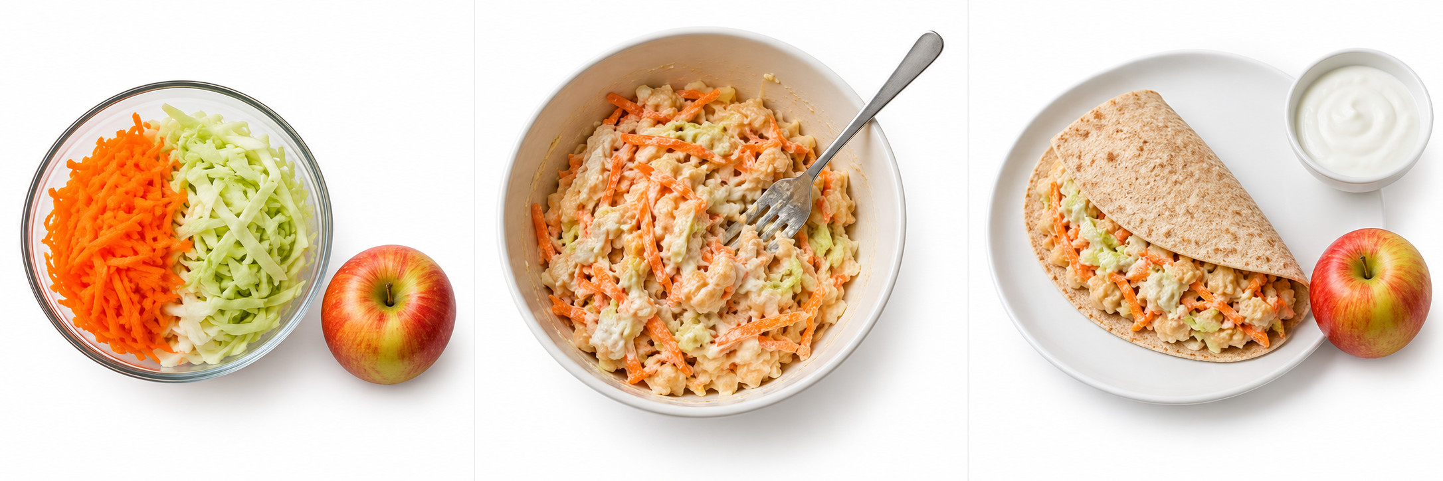
Original invented teaching pictures. Read left to right: prepare, mix, assemble. These are not pupil work or an exact guide to quantities.

1 Prepare
After the adult’s checks, wash hands with soap and water and dry them. Wash the carrot, cabbage and apple. Grate the carrot and finely slice the cabbage with adult-approved tools and supervision. Use prepared vegetables if agreed.

2 Mix
Mash 80 g of cooked beans labelled ready to eat with a fork. Mix in about 20 g from the single 60 g yoghurt portion. Add the carrot and cabbage. An adult opens tins and removes sharp lids.

3 Assemble
Put the filling on the wholemeal wrap and fold it. Serve with the apple and the remaining yoghurt. Ask the adult to check the plate and store or serve it safely. Tasting is optional.

Ingredients and the agreed method
Design and Technology LAUNCH Spring 1 Week 2 Thursday 14 January 2027 P1 Year A
Cold bean and vegetable wrap with fruit and plain yoghurt
Model ingredient | Amount for one person
Wholemeal wrap | 1 wrap
Ready-to-eat cooked beans | 80 g drained
Carrot | 60 g
Cabbage | 40 g
Plain yoghurt | 60 g
Apple | 1 small

These are the Week 1 model quantities for one person. Use the pupil’s actual approved plan and any checked substitution. Individual needs and appetite vary. One 60 g yoghurt portion is split: about 20 g in the filling and 40 g alongside.

Check the actual plan
Read the dish, ingredients, amounts and changes from the pupil’s own Week 1 plan. Keep it beside the station. A different ingredient or tool needs the adult’s approval first. Check every actual label against current individual records.

Tool and food choices
Only cooked beans labelled ready to eat go into this cold dish. Dry or merely soaked beans need a different cooking process. An adult opens tins and removes sharp lids. The adult demonstrates and supervises any knife or grater use. Offer prepared vegetables or pupil-directed adult handling.

Finishing safely
Put tools down at the stop point. Ask for the adult’s serving, storage or disposal decision. Follow the cleaning routine. Tasting is optional. An unfinished dish is recorded honestly.

If there is no kitchen
Use the checked cold assembly route. If clean handwashing, preparation, label checks or chilling cannot be approved, simulate and keep practical competence pending.

