CV practice cards
Read or ask an adult to read. Staff may cut on the table lines.
Cards | Cards
A  The role needs careful sorting. A learner sorted class kit by label. | B  A draft says: I am amazing at all jobs.
C  A learner helped set out chairs with a partner. | D  The date of an activity is not known.
E  An adult wrote the whole draft and the learner has not checked it. | F  The draft lists a completed award that is still in progress.
What fact matters? What help or safer step would fit?

Practice role and draft guide
MADE-UP VACANCY: stockroom assistant.
Tasks: read labels, sort light items, follow a list and ask if unsure.
Skills: careful checking, teamwork and clear questions.
No employer, vacancy, interview or job offer is real.
For your CV: role or goal; short profile; skills and true examples; learning; experience.
Use class or voluntary tasks if relevant. Mark missing dates or award status to check.

Words I can use
I would like to learn or work in __.
I can __. For example, I __.
The help I used was __.
I changed __ because __.

Help card
Please help me with this step.
I can point to what I mean.
Please read the words or show the step.
I can ask for a pause or private talk.

A visual guide
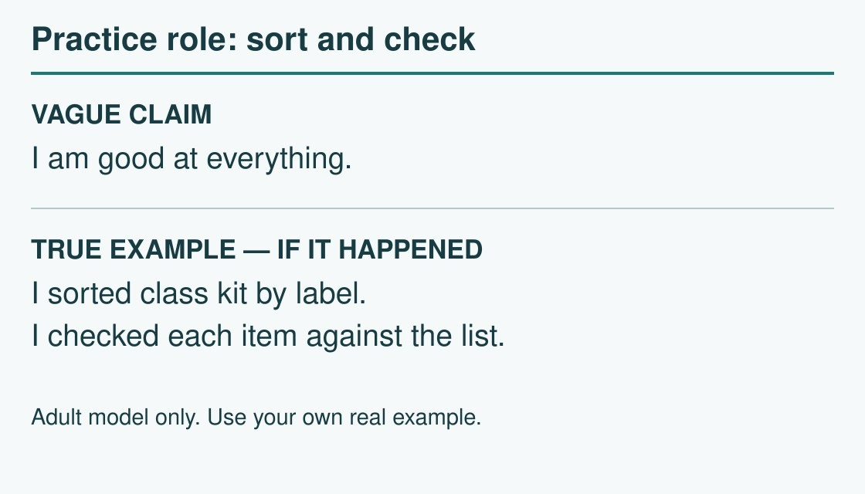
Role need → true example → clearer CV line.
The diagram is an example, not a record of your work. Use a fictional case or speak privately to staff. No personal details need to be shown to the group.
I notice __.
The next step is __.
I can ask __ for help.

