Application practice cards
Read or ask an adult to read. Staff may cut on the table lines.
Cards | Cards
A  A form asks why this role interests you. The answer lists only a favourite meal. | B  The form asks for teamwork. The learner describes their part in a real class task.
C  A box asks for a course result that is not yet confirmed. | D  The form says use short answers. A long response does not address the task.
E  The applicant cannot confirm whether a proposed time is possible. | F  All boxes contain words, but one example was copied from the adult model.
What fact matters? What help or safer step would fit?

Practice vacancy and form rules
MADE-UP VACANCY: stockroom assistant. Reference: PRACTICE-01.
Tasks: read labels, sort light items, follow a list and ask if unsure.
Skills: careful checking, teamwork and clear questions.
Instructions: give short, truthful answers; use a real example; mark facts to check.
No job, employer or offer is real. Do not sign, upload or send this practice form.
If the CV is missing, record that and use a true task example that can be checked.

Words I can use
The question asks me to __.
My example is __. My part was __.
This fits the role because __.
I need help to check __.

Help card
Please help me with this step.
I can point to what I mean.
Please read the words or show the step.
I can ask for a pause or private talk.

A visual guide
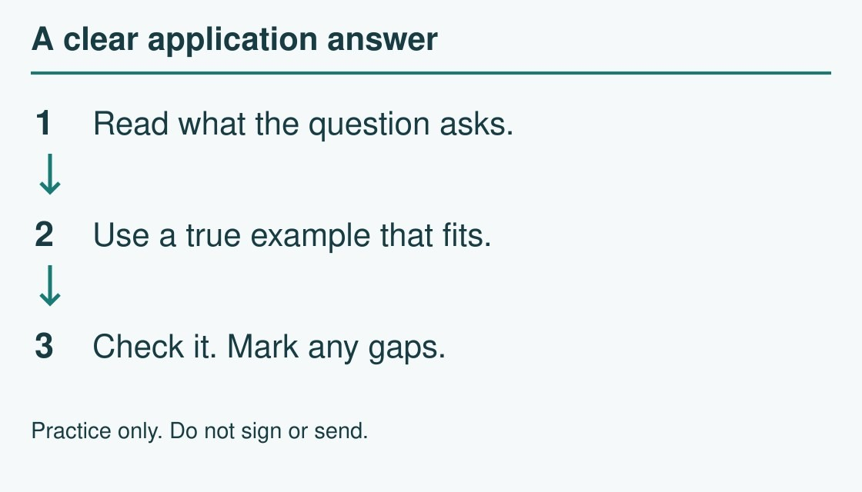
Read the question → use a true example → check.
The diagram is an example, not a record of your work. Use a fictional case or speak privately to staff. No personal details need to be shown to the group.
I notice __.
The next step is __.
I can ask __ for help.

