Digital footprint practice cards
Read or ask an adult to read. Staff may cut on the table lines.
Cards | Cards
A  A photo shows a finished craft and a name badge on the table. | B  A draft gives a home address so people can collect a project.
C  A post shows another person’s work. They have not agreed to share it. | D  A post says: I learnt to sort kit by label. It shows only the writer’s own work.
E  A post is for friends only. One friend makes a copy. | F  A message asks for a password to help improve a job profile.
What fact matters? What help or safer step would fit?

A made-up profile review
All cards are made up. They are not real posts or profiles.
Start with cards A, D and E. Choose keep after checks, edit, or do not share.
Say what detail matters and who might see it.
Draft one safer post about a task or piece of work. Do not post it.
Check the background of a photo as well as its main subject.
If a case causes worry, ask for a private talk. You do not have to share your own story.

Words I can use
I would __ because __.
The detail I would leave out is __.
The intended audience is __.
Before sharing, I would check __.

Help card
Please help me with this step.
I can point to what I mean.
Please read the words or show the step.
I can ask for a pause or private talk.

A visual guide
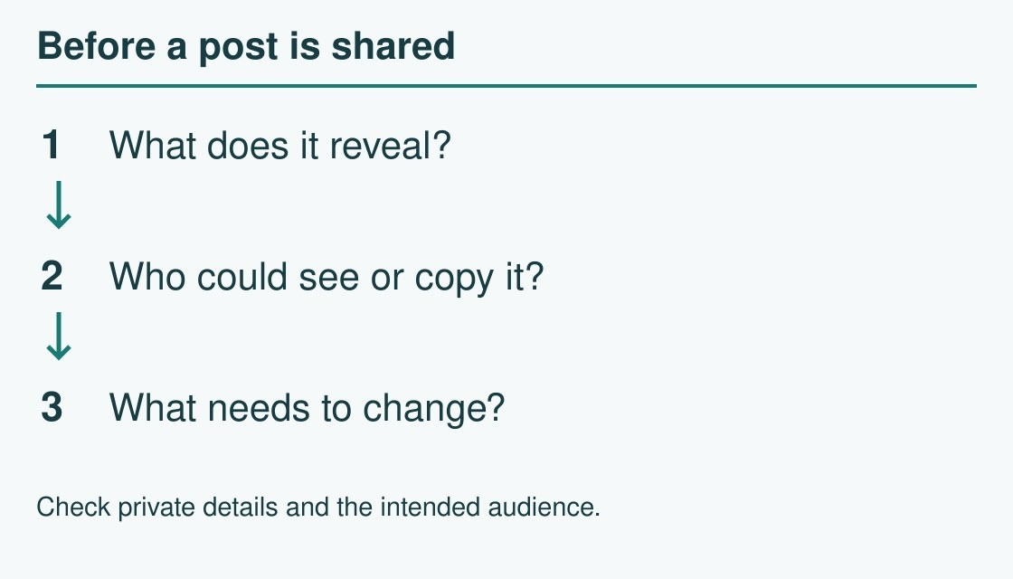
Check the detail, the audience and the next step.
The diagram is an example, not a record of your work. Use a fictional case or speak privately to staff. No personal details need to be shown to the group.
I notice __.
The next step is __.
I can ask __ for help.

