Mock interview practice cards
Read or ask an adult to read. Staff may cut on the table lines.
Cards | Cards
A  A question is unclear. The learner asks for it to be explained. | B  An answer says: I am good at all jobs. It gives no example.
C  A learner describes how they checked class kit against a list. | D  Feedback says: Add what you did next. The learner tries the answer again.
E  A learner uses their usual aid and takes time to respond. | F  A question asks about a task the learner has never done.
What fact matters? What help or safer step would fit?

Role brief questions and feedback
MADE-UP ROLE: stockroom assistant. No employer or job offer is real.
Tasks: read labels, sort light items, follow a list and ask if unsure.
Question 1: What interests you about this role, or why might it not fit?
Question 2: Tell me about a time you checked work or worked with someone. What was your part?
Question 3: What would you ask if a task or instruction was unclear?
Take turns only if you choose. An adult can ask one question in a quiet space. Use your usual support.

Words I can use
My task was __. I did __. Then __.
Please repeat or explain the question.
One clear part of your answer was __.
Please add __. My new answer is __.

Help card
Please help me with this step.
I can point to what I mean.
Please read the words or show the step.
I can ask for a pause or private talk.

A visual guide
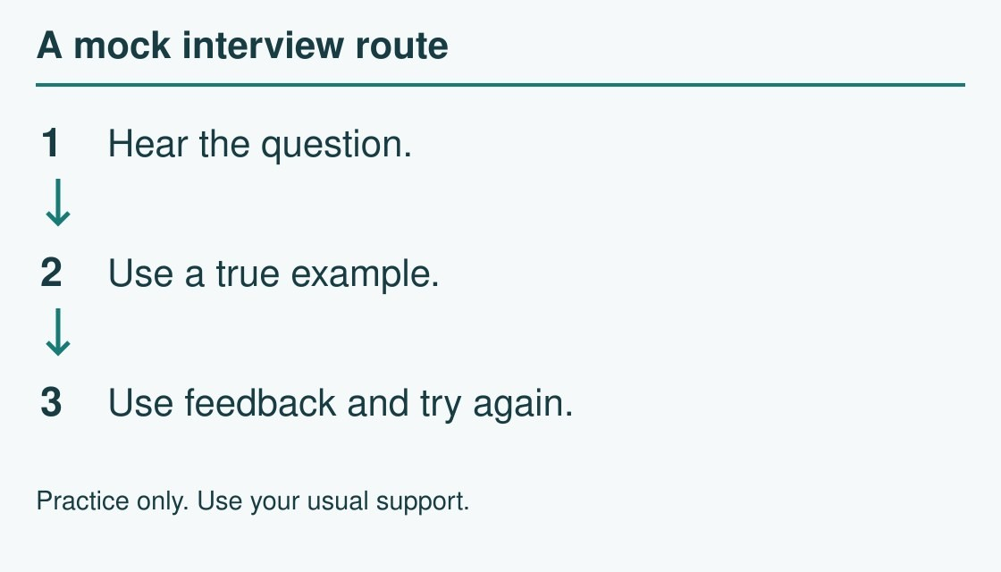
Hear the question → use a true example → try again.
The diagram is an example, not a record of your work. Use a fictional case or speak privately to staff. No personal details need to be shown to the group.
I notice __.
The next step is __.
I can ask __ for help.

