Portfolio check cards
All cases are made up. Read or ask an adult to read.
Cards | Cards
A  An index lists an application that is missing. | B  Two CV drafts are present with no version labels.
C  A claim says: I check kit. A work example shows the check. | D  An adult model is listed as the learner’s application.
E  A page carries a real contact detail. | F  A learner has no interview record from Week 4.
What fact matters? What help or next step fits?

Portfolio guide and blank starters
Five-item check
CV; application; fictional-post review; practice interview record; enquiry draft. This is a teaching list, not a qualification file limit.
Index columns
Item | file or page reference | actual date/version | ready, draft or missing | next step.
If work is missing
Mark it missing. Ask staff to help you find it. If you start new work, use today’s real date. Do not claim that old work exists.
CV starter
Learner ID. Role I am exploring. One skill. A true task that shows it. What I did. One next step. Keep private details out.
Application starter
MADE-UP ROLE: stockroom assistant. Tasks: read labels, sort light items, check a short list and ask if unsure. This is classroom practice. No employer, vacancy or offer is real. Say why the role could fit, give one true example and name one thing you would ask about. This is an unfinished starter until the learner adds their own response.
Check together
Is this my work? Can I find it? Is the claim true? What help did I use? What is missing?

A visual guide
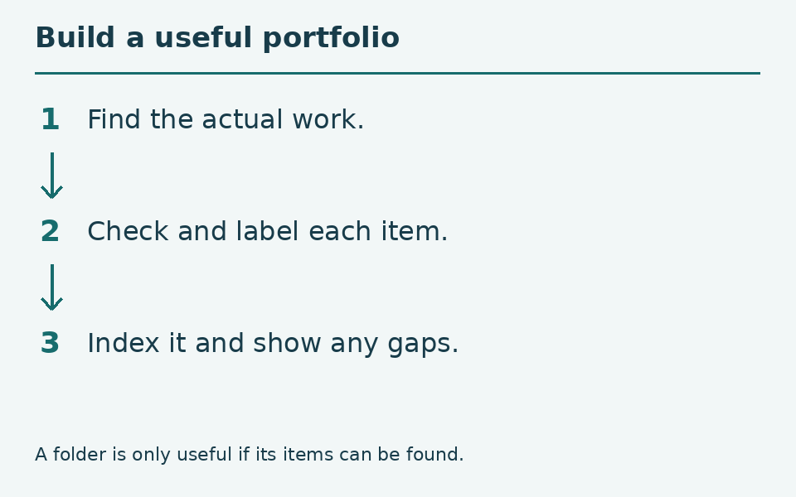
Actual work → clear label → honest index.
The diagram is a guide, not a record of your work. You can ask for a pause or private help.
Help card
Please read the words or show the step.
I can point to what I mean.
Please give me time to think.
I can ask for a pause or private talk.

