Assessment check cards
All cases are made up. Read or ask an adult to read.
Cards | Cards
A  A learner shows a CV and points to a true task. | B  The application is still missing.
C  A learner answers using a usual communication aid. | D  An adult supplies the reason in an interview answer.
E  A learner changes an answer after feedback. | F  The index is complete but no work can be opened.
What fact matters? What help or next step fits?

Role brief and interview questions
Assessment role
MADE-UP ROLE: stockroom assistant. Tasks: read labels, sort light items, check a short list and ask if unsure. This is classroom practice. No employer, vacancy or offer is real.
Question 1
Show one part of your CV or application. What skill does it show?
Question 2
Tell me about a true task where you checked work or worked with someone. What was your part?
Question 3
If an instruction in this role were unclear, what would you do or ask?
Access
Ask for the question to be read or explained. Point, speak, write or use your usual aid. Take a pause if needed. The adult records the help used.
Optional follow-up
How might you change one part of your application for a different role? This extends the task; it is not a requirement for every learner.

A visual guide
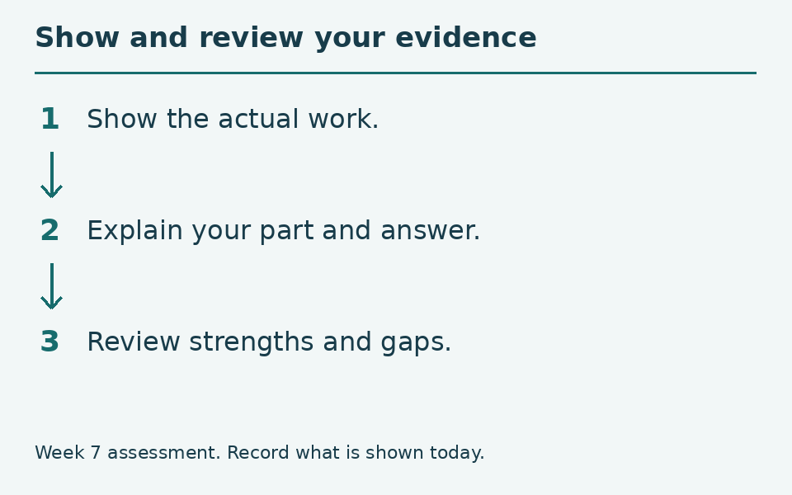
Show what you can do. Keep the record honest.
The diagram is a guide, not a record of your work. You can ask for a pause or private help.
Help card
Please read the words or show the step.
I can point to what I mean.
Please give me time to think.
I can ask for a pause or private talk.

