Facts and safer choice cards
Read or ask an adult to read. Staff may cut on the table lines.
Cards | Cards
A  A friend offers an unknown tablet and says it is safe. | B  A learner has medicine prescribed for them and is unsure about the instructions.
C  Someone says alcohol cannot affect balance or decisions. | D  A person plans to mix alcohol with another drug.
E  Friends pressure Kai to drink. Kai wants to leave with a trusted adult. | F  After taking a substance, a person is unconscious and will not wake.
What fact matters? What help or safer step would fit?

Facts to keep in mind
A drug can affect the body or brain.
Medicines can help when used as directed.
Alcohol can affect balance and decisions.
Mixing alcohol with other drugs can increase harm.
Looks cannot prove what a pill contains.
Someone who will not wake needs 999 help now.

Words I can use
No, I do not want that.
I am going to ask __ for help.
Please check these instructions with me.
The fact is __, so a safer choice is __.

Help card
Please help me with this step.
I can point to what I mean.
Please read the words or show the step.
I can ask for a pause or private talk.

A visual guide
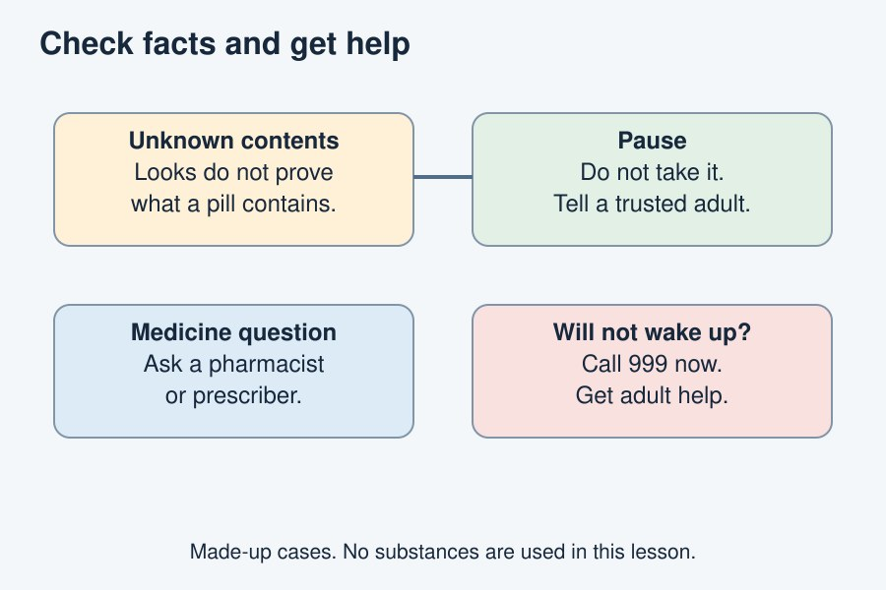
Use facts, avoid pressure and seek help early.
The diagram is an example, not a record of your work. Use a fictional case or speak privately to staff. No personal details need to be shown to the group.
I notice __.
The next step is __.
I can ask __ for help.

