Belonging and respect cards
Read or ask an adult to read. Staff may cut on the table lines.
Cards | Cards
A  A meeting takes spoken ideas only. Jo wants to write an idea. | B  A notice is hard to read. Lee asks for clear words and pictures.
C  A group laughs at someone’s different belief. | D  Two people want different quiet activities for a shared space.
E  A person is left out because the usual equipment is hard for them to use. | F  Someone says people who break rules no longer have rights.
What fact matters? What help or safer step would fit?

Human Rights Day: 10 December
Human rights belong to everyone.
People deserve dignity and respect.
Listen to the person affected by a barrier.
Offer different ways to take part.
Explain decisions and review whether a change helps.

Words I can use
The barrier is __.
I suggest __ because __.
What would help you?
After hearing your view, I would __.

Help card
Please help me with this step.
I can point to what I mean.
Please read the words or show the step.
I can ask for a pause or private talk.

A visual guide
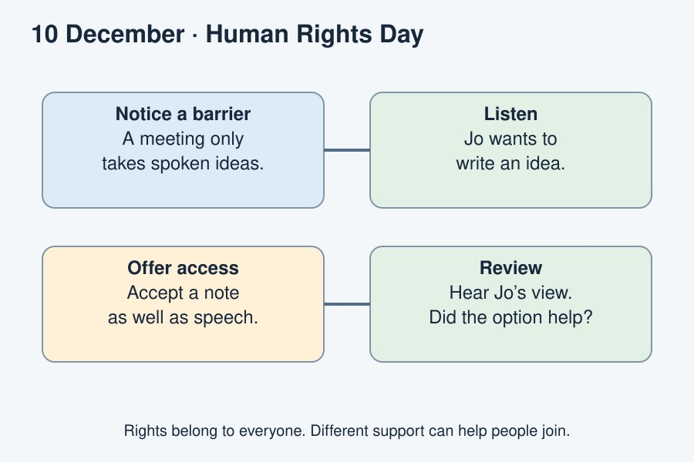
Human Rights Day: 10 December. Listen, include and review.
The diagram is an example, not a record of your work. Use a fictional case or speak privately to staff. No personal details need to be shown to the group.
I notice __.
The next step is __.
I can ask __ for help.

