Visual step cards
Autumn 2 · Week 2 · Lesson 2 · Wednesday 11 November 2026
I can keep my part with another part and use feedback to improve.
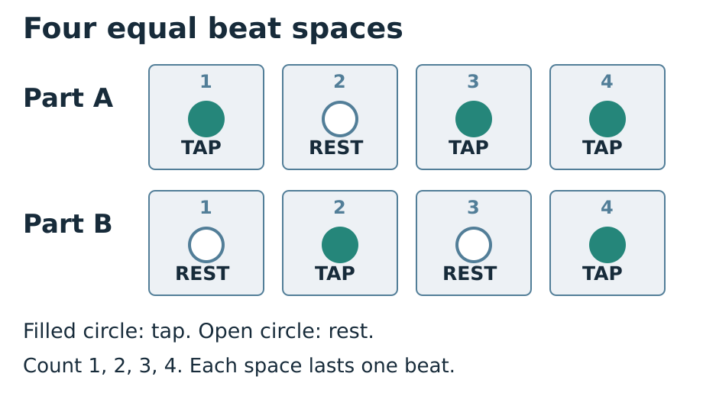
1. Recall: Read A or B. Point to your taps and rests.
2. Join: Wait for the count-in. Play your part with the other part.
3. Listen: Ask what stayed together and what needs care.
4. Retry: Use one next step. Try again and compare the result.
You can tap softly, point, sign, speak, draw or write. Ask for a pause or a quiet space. Follow the stop cue.

Words for our group piece
Autumn 2 · Week 2 · Lesson 2 · Wednesday 11 November 2026

pulse
The even beats shared by both parts.

rehearse
Practise a part so it becomes more secure.

cue
A clear signal that tells us when to act.

feedback
A useful comment about what happened and what to try.

Words for my record
My part had taps on ___.
________________________________________________________________
We shared the pulse by ___.
________________________________________________________________
The listener noticed ___.
________________________________________________________________
Picture colours: navy headings; blue outlines and beat numbers; teal TAP circles; white REST circles and paper; grey beat spaces; red STOP reminder. Logo: navy background, mint green ring, cream M, amber star, black corners. Words, numbers and shapes give the meaning.

Knowledge organiser
Autumn 2 · Week 2 · Lesson 2 · Wednesday 11 November 2026
I can keep my part with another part and use feedback to improve.
I can enter after the shared count-in.
I can keep my part while a different part plays.
I can use one comment and show the effect on another try.
pulse — The even beats shared by both parts.
rehearse — Practise a part so it becomes more secure.
cue — A clear signal that tells us when to act.
feedback — A useful comment about what happened and what to try.
Count every rest for one full beat. Watch the count-in and stop signal.
Picture colours: navy headings; blue outlines and beat numbers; teal TAP circles; white REST circles and paper; grey beat spaces; red STOP reminder. Logo: navy background, mint green ring, cream M, amber star, black corners. Words, numbers and shapes give the meaning.
My record: A_Take_Part.pdf · page 2 · Week 2 group practice and response

Two parts, one pulse
Autumn 2 · Week 2 · Lesson 2 · Wednesday 11 November 2026
Keep your own score visible. The two patterns fit the same four beats.
A: 1 TAP · 2 REST · 3 TAP · 4 TAP.
B: 1 REST · 2 TAP · 3 REST · 4 TAP.
Both tap on 4. Use this to check that the parts line up.
Lost your place? Follow silently. Rejoin on the next 1 cue.
My check or next step
________________________________________________________________
________________________________________________________________

Supported route
Autumn 2 · Week 2 · Lesson 2 · Wednesday 11 November 2026

Recall
Show part A softly or silently from last time.
Where is its rest, and how long does it last?

In your book
1. Choose A or B and point to it with an adult.
2. Rehearse your own part once with the other part silent.
3. Wait for the count-in and join for two repeats.
4. Use a silent pointer or next-beat-1 cue if you lose your place.
5. Choose one helpful comment, respond and try again.
My words or sketch
________________________________________________________________
________________________________________________________________
________________________________________________________________

Check before you finish
Which part did you keep, and where were its rests?
How could you rejoin after losing your place?
What did the feedback help you change or check?
You can tap softly, point, sign, speak, draw or write. Ask for a pause or a quiet space. Follow the stop cue.
Prompt used __________ Support given __________________

Independent route
Autumn 2 · Week 2 · Lesson 2 · Wednesday 11 November 2026

Recall
Show part A softly or silently from last time.
Where is its rest, and how long does it last?

In your book
1. Recall your chosen part without copying the other player.
2. Join A and B for two repeats after one count-in.
3. A listener checks the start, full rests and shared tap on beat 4.
4. Choose one next step and record your response.
5. Try again with less cueing and compare what happened.
My words or sketch
________________________________________________________________
________________________________________________________________
________________________________________________________________

Check before you finish
Which part did you keep, and where were its rests?
How could you rejoin after losing your place?
What did the feedback help you change or check?
You can tap softly, point, sign, speak, draw or write. Ask for a pause or a quiet space. Follow the stop cue.
Prompt used __________ Support given __________________

Aspire route
Autumn 2 · Week 2 · Lesson 2 · Wednesday 11 November 2026

Recall
Show part A softly or silently from last time.
Where is its rest, and how long does it last?

In your book
1. Keep A or B for four repeats while the other part plays.
2. Direct a silent count-in and a safe beat-1 re-entry cue.
3. Explain why beat 4 can help the players check alignment.
4. Swap parts after a new count-in, keeping their rests accurate.
5. Use specific listener evidence to judge whether your practice change helped.
My words or sketch
________________________________________________________________
________________________________________________________________
________________________________________________________________

Check before you finish
Which part did you keep, and where were its rests?
How could you rejoin after losing your place?
What did the feedback help you change or check?
You can tap softly, point, sign, speak, draw or write. Ask for a pause or a quiet space. Follow the stop cue.
Prompt used __________ Support given __________________

My group part and response
Autumn 2 · Week 2 · Lesson 2 · Wednesday 11 November 2026
Pupil code __________ Actual date __________
A_Take_Part.pdf · page 2 · Week 2 group practice and response
Show your part and circle a beat you checked
________________________________________________________________
________________________________________________________________
My part was ___. My rests were on ___.
________________________________________________________________
The listener noticed ___.
________________________________________________________________
My next step was ___. I responded by ___.
________________________________________________________________
On the next try ___.
________________________________________________________________
Pupil code __________ Actual date __________ Support used __________
An adult wrote my words: yes / no. I checked them: yes / not yet.
This records a real practice attempt. Keep your own contribution visible or described.

Compare the two original parts
Autumn 2 · Week 2 · Lesson 2 · Wednesday 11 November 2026
Compare these two original class parts. They are teaching examples. Count each box for one equal beat. A: TAP REST TAP TAP. B: REST TAP REST TAP.
Both parts use ___ equal beats.
________________________________________________________________
The rest is on beat ___ in part A and beats ___ in part B.
________________________________________________________________
When both parts play, we tap together on beat ___.
________________________________________________________________
I can keep my part by ___.
________________________________________________________________
These are original class patterns. They are not works by named artists and do not count as an artist encounter. Compare what you can hear or show; do not invent a performance record.

My short book tasks
Autumn 2 · Week 2 · Lesson 2 · Wednesday 11 November 2026

Look back
Show part A softly or silently from last time.
________________________________________________________________
Where is its rest, and how long does it last?
________________________________________________________________
What next step did you really choose?
________________________________________________________________
Show the stop cue before the group starts.
________________________________________________________________

Look and choose
Both parts share four equal beats. A taps on 1, 3, 4. B taps on 2, 4. On which beat do both tap?
My choice and reason
________________________________________________________________

At the end
Which part did you keep, and where were its rests?
How could you rejoin after losing your place?
What did the feedback help you change or check?
My next step
________________________________________________________________
Respond in the same colour, on the same page or usual mode.

TA brief
Autumn 2 · Week 2 · Lesson 2 · Wednesday 11 November 2026
GROW uses Independent as the starting route. Offer Supported and optional Aspire without changing the weekly outcome. Use a pair and a trio for five learners; rotate player, pulse keeper and listener so every pupil learns a part and has a personal record. Agree a quiet stop cue. Model following one instruction at a time: look, wait, play, stop. Quiet finger taps, silent pointing or signs are valid access modes; offer a quiet space and a pause. Do not require solos or a public audience. Scribe exact words or confirmed choices, read them back and allow corrections. Plan in any language before sharing in the chosen mode. Give one precise success and one NS next step. The pupil responds in the same colour, on the same page or usual mode, then tries the part again. Record R only when Voice and Audience are present, one NS has been set and the pupil has responded. Use VF / WS / I / NS / // / ? / E / R accurately.

Prompt ladder
1. Point to the relevant place or instruction.
2. Ask one short question.
3. Rephrase the instruction.
4. Provide a scaffold or a choice.
5. Model the first step only, then return the task.

Focus through the lesson
I do: Align the two scores and track the same beat column. Check chosen access modes.
We do: Listen for copying, compressed rests or rushing. Fade voice before fading the score.
Independent: Keep one individual observation per pupil. Prompt specific listener detail, then let the pupil choose and try the next action.

One end question
What helped you keep your own part, and what changed on the next try?
Give one next step. Respond in the same colour, on the same page or usual mode. Record R only after Voice and Audience are present, one NS is set, and the pupil responds.

Staff answers and checks
Autumn 2 · Week 2 · Lesson 2 · Wednesday 11 November 2026

Arrival
TAP REST TAP TAP across four equal beats. Provide the score if retrieval needs support.
Beat 2 for one full beat.
A genuine recorded next step; if no record exists, agree a new aim without inventing history.
The agreed STOP signal is recognised and acted on; use silent rehearsal first.

Starter
Beat 4. Align the two scores and point down column 4. Beat 2 has a rest in A and a tap in B.

Guided practice
A sounds on 1, 3 and 4; B sounds on 2 and 4. Both sound together on 4. They keep the same four-beat length, including silent positions. Recovery follows the pulse silently until the next beat-1 cue.

Exit
A rests on 2; B rests on 1 and 3. Accept the chosen score accurately described or shown.
Follow the pulse silently and rejoin at the next beat-1 cue. Do not rush extra sounds to catch up.
An observable individual response and another attempt, such as a more aligned beat 4. A reasoned decision to keep a secure method is valid if checked.
Accept pointing, quiet movement, speech, signs, drawing and checked scribing. Check the actual beat positions and part; participation alone does not show that a pulse or part was learnt.

