Adult actions and backup routes
Read or ask an adult to read. Staff may cut on the table lines.
Cards | Cards
A  An adult listens and takes a worry seriously. | B  An adult says you must keep being hurt a secret.
C  The teacher is away. Another known staff member is at the office. | D  An adult explains who needs to know so they can help keep you safe.
E  A friendly online stranger asks for your address to help. | F  Sam cannot think of anyone to ask. Sam shows a help card to staff.
What fact matters? What help or safer step would fit?

A role is a starting point
Choose by actions, not just a title.
A trusted adult listens and takes a concern seriously.
They respect boundaries and explain the help they can offer.
If the first person cannot help, try another trusted adult.

Words I can use
I can ask __ at __.
I trust this action because __.
If that person is away, I can ask __.

Help card
Please help me with this step.
I can point to what I mean.
Please read the words or show the step.
I can ask for a pause or private talk.

A visual guide
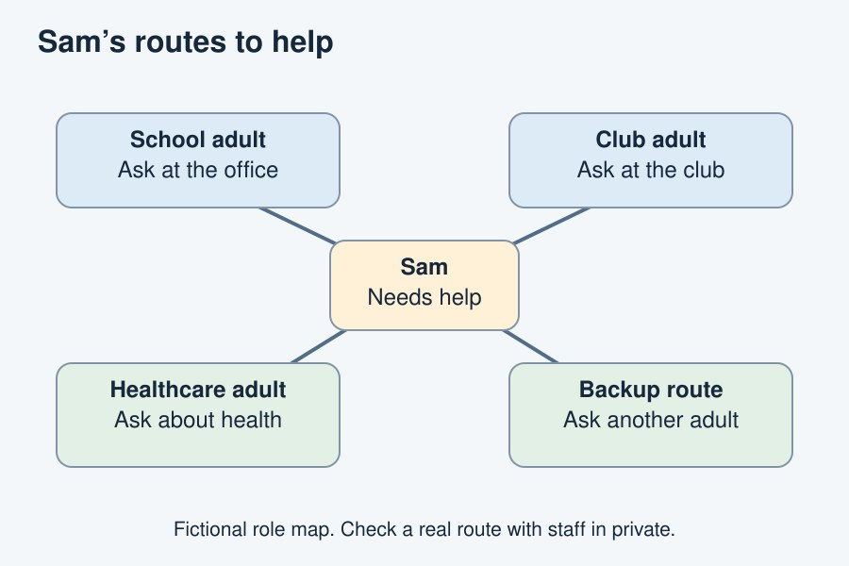
A network gives us more than one route to help.
The diagram is an example, not a record of your work. Use a fictional case or speak privately to staff. No personal details need to be shown to the group.
I notice __.
The next step is __.
I can ask __ for help.

