Wellbeing and access cards
Read or ask an adult to read. Staff may cut on the table lines.
Cards | Cards
A  Jo cannot follow a long spoken task. | B  Sam finds the busy room too much.
C  Lee wants to join a game but cannot use its usual controls. | D  Rae has a worry that keeps coming back.
E  Kit likes a short calm drawing break. | F  An adult chooses help without asking Jo.
What fact matters? What help or safer step would fit?

A date for taking part
3 December is the International Day of Persons with Disabilities.
People have different needs. Ask what helps them take part.
A barrier can be in the room, task or way we share words.
A small calm activity may help wellbeing. A lasting worry needs support.

Words I can use
It is hard to join because __.
A change that could help is __.
Please help me with __.
We can check by asking __.

Help card
Please help me with this step.
I can point to what I mean.
Please read the words or show the step.
I can ask for a pause or private talk.

A visual guide
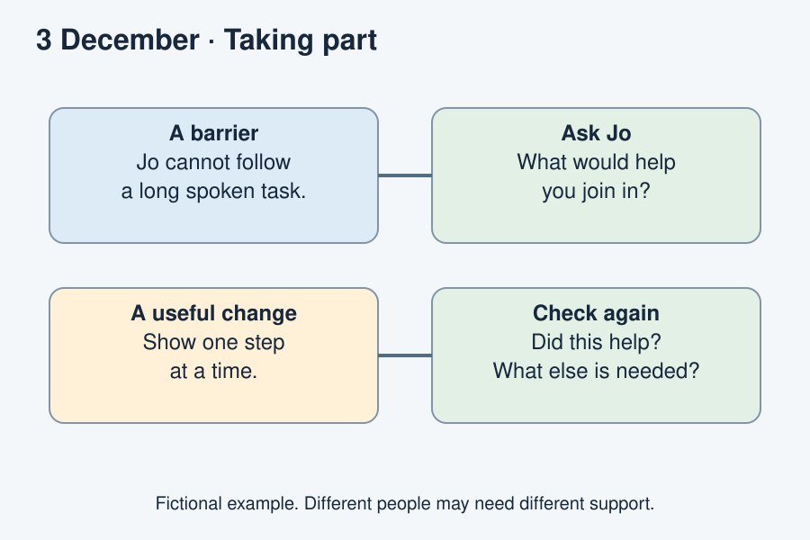
Listen to the person. Change the barrier. Check again.
The diagram is an example, not a record of your work. Use a fictional case or speak privately to staff. No personal details need to be shown to the group.
I notice __.
The next step is __.
I can ask __ for help.

