Enquiry practice cards
All cases are made up. Read or ask an adult to read.
Cards | Cards
A  A caller asks what training is given. | B  A draft includes a full home address.
C  A reply is unclear. The caller asks for it again. | D  An email says: GIVE ME THE JOB NOW.
E  The adult says that the hours are not confirmed. | F  An email draft has no subject or closing.
What fact matters? What help or next step fits?

Role, replies and message stems
Role brief
MADE-UP ROLE: stockroom assistant. Tasks: read labels, sort light items, check a short list and ask if unsure. This is classroom practice. No employer, vacancy or offer is real.
Caller or writer
Choose one fact to ask about: training, hours or how to apply. No contact details, pay or deadline are supplied.
Adult practice replies
Training question: The task is shown at the start, then a short list is used. Hours question: The hours have not been confirmed. Any other detail: That is still to check.
Call stems
Hello. I am asking about the role. Could you tell me __? Please repeat or explain __. I have noted __. Thank you.
Email stems
Subject: Question about the role. Hello. I am interested in the role. Could you tell me __? Thank you. Applicant.
Limit
Rehearse or draft only. Do not call, send, log in or add real details.

A visual guide
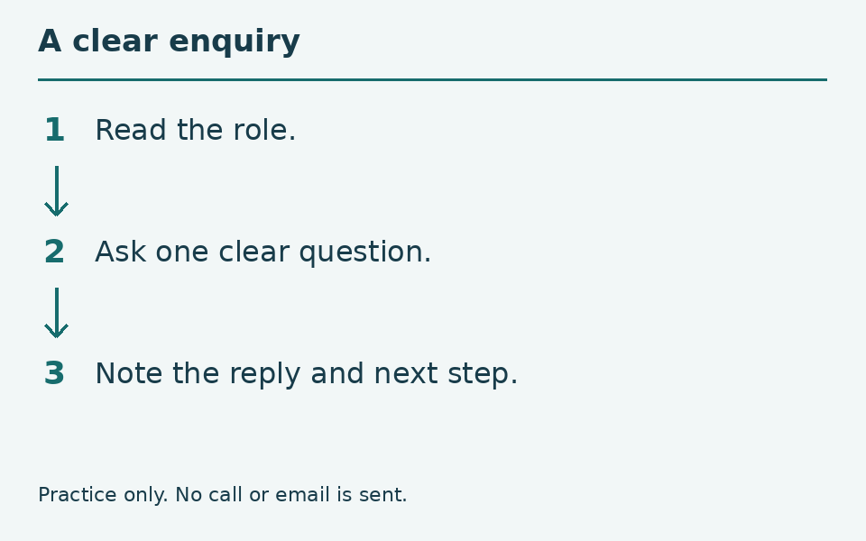
Read → ask → listen or read → note.
The diagram is a guide, not a record of your work. You can ask for a pause or private help.
Help card
Please read the words or show the step.
I can point to what I mean.
Please give me time to think.
I can ask for a pause or private talk.

