Material and tool cards
Read or ask an adult to read. Staff may cut these cards on the table lines.
Cards | Cards
A  Paper: a thin sheet for a sketch or model. | B  Card: a sheet for a small model.
C  Ruler: a tool with a scale. | D  Pencil: a tool that leaves a mark.
E  Scissors: a tool for cutting. Use the picture today. | F  Tape: a material used to join parts.
Sort each item. Give a use and a safe step.

Sort and compare
Material | Tool
What we use to make something. | An item that helps us do a task.

Compare the samples
Use paper and card of the same size. Bend each gently. Say which feels harder to bend. Do not fold or tear the samples.
I noticed __.
For my model I would choose __ because __.
A tool I could use is __. It helps me __.

Spot a hazard
A sharp staple is in a card sample. A pencil is being waved. A desk is cluttered. Choose one to discuss; do not act it out.
The hazard is __.
My safe step is __.
It helps because __.

Help card
Please help me with this step.
I can point to the part I mean.
Please read the words or steady the ruler.
I can ask for a pause.

A clear work space
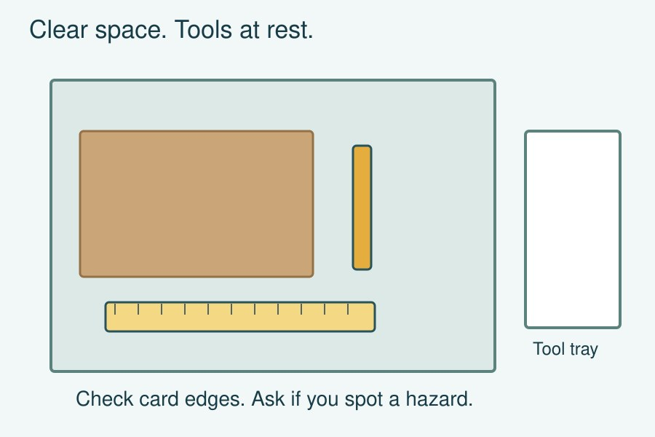
Clear the desk. Check the card edge. Put tools on the mat or in the tray when they are not in use.
Tell the adult if you spot a sharp staple or rough edge. Ask before using a new tool. Use the scissors picture only today.

