Skills and evidence review cards
Read or ask an adult to read. Staff may cut on the table lines.
Cards | Cards
A  A marked plan has the learner’s actual measurements. | B  A model was folded with an adult starting one crease.
C  A test sheet records a slip at the first load. | D  The evaluation links a proposed change to a real observation.
E  A presentation outline exists but no audience exchange is recorded. | F  A folder contains a polished adult model with no pupil response.
Follow the sequence and explain a check.

Check before banking
Is this my work?
Which skill does it show?
What help did I use?
What is missing or not yet checked?
What is one clear next step?
Staff record what is actually stored.

Words I can use
This shows I can __.
The help I used was __.
The gap is __.
Next I will __ with __.

Help card
Please help me with this step.
I can point to what I mean.
Please read the words or show the step.
I can ask for a pause or private talk.

A visual guide
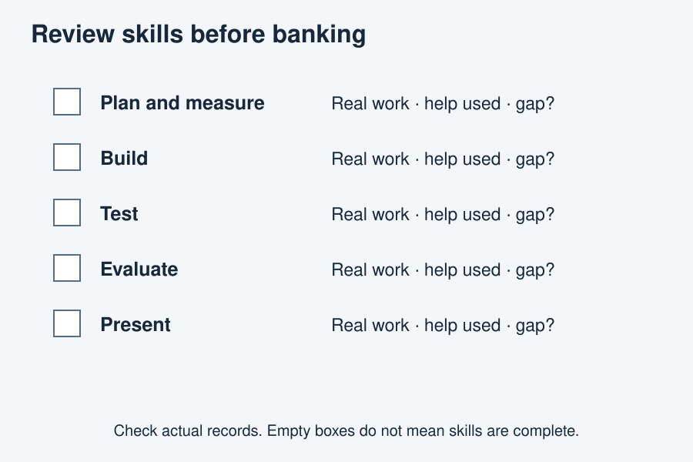
Review real work. Keep gaps visible. Choose a next step.
The diagram is an example, not a record of your work. It is not to scale. Use a ruler for real dimensions.
I notice __.
The next step is __.
I can ask __ for help.

