Personal safety case cards
Read or ask an adult to read. Staff may cut on the table lines.
Cards | Cards
A  Alex misses the bus. The club reception is still staffed. | B  An unknown online contact offers a lift and asks for Alex’s location.
C  A friend suggests a shortcut through a closed building site. | D  A collection plan changes. Sam is unsure who will arrive.
E  Someone pressures Jo to go somewhere after Jo has said no. | F  A person nearby collapses and cannot be woken.
What fact matters? What help or safer step would fit?

A safer plan can include
Check an agreed travel or collection plan.
Stay with suitable staff if a plan changes.
Set a boundary and seek help if it is ignored.
If there is immediate danger, get emergency help.
Being harmed is not your fault.

Words I can use
The fact I know is __.
The missing detail is __.
A safer step is __ because __.
If that fails, I can ask __.

Help card
Please help me with this step.
I can point to what I mean.
Please read the words or show the step.
I can ask for a pause or private talk.

A visual guide
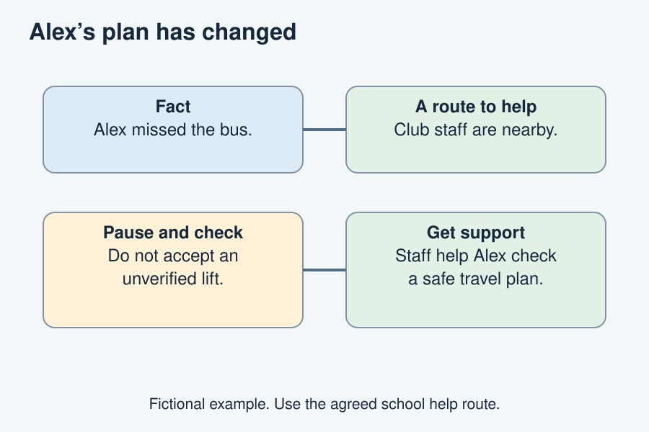
Pause, check facts, choose a safer step and get help.
The diagram is an example, not a record of your work. Use a fictional case or speak privately to staff. No personal details need to be shown to the group.
I notice __.
The next step is __.
I can ask __ for help.

