Online choices case cards
Read or ask an adult to read. Staff may cut on the table lines.
Cards | Cards
A  A group photo includes someone who has said no to posting it. | B  An online contact asks for Lee’s school and home address.
C  A group keeps posting hurtful comments about Jo. | D  A post makes a strong claim but gives no source.
E  Kit finishes using a shared computer but leaves an account open. | F  An unknown contact pressures Sam to keep a chat secret.
What fact matters? What help or safer step would fit?

Pause before sharing
Ask about an ordinary photo before sharing it.
Respect a person who says no.
Keep private details out of public posts.
Check a claim before passing it on.
Ask trusted staff for help with harmful contact.
No real account or personal story is needed here.

Words I can use
I will not share this because __.
Please do not post __.
A reliable source I could check is __.
I need help with __.

Help card
Please help me with this step.
I can point to what I mean.
Please read the words or show the step.
I can ask for a pause or private talk.

A visual guide
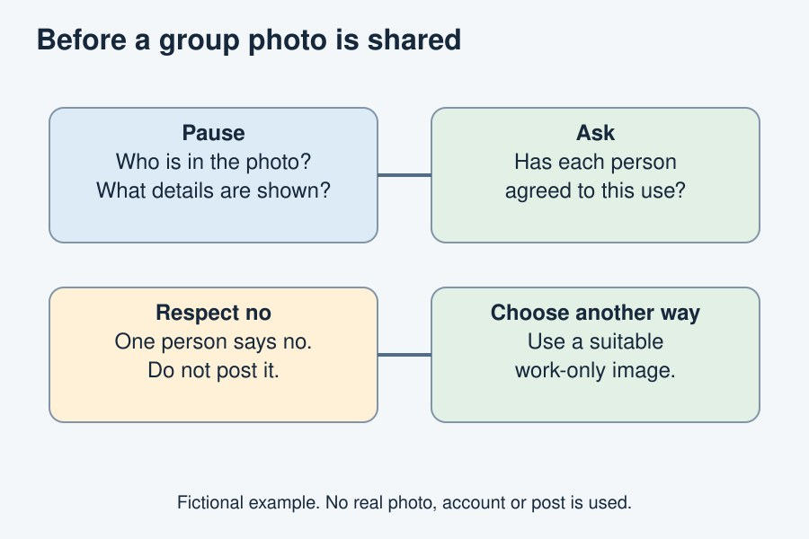
Pause, ask, respect the answer and get help when needed.
The diagram is an example, not a record of your work. Use a fictional case or speak privately to staff. No personal details need to be shown to the group.
I notice __.
The next step is __.
I can ask __ for help.

