Adult-life task cards
Read or ask an adult to read. Staff may cut on the table lines.
Cards | Cards
A  Sam has £20. Travel costs £6 and food costs £7. How much remains? | B  A supervisor gives a work task. One step is unclear to Lee.
C  An online contact asks Jo to share another person’s private address. | D  A travel plan changes and Kit is unsure who will collect them.
E  A shared meeting offers no way for Rae to give a written idea. | F  A person feels pressured to take an unknown tablet.
What fact matters? What help or safer step would fit?

Show your choice and reason
Do A, B and C first.
Use the facts in the task.
Show the money steps or explain them.
Ask a clear question if a work step is unclear.
Respect private information.
Keep your own work and record the help you use.

Words I can use
I worked out __ by __.
Please explain __.
I would __ because __.
My next step is __.

Help card
Please help me with this step.
I can point to what I mean.
Please read the words or show the step.
I can ask for a pause or private talk.

A visual guide
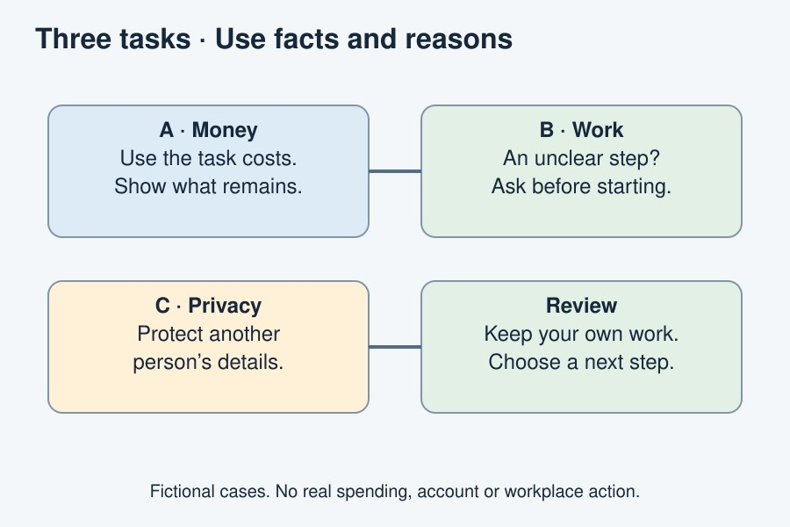
Use facts, explain choices, ask for support and review.
The diagram is an example, not a record of your work. Use a fictional case or speak privately to staff. No personal details need to be shown to the group.
I notice __.
The next step is __.
I can ask __ for help.

