Visual step cards
Autumn 2 · Week 2 · Lesson 1 · Monday 9 November 2026
I can keep a steady beat and leave a quiet rest.
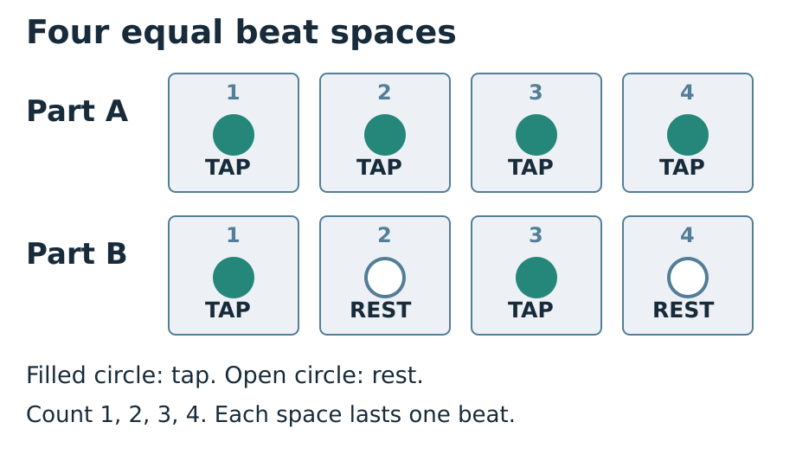
1. Watch: Watch the count-in: one, two, three, four.
2. Tap: Tap once in each numbered space. Keep it even.
3. Rest: At REST, stay quiet for one whole beat.
4. Check: Try it again. Are the gaps still the same?
You can tap, point, sign, nod or use a quiet hand move. Ask for less sound or a pause. Use your usual way to show what you know.

Words for our group piece
Autumn 2 · Week 2 · Lesson 1 · Monday 9 November 2026

beat
The even pulse you can tap or show.

steady
The beat keeps the same speed.

rest
A quiet beat. Keep its space in time.

count-in
A count that tells us when to start.

Words for my record
I keep the beat by ___.
________________________________________________________________
At REST I ___.
________________________________________________________________
My taps were ___.
________________________________________________________________
Picture colours: navy headings; blue outlines and beat numbers; teal TAP circles; white REST circles and paper; grey beat spaces; red STOP reminder. Logo: navy background, mint green ring, cream M, amber star, black corners. Words, numbers and shapes give the meaning.

Knowledge organiser
Autumn 2 · Week 2 · Lesson 1 · Monday 9 November 2026
I can keep a steady beat and leave a quiet rest.
I can leave the same gap from beat to beat.
I can keep a rest quiet for one whole beat.
I can start and stop with a cue.
beat — The even pulse you can tap or show.
steady — The beat keeps the same speed.
rest — A quiet beat. Keep its space in time.
count-in — A count that tells us when to start.
Count every rest for one full beat. Watch the count-in and stop signal.
Picture colours: navy headings; blue outlines and beat numbers; teal TAP circles; white REST circles and paper; grey beat spaces; red STOP reminder. Logo: navy background, mint green ring, cream M, amber star, black corners. Words, numbers and shapes give the meaning.
My record: A_Take_Part.pdf · page 1

Read four beat spaces
Autumn 2 · Week 2 · Lesson 1 · Monday 9 November 2026
Keep each space the same length. Read left to right.
A: TAP · TAP · TAP · TAP.
B: TAP · REST · TAP · REST.
At REST, keep one quiet beat.
Count in four. Then play B twice.
My check or next step
________________________________________________________________
________________________________________________________________

Supported route
Autumn 2 · Week 2 · Lesson 1 · Monday 9 November 2026

Recall
Choose a quiet way to tap or show a beat.
Point to the four numbered spaces.

In your book
1. Use the four large spaces with help.
2. Watch a count-in of four.
3. Tap A once with a partner.
4. Point through B. Keep each REST quiet.
5. Try B once more. Show one thing to keep.
My words or sketch
________________________________________________________________
________________________________________________________________
________________________________________________________________

Check before you finish
What is a steady beat?
What do you do at REST?
Show B once after the count-in.
You can tap, point, sign, nod or use a quiet hand move. Ask for less sound or a pause. Use your usual way to show what you know.
Prompt used __________ Support given __________________

Independent route
Autumn 2 · Week 2 · Lesson 1 · Monday 9 November 2026

Recall
Choose a quiet way to tap or show a beat.
Point to the four numbered spaces.

In your book
1. Give a quiet count-in of four.
2. Tap A for four even beats.
3. Read B: TAP REST TAP REST.
4. Play B twice at the same pace.
5. Choose one next step. Try it again.
My words or sketch
________________________________________________________________
________________________________________________________________
________________________________________________________________

Check before you finish
What is a steady beat?
What do you do at REST?
Show B once after the count-in.
You can tap, point, sign, nod or use a quiet hand move. Ask for less sound or a pause. Use your usual way to show what you know.
Prompt used __________ Support given __________________

Aspire route
Autumn 2 · Week 2 · Lesson 1 · Monday 9 November 2026

Recall
Choose a quiet way to tap or show a beat.
Point to the four numbered spaces.

In your book
1. Keep the same pulse for two rounds of B.
2. Give your partner a clear count-in.
3. Try B with a silent nod for every beat.
4. Tell how the nod helps with each rest.
5. Change one tap to a rest. Keep four spaces.
My words or sketch
________________________________________________________________
________________________________________________________________
________________________________________________________________

Check before you finish
What is a steady beat?
What do you do at REST?
Show B once after the count-in.
You can tap, point, sign, nod or use a quiet hand move. Ask for less sound or a pause. Use your usual way to show what you know.
Prompt used __________ Support given __________________

My steady beat
Autumn 2 · Week 2 · Lesson 1 · Monday 9 November 2026
Pupil code __________ Actual date __________
A_Take_Part.pdf · page 1
Draw four spaces. Mark TAP or REST.
________________________________________________________________
________________________________________________________________
Pupil code ___ Date ___
________________________________________________________________
I used ___ to show the beat.
________________________________________________________________
A thing that worked was ___.
________________________________________________________________
My next step is ___.
________________________________________________________________
When I tried again ___.
________________________________________________________________
Give your response in the same colour, on the same page or usual mode.
An adult wrote my words: yes / no. I checked them: yes / not yet.
Use your usual mode. A helper can scribe your checked words.

Compare the two original parts
Autumn 2 · Week 2 · Lesson 1 · Monday 9 November 2026
Try two short class parts. Part A has four taps. Part B has a tap, a rest, a tap and a rest. Each part has four beat spaces.
Both parts have ___ beat spaces.
________________________________________________________________
Part A has ___. Part B has ___.
________________________________________________________________
In a rest I ___.
________________________________________________________________
I keep the beat by ___.
________________________________________________________________
These are new class patterns. Count each rest for one full beat. A rest is quiet time; it does not remove the beat.

My short book tasks
Autumn 2 · Week 2 · Lesson 1 · Monday 9 November 2026

Look back
Choose a quiet way to tap or show a beat.
________________________________________________________________
Point to the four numbered spaces.
________________________________________________________________
Show the STOP cue.
________________________________________________________________
Tap four slow, even taps with help.
________________________________________________________________

Look and choose
Which part has a quiet rest: A with four taps or B with tap, rest, tap, rest?
My choice and reason
________________________________________________________________

At the end
What is a steady beat?
What do you do at REST?
Show B once after the count-in.
My next step
________________________________________________________________
Respond in the same colour, on the same page or usual mode.

TA brief
Autumn 2 · Week 2 · Lesson 1 · Monday 9 November 2026
Use Supported as needed, Independent for a pupil ready to take the lead, and Aspire for more depth. The route changes help, not the shared beat goal. Use five individual records within a pair and a trio; rotate beat keeper, part player and watcher. Never require solo performance. Quiet finger taps, a visible nod or pointing can show the same timing. Teach a raised flat hand as STOP; agree it before sound starts. Keep volume low and use a soft surface. Wait for each pupil to opt into a role and use a trusted partner when needed. Read back scribed words and let the pupil correct them. Give one clear success and one next step. A pupil responds in the same colour, on the same page or usual mode. Mark R only when Voice and Audience are present, one NS has been given and the pupil has made the response. Use VF, WS, I, NS, //, ?, E and R only for what happened. A photograph or class tick does not prove an individual skill. Pupil code and staff fields stay blank until actual use.

Prompt ladder
1. Point to the place or instruction.
2. Ask one short question.
3. Say the instruction in a new way.
4. Give a choice or a small guide.
5. Show the first step only. Then give the task back.

Focus through the lesson
I do: Track who follows the pointer through the quiet beat. Prompt by pointing before speaking.
We do: Watch one pupil per round; note whether rests keep their full time. Fade the shared nod when ready.
Independent: Use the five-step ladder only as needed. Record the exact help and return the next step to the pupil.

One end question
How do you keep the beat when the part is quiet?
Give one next step. Respond in the same colour, on the same page or usual mode. Record R only after Voice and Audience are present, one NS is set, and the pupil responds.

Staff answers and checks
Autumn 2 · Week 2 · Lesson 1 · Monday 9 November 2026

Arrival
Finger tap, nod, pointer or another comfortable timed movement. No sound is required.
The pupil identifies all four positions in order.
A raised flat hand or the agreed printed STOP cue. Check pupils can see it.
Four movements with roughly equal time gaps. A missed attempt is diagnostic; model again without judgement.

Starter
B. Beats two and four are full quiet rests. A and B both keep the same four even beat spaces. Do not treat B as unsteady because it has fewer sounds.

Guided practice
All four beat positions continue at the same pace. In B, sounds occur on 1 and 3; 2 and 4 are silent full beats. Use a visible pointer or nod to show the pulse. Do not count the two sounds as two beats.

Exit
An even pulse, with the same gap between beats. Accept a demonstration.
Stay quiet for one whole beat while the pulse continues.
After four even counts, tap on 1 and 3 and keep 2 and 4 quiet. Note the actual support and next step.
Accept pointing, quiet movement, speech, signs, drawing and checked scribing. Check the actual beat positions and part; participation alone does not show that a pulse or part was learnt.

