Scenario cards
Made-up cases. Read or ask an adult to read. Cut on the table lines.
Case cards | Case cards
A  Rae feels thirsty. Rae has water in a clean cup. | B  A lead lies across a path. People walk towards it.
C  Jay wants to use a bike. We do not know if it has been checked. | D  Lee joins a seated ball game. An adult checks the space and rules.
E  Kit feels tired. A friend says to stay up all night to play. | F  A club offers a new snack. The ingredients are not shown.
For each case: What is the clue? What could happen? What is a safer step?

Sort labels and help frames
Safer | Risk | Need more information
Less chance of harm. | Harm could happen. | We need to check a fact.

My reason
I chose __ because __.
The clue is __.
A safer step is __.
I need to check __ with __.

Steps I can use
1 Pause | 2 Spot a clue | 3 Choose a safer step | 4 Ask for help
Take a moment. | What do I know? | What could reduce harm? | Who can help?

Private help card
Can I speak to you in private?
I need help.
I can show this card to the adult.
I can pass and use another made-up case.
If one adult cannot help, ask another trusted adult. Getting help is okay.

Picture prompt
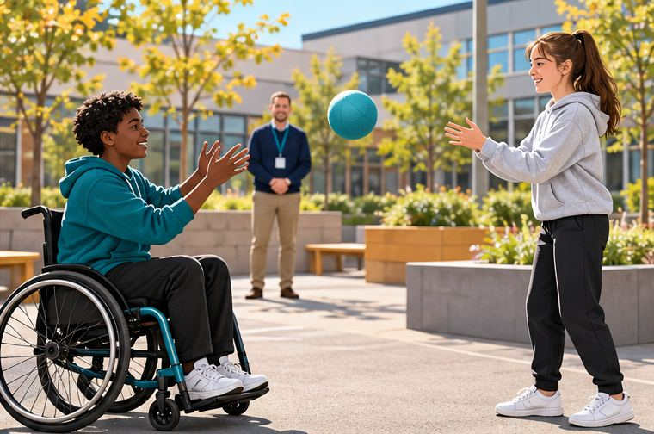
This picture shows a made-up scene.
The adult has checked the game and space.
What choice helps people join in safely?
What could someone do if they need a break?
Point, say, draw or use your own words.

