Tool knowledge and hazard picture
Pink supported edition
Using gardening tools safely.

Names and jobs
Tool | Job and limit
Hand trowel | Scoop medium or make a small planting hole. Work over a tray.
Hand fork | Loosen soil in a clear area. Keep away from living roots.
Secateurs | Cut suitable small stems. Adult controls blades and permission.
Watering can | Give controlled water after checking moisture.
Gloves | Help protect skin. They do not make blade contact safe.

The adult checks each tool. You may observe or record. Secateurs stay closed and locked for pupil carrying.

Tool knowledge and hazard picture continued
Pink supported edition

Spot a hazard
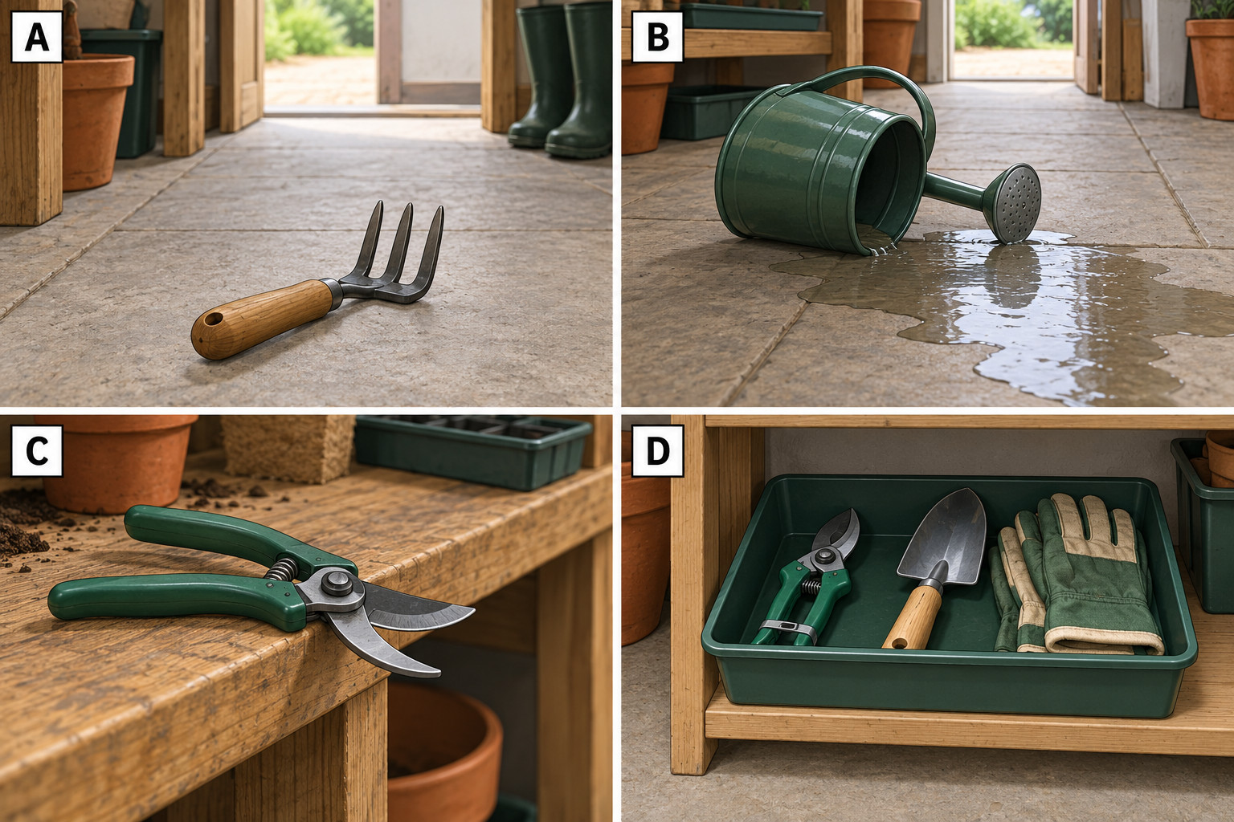
The picture is invented. Look at one panel. Tell the adult or use your book.
Panel __ shows __.
A safer action is __.
Discuss the picture. Do not recreate the hazards.

