Tool knowledge and hazard picture
White standard edition
Using gardening tools safely.

Tool names and jobs
Tool | Job and limit
Hand trowel | Scoop medium or make a small planting hole. Work over a tray.
Hand fork | Loosen soil in a clear area. Keep away from living roots.
Secateurs | Cut suitable small stems. Adult controls blades and permission.
Watering can | Give controlled water after checking moisture.
Gloves | Help protect skin. They do not make blade contact safe.

Carry clean and store
Walk with one tool low, sharp ends down and away from people. Keep a gap. Park tools before changing jobs. Carry secateurs closed and locked. Brush, wipe and dry blunt tools only. The adult cleans sharp blades. Store securely and wash hands.

Tool knowledge and hazard picture continued
White standard edition

An invented work area
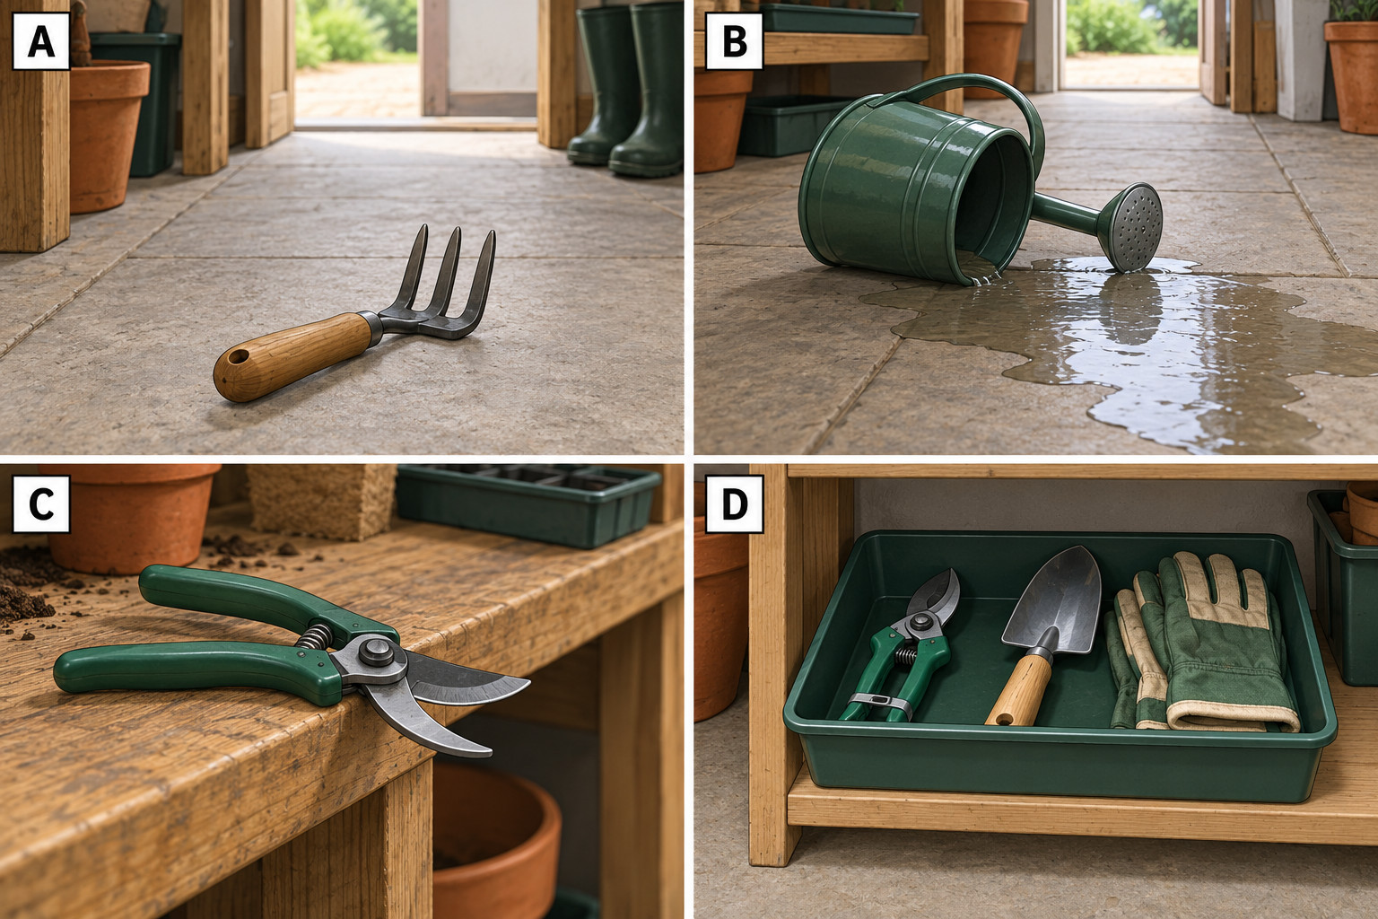
Look at one panel at a time. Which show a hazard? What should the adult do? Which shows a safer storage example?
In your book: In panel __, the hazard is __. A safer action is __. The picture is invented. Do not recreate its hazards.

