Real group growth record
White standard edition
Record growth (links Science).

Actual group measurements
Original tray code ____ Measurement method and precision ____
Use your book or tell the adult what to scribe. Leave unavailable values honest.
Shoot code | Height cm | Whole leaves | Condition
____ | ____ | ____ | ____
____ | ____ | ____ | ____
____ | ____ | ____ | ____
____ | ____ | ____ | ____
____ | ____ | ____ | ____

Record the actual height, whole expanded leaf count and visible condition. These are different observations. Use the same agreed whole-leaf unit, endpoint and precision each time. Do not copy the invented model.

Real group growth record continued
White standard edition

One verified repeated series
Selected tray and marked shoot code ____
Use that same shoot and consistent earlier records.
Week | Verified height in cm
1 | ____
2 | ____
3 | ____
4 | ____
5 | ____

Keep earlier records. Mark unavailable values rather than guessing. Do not invent earlier leaf counts or heights. Mark a changed method and break the series. One verified height allows one point, not a trend.

Real group growth record continued
White standard edition

Our real growth graph
Selected tray and shoot code ____
Choose equal height steps that fit the actual values. Write the height scale at the blank ticks.
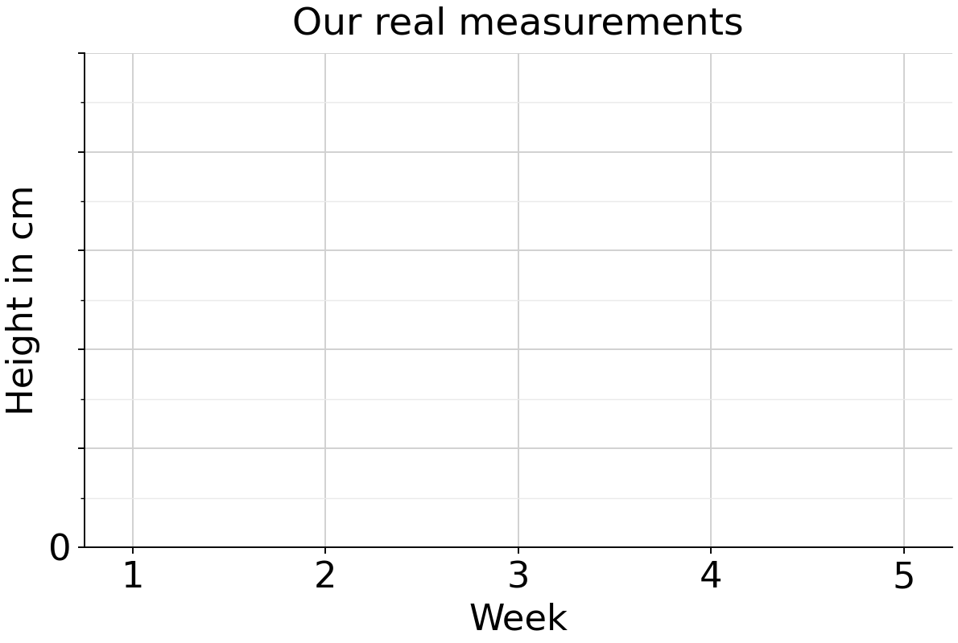
Missing is not zero. Break the line at unavailable weeks or a changed method. One verified value gives one point, without a growth trend.

