A fair turn record
25 February 2027 | P3
White paper | Point, tell, write or ask an adult to write.
My code ____ Date ____
Read an easy-read story that teaches fairness.
In your book: give one line about the fair plan.
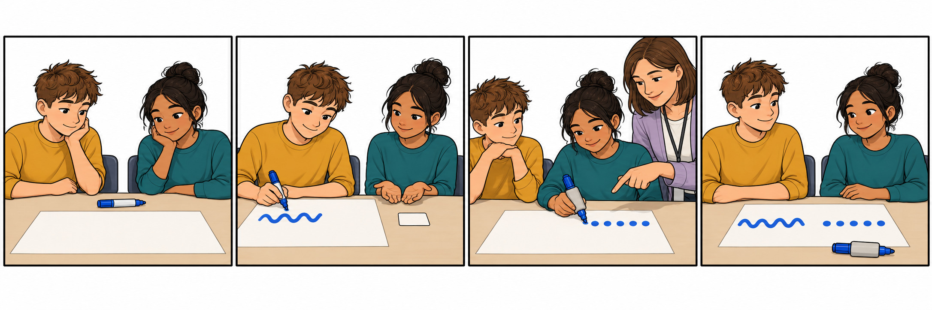
1 Both want the pen.
2 One draws. One waits.
3 The next pupil has a turn and a grip.
4 Both have a turn. Both can draw.

Words
fair, turn, wait, help, both, grip

Start and model
Start: It is fair because __.
Model: It is fair. Both have a turn.
Point, tell, write or ask an adult to write. You can keep or change your line.

A fair turn record continued
25 February 2027 | P3
White paper | Point, tell, write or ask an adult to write.

Adult record
Keep actual records blank until the lesson. Record the pupil’s choice, not an adult’s model.
Record | Actual evidence
Pupil code and date | __________________
Story order or matching | __________________
Fair action selected | __________________
Exact line or selected words | __________________
Reading mode | Read / listened / read with help: ______
Prompt and adult help | __________________
Read-back confirmation or change | __________________
Voice and audience reply | __________________
One NS | __________________
Pupil response and mode | __________________
R only after reply and response | __________________
Review and actual banking E | __________________
Offer the authentic response to the Communication portfolio. No result or award completion is prefilled.

