A fair turn
25 February 2027 | P3
White paper | Point, tell, write or ask an adult to write.
Route: Supported | My code ____
In your book: give one line about the fair plan. You can point or ask an adult to write.
1 Read with an adult. Point to each picture.
2 Pick the fair words: both have a turn / one keeps the pen.
3 Ask an adult to write your choice. Keep or change it.

Words
fair, turn, wait, help, both, grip

Start
It is fair because __.
The grip helps __.

Model
It is fair. Both have a turn.
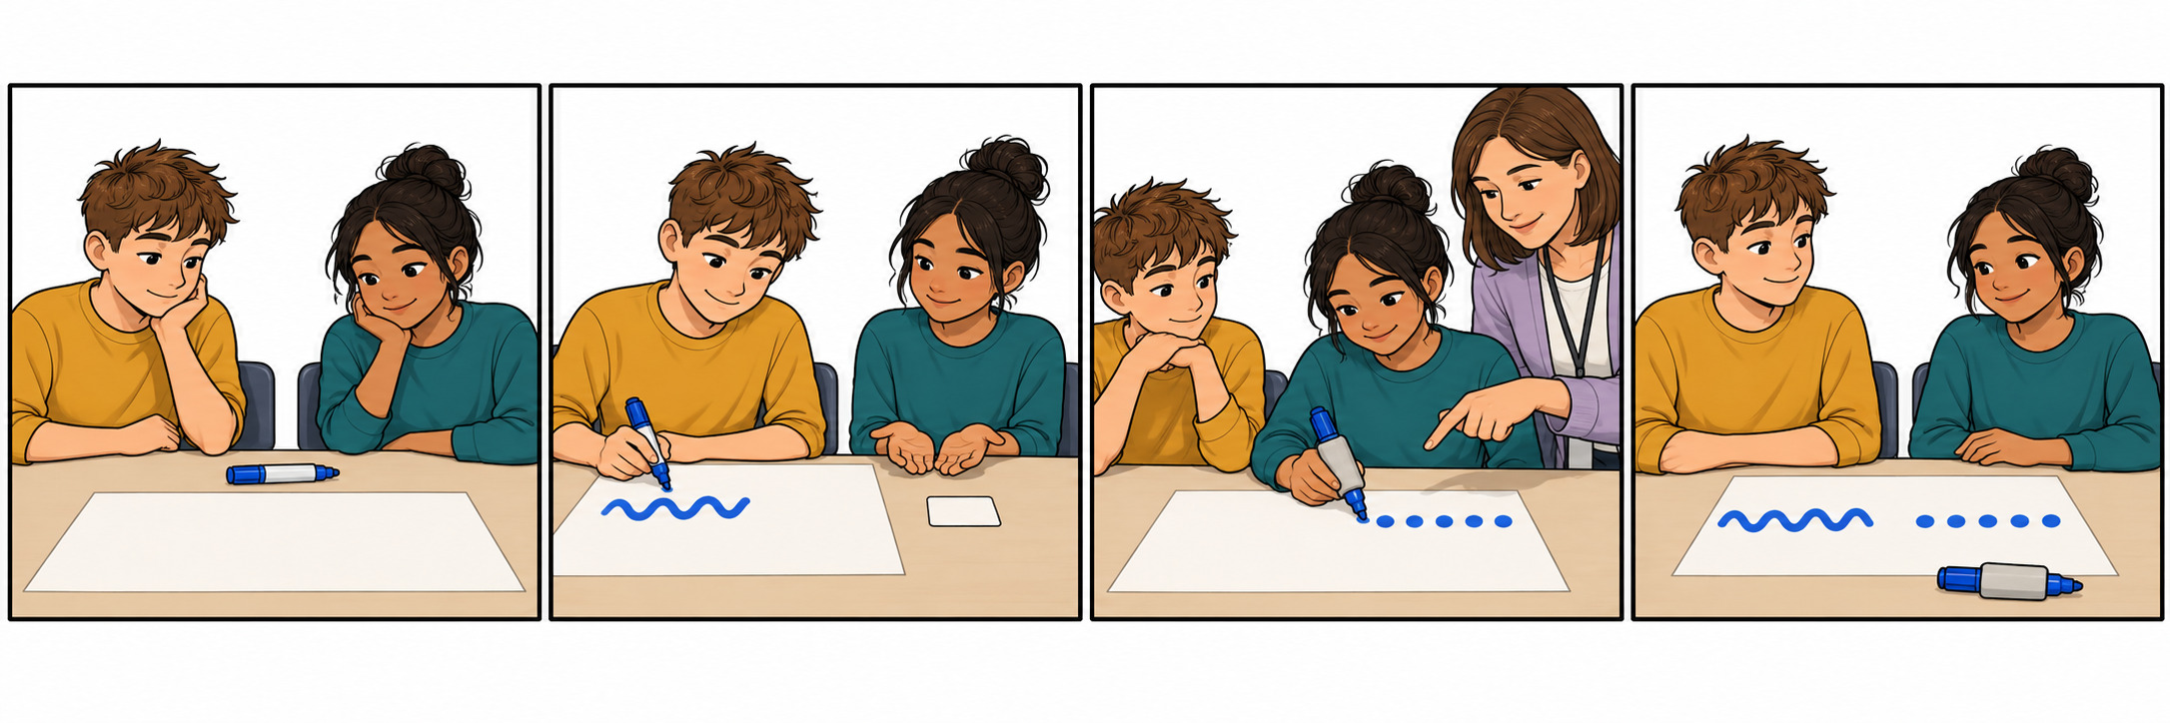

Finish
Show the fair part. Give one line. Keep or change it. You can pass or rest.

A fair turn continued
25 February 2027 | P3
White paper | Point, tell, write or ask an adult to write.
Route: Independent | My code ____
In your book: give one line about the fair plan. You can point or ask an adult to write.
1 Read or follow the story. Put the four pictures in order.
2 Find the fair plan. Use a picture to help.
3 In your book, give one line. Use the words and start below.

Words
fair, turn, wait, help, both, grip

Start
It is fair because __.
The grip helps __.

Model
It is fair. Both have a turn.

Finish
Show the fair part. Give one line. Keep or change it. You can pass or rest.

A fair turn continued
25 February 2027 | P3
White paper | Point, tell, write or ask an adult to write.
Route: Aspire | My code ____
In your book: give one line about the fair plan. You can point or ask an adult to write.
1 Read or follow the story. Check the picture order.
2 Say why the grip helps. Is this still fair?
3 In your book, give one line about the turn or the help.

Words
fair, turn, wait, help, both, grip

Start
It is fair because __.
The grip helps __.

Model
It is fair. Both have a turn.

Finish
Show the fair part. Give one line. Keep or change it. You can pass or rest.

