The fair turn story
25 February 2027 | P3
Pink paper | Point, tell, write or ask an adult to write.

A fair turn
Two pupils make a poster.
There is one blue pen.
Both want to draw.
The first pupil uses the pen.
The other pupil waits.
They make a plan.
Each will have a turn.
The next pupil needs a thick grip.
An adult puts a grip on the pen.
The next pupil can use the pen now.
Both pupils add a mark.
Both have a turn and the help they need.
That is fair.

Words and start
fair, turn, wait, help, both, grip
It is fair because __.
Model: It is fair. Both have a turn.

The fair turn story continued
25 February 2027 | P3
Pink paper | Point, tell, write or ask an adult to write.

Four pictures in order
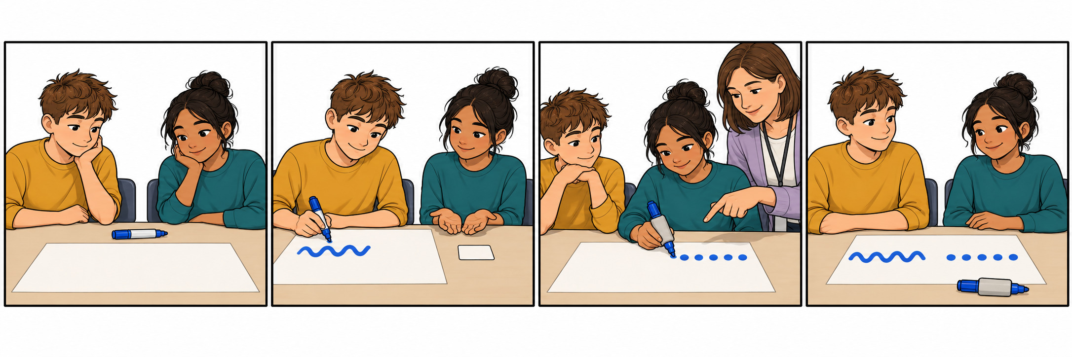
1 Both want the pen.
2 One draws. One waits.
3 The next pupil has a turn and a grip.
4 Both have a turn. Both can draw.

Mix and match
An adult can cut the picture strip into four parts along the black lines. Mix them. Put them in story order. Match the lines to the pictures.
Words: first, next, last, turn, help.
Start: First __. Next __.
Model: First both want the pen.
You can point. An adult can read or move a card for you. Finish: four pictures in order.

