My fair and unfair reasons
4 March 2027 | P3
Pink paper | Point, tell, write or ask an adult to write.
My code ____ Date ____
Talk about what is fair and unfair.
In your book: show your sort. Give one reason for each group.
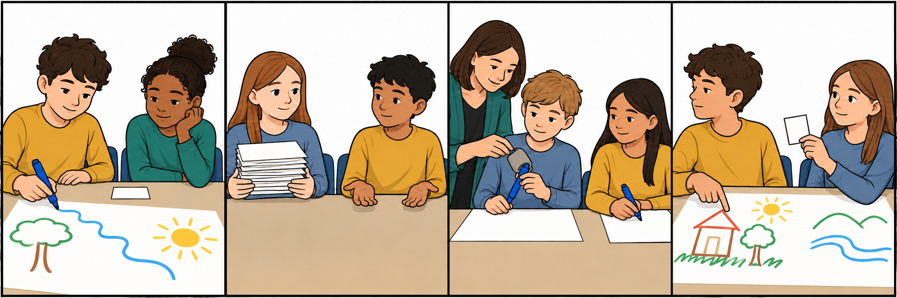
Fair | Unfair
Card letters __ | Card letters __

Words
fair, unfair, turn, share, help, say

Start and model
It is fair because __.
It is unfair because __.
Model: It is fair because both have a turn.
Point, tell, write or ask an adult to write. Listen to your reasons. Keep or change them.

My fair and unfair reasons continued
4 March 2027 | P3
Pink paper | Point, tell, write or ask an adult to write.

Adult record
Keep actual records blank until the lesson. Record the pupil’s own choices and reasons, not an adult’s model.
Record | Actual evidence
Pupil code and date | __________________
Own A–D sort | __________________
Fair card and exact reason | __________________
Unfair card and exact reason | __________________
Reading mode | Read / listened / read with help: ______
Prompt and adult words | __________________
Read-back keep/change | __________________
Voice and audience reply | __________________
One NS | __________________
Pupil response and mode | __________________
R after reply and response | __________________
Review and actual banking E | __________________
Offer authentic reasons to the Communication portfolio. No result or completion is prefilled.

