Fair and unfair choices
4 March 2027 | P3
Pink paper | Point, tell, write or ask an adult to write.
Route: Supported | My code ____
In your book: give one fair reason and one unfair reason. You can point, tell or ask an adult to write.
1 Read A and B with an adult. Point to fair or unfair.
2 Pick words for why. An adult can write your words.
3 Try C and D with help. Give one fair and one unfair reason.

Words
fair, unfair, turn, share, help, say

Start
It is fair because __.
It is unfair because __.

Model
It is fair because both have a turn.
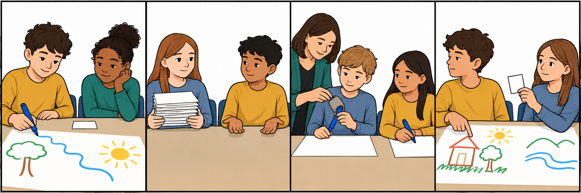

Finish
Four cards sorted. One fair reason. One unfair reason. Keep or change your words. You can pass or rest.

Fair and unfair choices continued
4 March 2027 | P3
Pink paper | Point, tell, write or ask an adult to write.
Route: Independent | My code ____
In your book: give one fair reason and one unfair reason. You can point, tell or ask an adult to write.
1 Read or listen to all four cards. Sort A–D.
2 Pick one fair card and one unfair card.
3 In your book: give one sentence for each card.

Words
fair, unfair, turn, share, help, say

Start
It is fair because __.
It is unfair because __.

Model
It is fair because both have a turn.

Finish
Four cards sorted. One fair reason. One unfair reason. Keep or change your words. You can pass or rest.

Fair and unfair choices continued
4 March 2027 | P3
Pink paper | Point, tell, write or ask an adult to write.
Route: Aspire | My code ____
In your book: give one fair reason and one unfair reason. You can point, tell or ask an adult to write.
1 Sort A–D. Pick one card in each group.
2 Give one sentence for each card.
3 Pick B or D. Say a fair change and why it helps.

Words
fair, unfair, turn, share, help, say

Start
It is fair because __.
It is unfair because __.

Model
It is fair because both have a turn.

Finish
Four cards sorted. One fair reason. One unfair reason. Keep or change your words. You can pass or rest.

