Fair and unfair cards
4 March 2027 | P3
Pink paper | Point, tell, write or ask an adult to write.

Four made-up cards
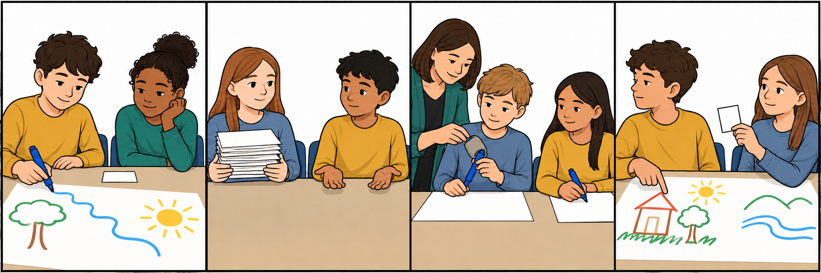
A Two pupils want one pen. They take turns. Both can draw.
B One pupil keeps all the paper. The other has none. They cannot join.
C One pupil needs a thick grip. An adult gives them one. Both can draw.
D Two pupils share a poster. One says, Only my ideas count. The other has no say.
Words: fair, unfair, turn, share, help, say
Start: It is fair because __.
Model: It is fair because both have a turn.

Fair and unfair cards continued
4 March 2027 | P3
Pink paper | Point, tell, write or ask an adult to write.

Fair and unfair sort
Fair | Unfair
Put cards here. | Put cards here.
Why? __ | Why? __

Card strips
A Two pupils want one pen. They take turns. Both can draw.
B One pupil keeps all the paper. The other has none. They cannot join.
C One pupil needs a thick grip. An adult gives them one. Both can draw.
D Two pupils share a poster. One says, Only my ideas count. The other has no say.

Words and start
fair, unfair, turn, share, help, say
It is fair because __.
It is unfair because __.
Model: It is fair because both have a turn.
An adult can cut the A–D card strips. Keep the picture board in view. Read or listen. Sort the cards and give one reason for each group.

