Fair and unfair support
4 March 2027 | P3
Pink paper | Point, tell, write or ask an adult to write.

Ready starter
Two pupils want to draw. Choose the fair plan.
A Both get a sheet of paper.
B One keeps all the paper.

Words
fair, unfair, turn, share, help, say

Start
I choose __ because __.

Model
I choose A because both can draw.
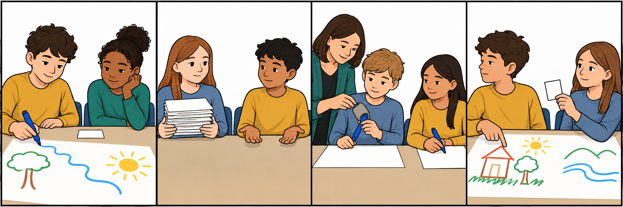
Show your choice in a quiet way. You can point or ask an adult to write. You can rest or ask for help.

Fair and unfair support continued
4 March 2027 | P3
Pink paper | Point, tell, write or ask an adult to write.

Talk frames
It is fair because __.
It is unfair because __.

Words
fair, unfair, turn, share, help, say
both have a turn / one has no paper / the grip helps / one has no say

Model
It is fair because both have a turn.
It is unfair because one has no paper.

My book reasons
Pick a fair card and an unfair card. Give one sentence for each. Point, tell or ask an adult to write. Use the picture board.

Keep or change
An adult reads your words back. Keep or change them. Show one change after one next step.
You can pass or rest. Plan in any language. Use your usual aid.

