Fair and unfair words
4 March 2027 | P3
Pink paper | Point, tell, write or ask an adult to write.
Word | Meaning in these cards
fair | Each can join and get the help they need.
unfair | One is kept out or has no fair chance.
turn | A time when you can use a shared thing.
share | Let each person use or have some.
help | Make it easier for someone to join.
say | A chance to give your idea.

Start and model
It is fair because __.
It is unfair because __.
Model: It is fair because both have a turn.
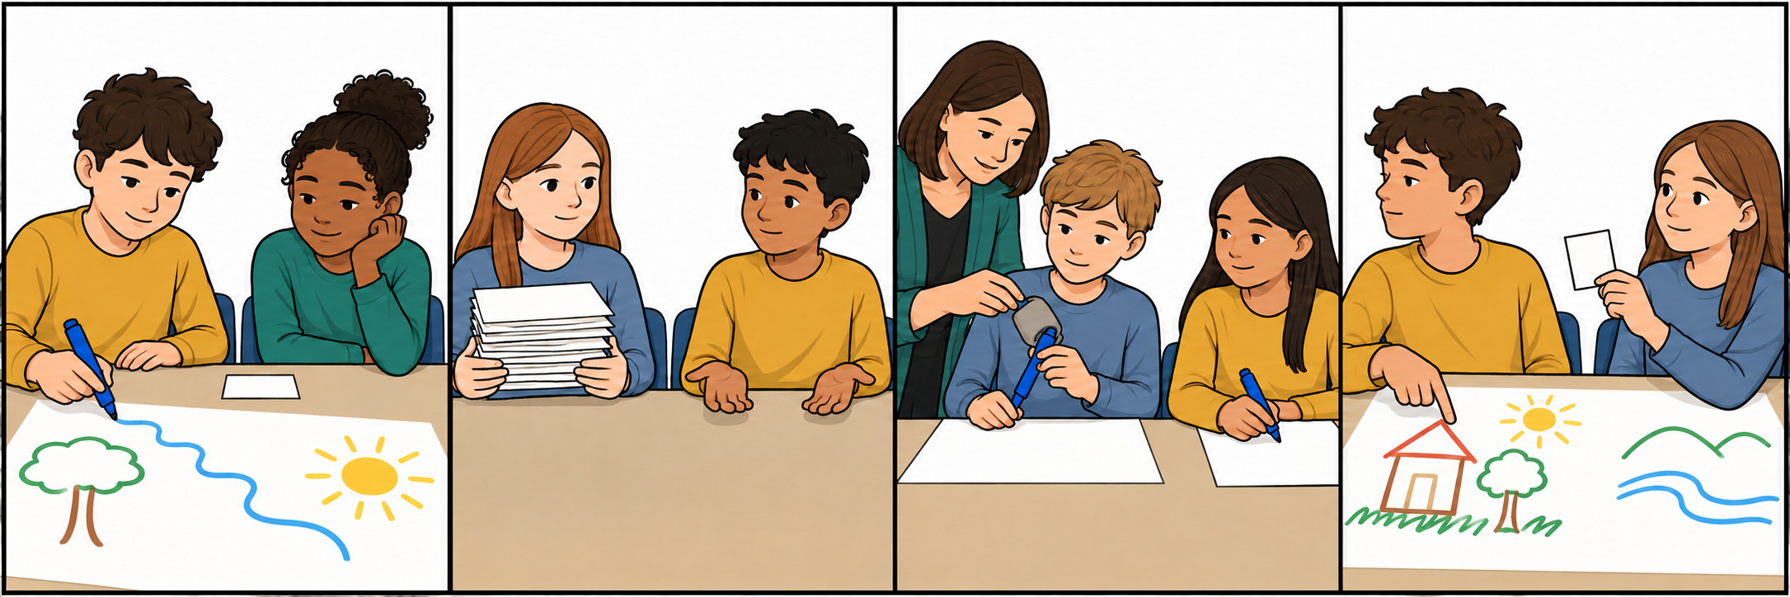
Point, tell or ask an adult to read. Use these words for the cards and your book reasons.

