Ways to care
11 March 2027 | P3
Pink paper | Point, tell, write or ask an adult to write.
Route: Supported | My code ____
In your book: show ways to care. Help plan ONE class action for Week 5.
1 Match one caring picture to school, home and the shared path.
2 Point to a way to care. Ask an adult to write your words.
3 Help choose ONE class plan. Keep or change your line.

Words
care, ask, help, share, space, plan

Start
This cares because __.
We could __. We would need __.

Model only
We could make a book tray. It could help the class.
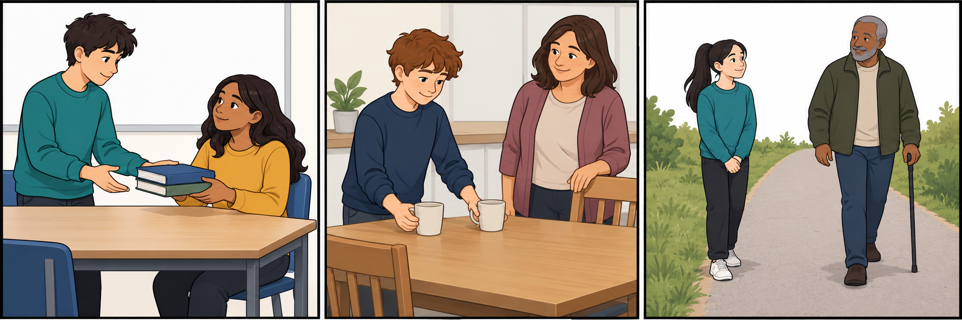

Finish
Show a caring choice. Keep our plan for later. We do not do the action today. You can pass or rest.

Ways to care continued
11 March 2027 | P3
Pink paper | Point, tell, write or ask an adult to write.
Route: Independent | My code ____
In your book: show ways to care. Help plan ONE class action for Week 5.
1 Sort the six action cards into caring and not caring.
2 Say why one action helps. Use a picture and the word bank.
3 Record our ONE class plan with what, who, kit and adult check.

Words
care, ask, help, share, space, plan

Start
This cares because __.
We could __. We would need __.

Model only
We could make a book tray. It could help the class.

Finish
Show a caring choice. Keep our plan for later. We do not do the action today. You can pass or rest.

Ways to care continued
11 March 2027 | P3
Pink paper | Point, tell, write or ask an adult to write.
Route: Aspire | My code ____
In your book: show ways to care. Help plan ONE class action for Week 5.
1 Sort the actions. Say why ask first or leave space matters.
2 Help choose ONE class action for Week 5.
3 Add one check so each pupil can join or choose a role.

Words
care, ask, help, share, space, plan

Start
This cares because __.
We could __. We would need __.

Model only
We could make a book tray. It could help the class.

Finish
Show a caring choice. Keep our plan for later. We do not do the action today. You can pass or rest.

