Caring action cards
11 March 2027 | P3
White paper | Point, tell, write or ask an adult to write.

Three made-up scenes
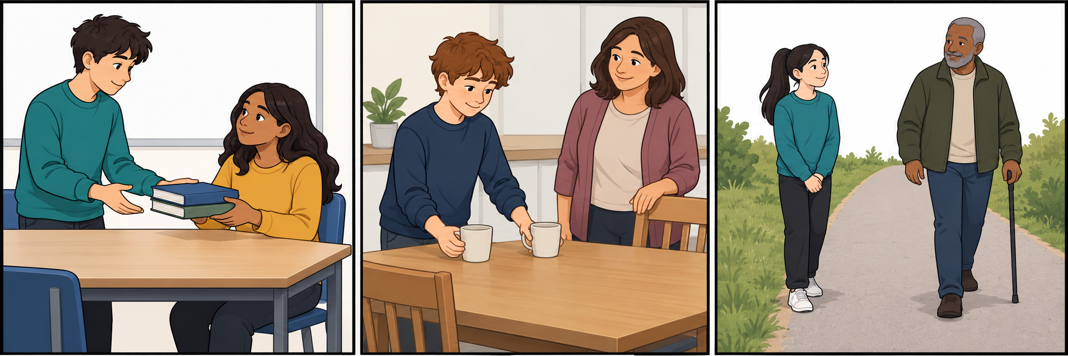
A School: A pupil has books to carry. Another asks, Can I help? They wait for yes or no.
B Home: A child and an adult share a small task. The child puts cups on the table. This helps the adult.
C Shared path: A child leaves space. An adult can pass. The child does not touch the person or their stick.

Words and start
care, ask, help, share, space, plan
Start: This cares because __.
Model: This cares because they ask first.
These are made up. You do not need to tell a story about your own home.

Caring action cards continued
11 March 2027 | P3
White paper | Point, tell, write or ask an adult to write.

Action cards to sort
Card | Made-up action
A | A pupil asks before they help with books.
B | A child puts cups on a table with an adult.
C | A child leaves space on a shared path.
D | A pupil grabs books after the other says no.
E | A child shouts while another tries to rest.
F | A child blocks the shared path.
An adult can cut out the rows. Sort: caring / not caring. Name the action, not the person.

Words start and model
care, ask, help, share, space, plan
Start: This cares because __.
Model: A cares because they ask first.
Point, tell or ask an adult to read. Finish: show one caring action for each place. Give one reason.

