Care words
11 March 2027 | P3
White paper | Point, tell, write or ask an adult to write.
Word | Meaning here
care | Think about what could help someone.
ask | Find out what help is wanted.
help | Do a safe small task with someone.
share | Do a small part of a task.
space | Room for a person to pass or work.
plan | Think what we could do before we do it.

Start and model
Start: This cares because __.
We could __.
Model: They ask first. We could make a book tray.
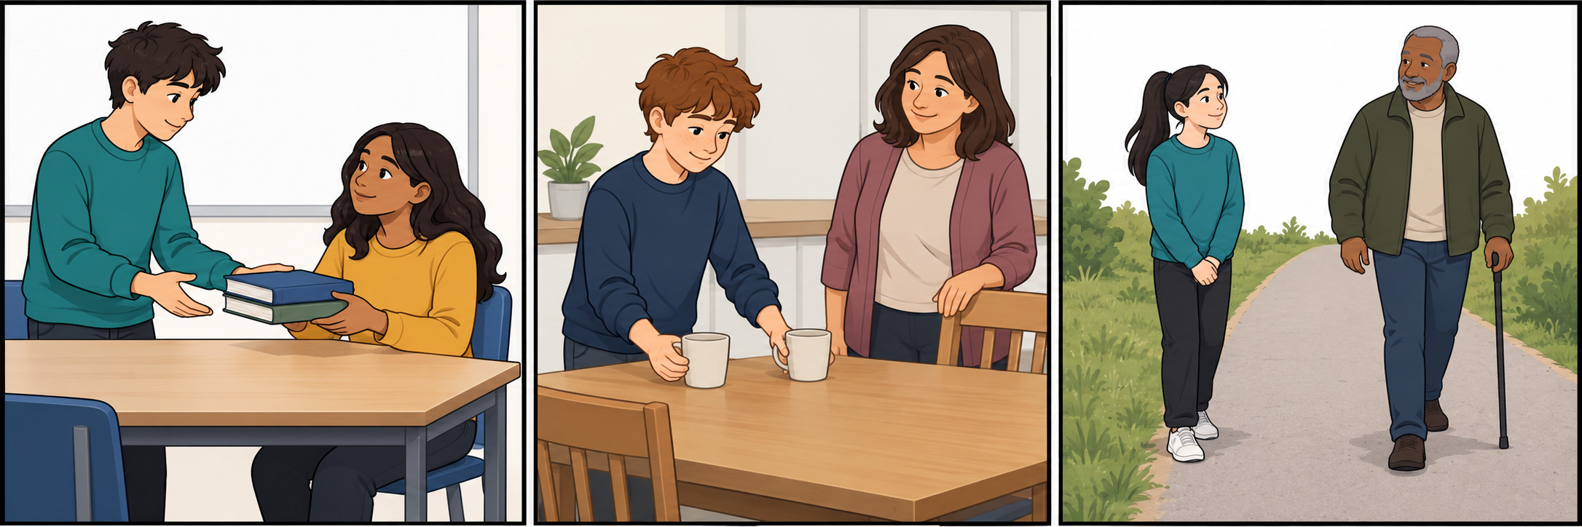
Point or ask an adult to read. Plan in any language. Keep these words with the task.

