My people and fairness record
18 March 2027 | P3
Pink paper | Point, tell, write or ask an adult to write.
My code ____ Date ____
Recognise people who stood up for fairness (Int'l Women's Day).
In your book: show your two matches. Give one line about one person.
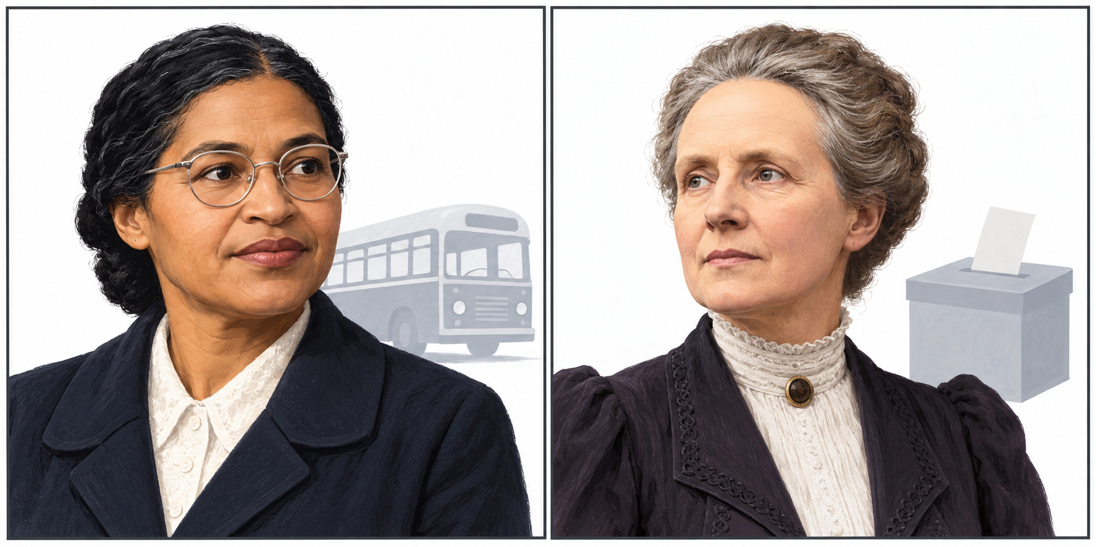
New drawings. Left: Rosa Parks. Right: Millicent Fawcett.

Words
fair, rule, seat, vote, group, help

Start and model
__ stood up for fairness.
She asked for __.
Model: Rosa Parks stood up for fair bus rules.
Many people worked for change. Point, tell, write or ask an adult to write. Listen to your line. Keep or change it.

My people and fairness record continued
18 March 2027 | P3
Pink paper | Point, tell, write or ask an adult to write.

Adult record
Keep actual records blank. Record the pupil’s recognition and choices, not a copied adult model.
Record | Actual evidence
Pupil code and date | __________________
Rosa Parks recognition/action | __________________
Millicent Fawcett recognition/action | __________________
Fairness links | __________________
Exact line or selected words | __________________
Reading mode | Read / listened / read with help: ______
Prompt and adult words | __________________
Read-back keep/change | __________________
Voice and audience reply | __________________
One NS | __________________
Pupil response and mode | __________________
Review and actual banking E | __________________
R follows Voice, audience reply, one NS and own response. Offer the authentic explanation to the Communication portfolio. No result or completion is prefilled.

