People who stood up for fairness
18 March 2027 | P3
White paper | Point, tell, write or ask an adult to write.
Route: Supported | My code ____
In your book: give one line about one person. Point, tell or ask an adult to write.
1 An adult reads the two names. Point to each person.
2 Match seat and vote cues with help.
3 Pick one line for your book. Ask an adult to write.

Words
fair, rule, seat, vote, group, help

Start
__ stood up for fairness.
She asked for __.

Model
Rosa Parks stood up for fair bus rules.
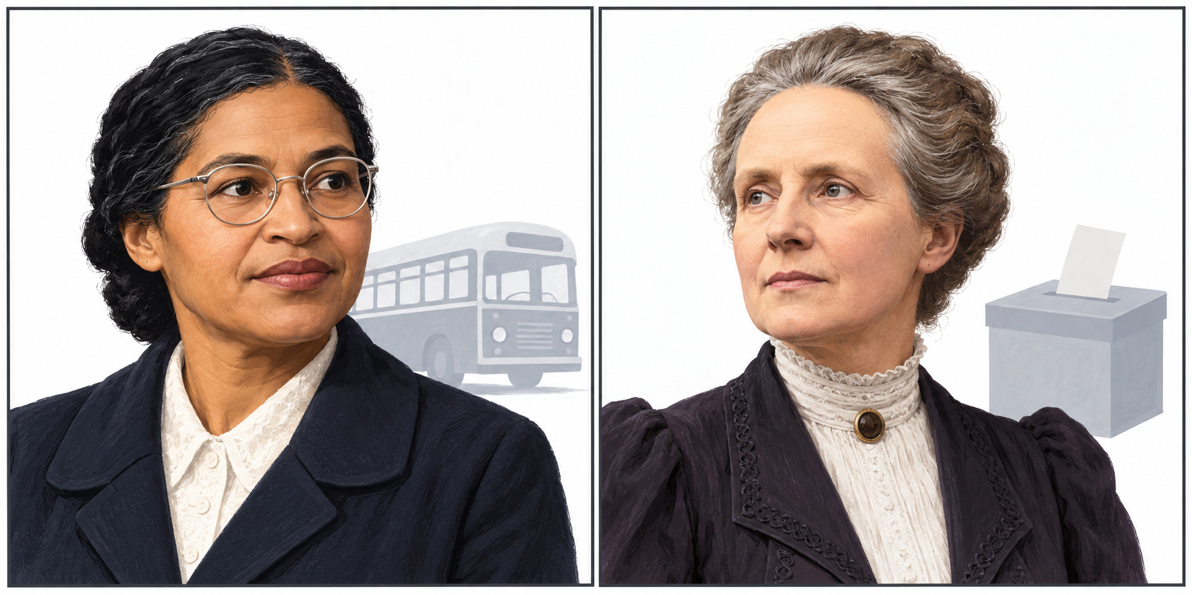
New drawings. Left: Rosa Parks. Right: Millicent Fawcett.

Finish
Show both people and their actions. Give one line. Keep or change it. You can pass or rest.

People who stood up for fairness continued
18 March 2027 | P3
White paper | Point, tell, write or ask an adult to write.
Route: Independent | My code ____
In your book: give one line about one person. Point, tell or ask an adult to write.
1 Read or listen. Match both names to their actions.
2 Add the fair aim for each person.
3 In your book: give one line about one person.

Words
fair, rule, seat, vote, group, help

Start
__ stood up for fairness.
She asked for __.

Model
Rosa Parks stood up for fair bus rules.
New drawings. Left: Rosa Parks. Right: Millicent Fawcett.

Finish
Show both people and their actions. Give one line. Keep or change it. You can pass or rest.

People who stood up for fairness continued
18 March 2027 | P3
White paper | Point, tell, write or ask an adult to write.
Route: Aspire | My code ____
In your book: give one line about one person. Point, tell or ask an adult to write.
1 Match both names, actions and fair aims.
2 Give one book line about one person.
3 Say how the action was for fairness. Many people helped.

Words
fair, rule, seat, vote, group, help

Start
__ stood up for fairness.
She asked for __.

Model
Rosa Parks stood up for fair bus rules.
New drawings. Left: Rosa Parks. Right: Millicent Fawcett.

Finish
Show both people and their actions. Give one line. Keep or change it. You can pass or rest.

