People and fairness cards
18 March 2027 | P3
Pink paper | Point, tell, write or ask an adult to write.

Two people from the past
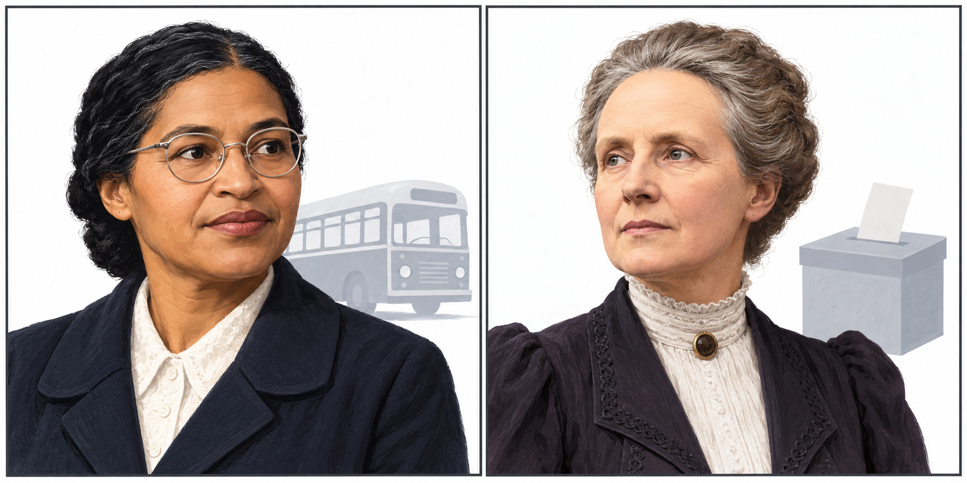
New drawings. Left: Rosa Parks. Right: Millicent Fawcett.
A Rosa Parks
She kept her bus seat in 1955. She said no to an unfair bus rule. The rule treated Black people unfairly.
B Millicent Fawcett
She led a peaceful group for women’s votes. She gave talks and worked with others. They asked for women to vote.
Many people worked together for change. This month we mark a day for women. It was on 8 March.
Words: fair, rule, seat, vote, group, help
Start: __ stood up for fairness.
Model: Rosa Parks stood up for fair bus rules.

People and fairness cards continued
18 March 2027 | P3
Pink paper | Point, tell, write or ask an adult to write.

Name action and fair aim
Name cards: Rosa Parks / Millicent Fawcett
Action strip | Fair aim strip
Kept her bus seat in 1955. | Black people should be treated fairly.
Led a peaceful group for women’s votes. | Women should have a fair say in who makes the rules.

Match
An adult can cut the names and strips. Use the two labelled drawings on page 1. Put each name with an action and a fair aim. You can point. An adult can read or move a strip for you.

Words and start
fair, rule, seat, vote, group, help
__ stood up for fairness.
She asked for __.
Model: Rosa Parks stood up for fair bus rules.
Finish: show both people and the links. Then give one line in your book. Many people helped bring change.

